Gary
Hayti
Chamberlain
Selby
Eureka
Reliance
Belvidere
Quinn
New Underwood
Figure 1. Producer mob grazing sites in South Dakota.

Figure 2. Stocking density at producer sites in 2012 and 2013.

Figure 3. Biomass of vegetation before and after mob grazing events.

Figure 4. Newly trampled litter at three sites after mob grazing.

Figure 5. Utilization (consumption + trampling) from 5 different experimental stocking densities at Volga.

Figure 6. Changes in soil moisture from mob grazing, ungrazed, and bareground at Volga in 2013.

Figure 7. Changes in soil temperature from mob grazing, ungrazed, and bareground at Volga in 2013.

Figure 8. Changes in soil moisture from mob grazing, ungrazed, and bareground at Chamberlain in 2013.

Figure 9. Changes in soil temperature from mob grazing, ungrazed, and bareground at Chamberlain in 2013.

Figure 10. Changes in soil moisture from mob grazing, ungrazed, and bareground at Quinn in 2013.

Figure 11. Changes in soil temperature from mob grazing, ungrazed, and bareground at Quinn in 2013.

Figure 12. Weed response from mob grazing, no grazing, rotation, and herbicide/mob grazing on buckbrush an wormwood sage at three locations in 2013.
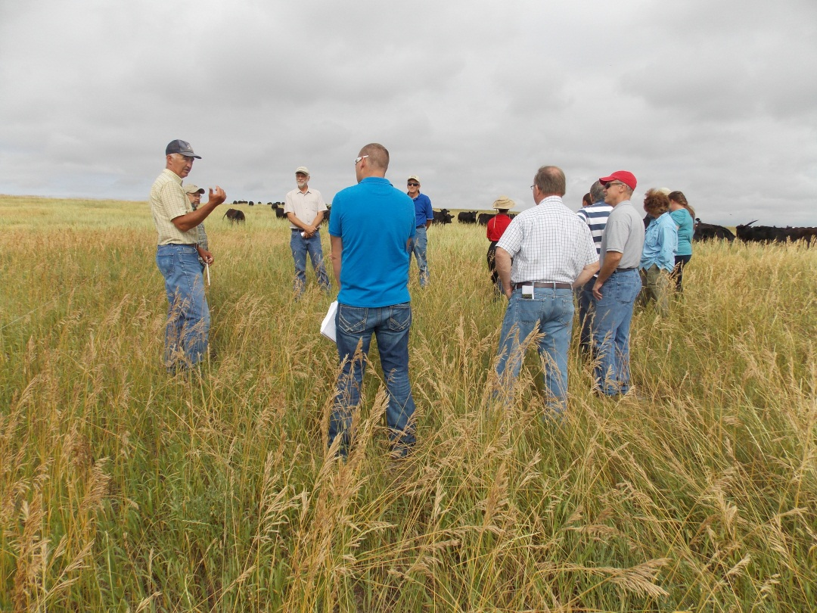
Figure 13. Rancher Pat Guptill from Quinn, SD describes his mob grazing operation to tour participants on July 15, 2013.

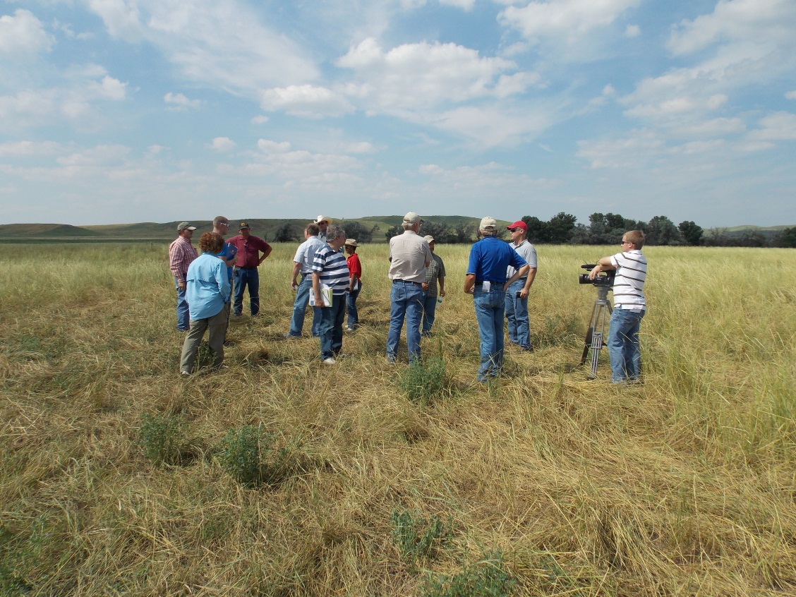

Figure 14. Rancher Randy Holmquist from Reliance, SD shows tour participants an area where he experiments with 1,000,000 lbs of beef per acre.

