2013 Climate Extension Event Photos
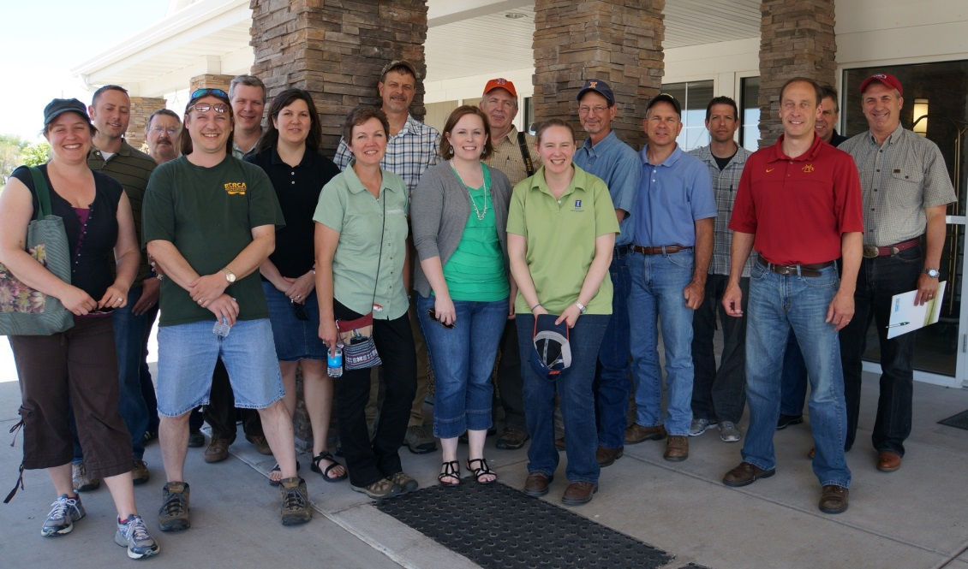
Climate Extension Team-May 2013 Extension Educator meeting in Monmouth, IL
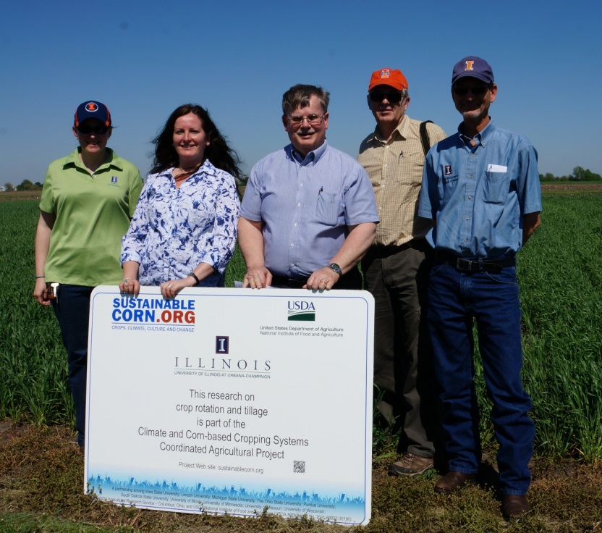
Illinois Climate Research and Extension Team- May 2013 Extension Educator meeting in Monmouth, IL
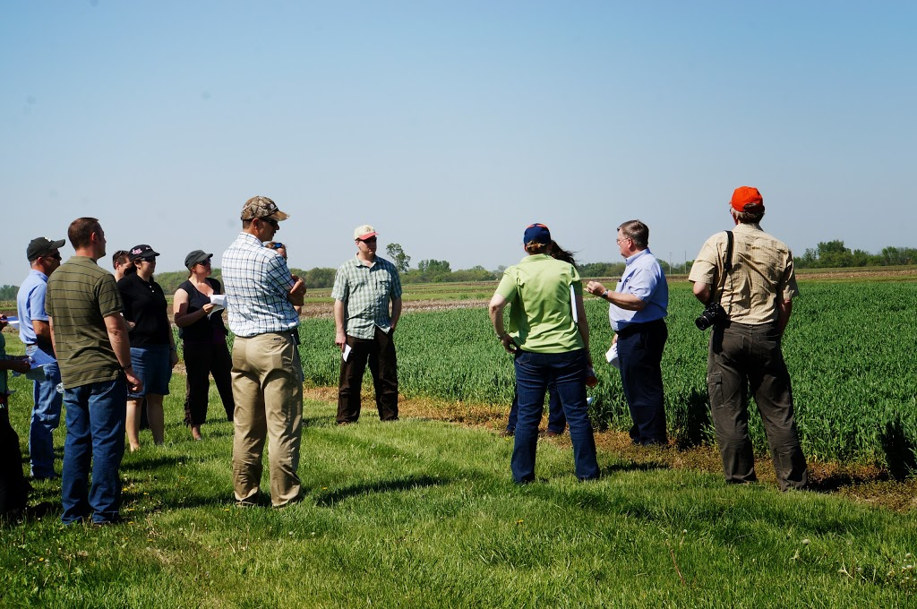
Research Site visit and presentations-May 2013 Extension Educator meeting in Monmouth, IL

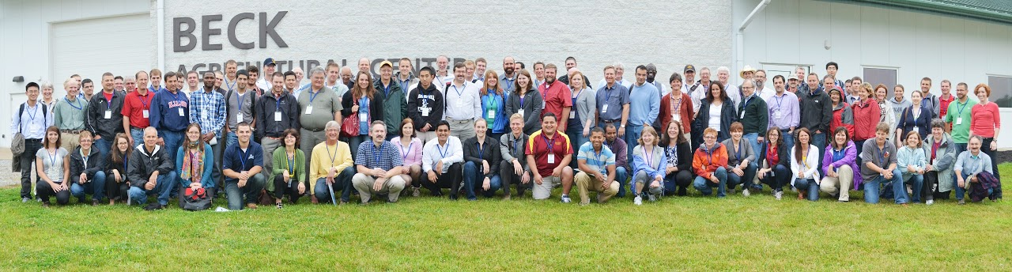
2013 Climate and Corn Systems CAP Annual Meeting, West Lafayette, IN
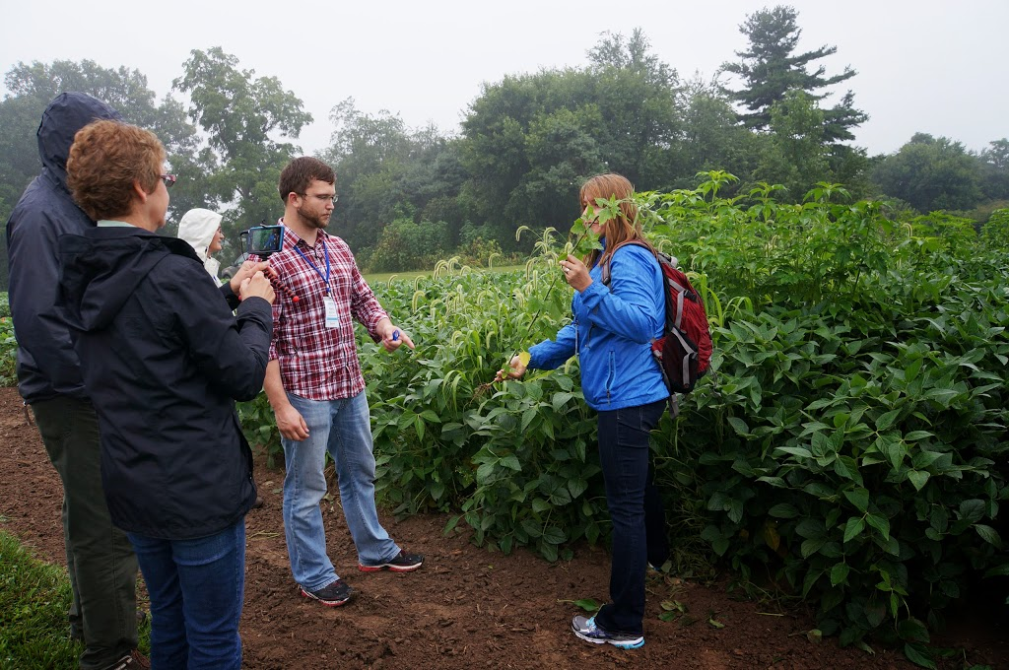
Extension Educator Marilyn Thelen (Michigan State University) learning video techniques- 2013 Climate and Corn Systems CAP Annual Meeting, West Lafayette, IN
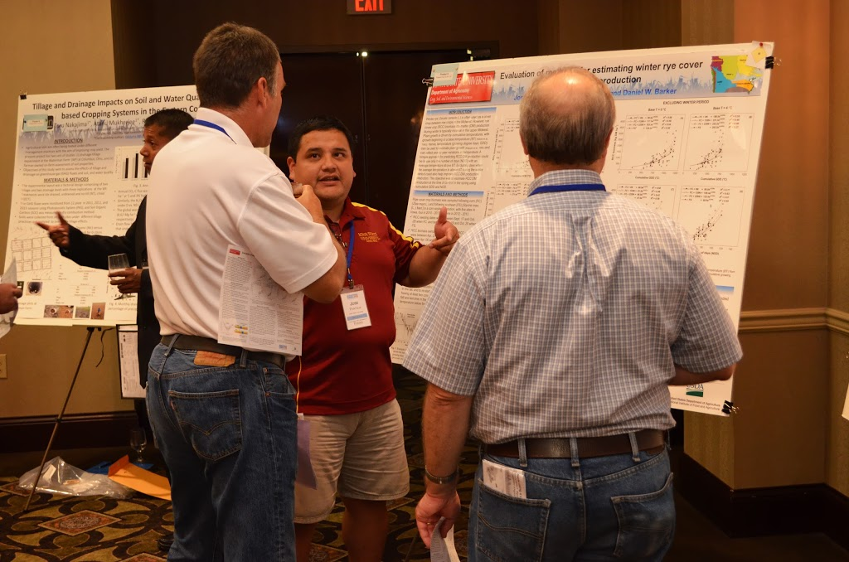
Extension Educator Charles Ellis (University of Missouri) discusses a cover crop research poster with Iowa State University graduate student Jose Pantoja- 2013 Climate and Corn Systems CAP Annual Meeting, West Lafayette, IN
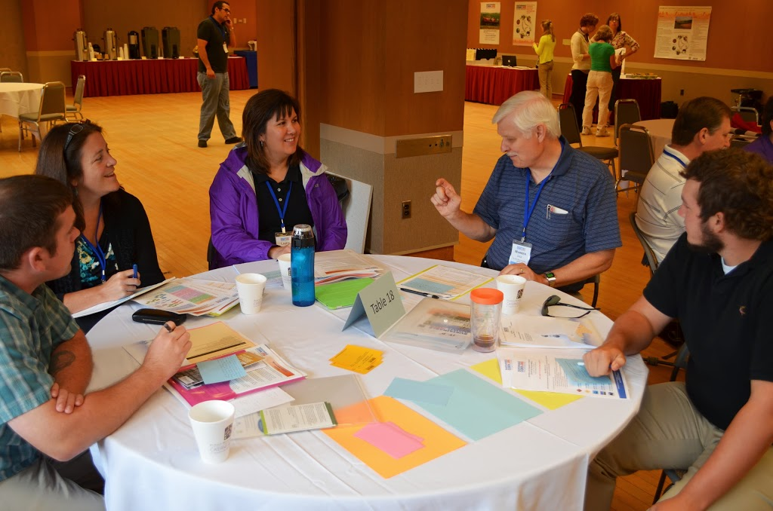
Extension Educator Laura Edwards (South Dakota State University) participates in table discussions with CSCAP researchers, evaluators and graduate students- 2013 Climate and Corn Systems CAP Annual Meeting, West Lafayette, IN

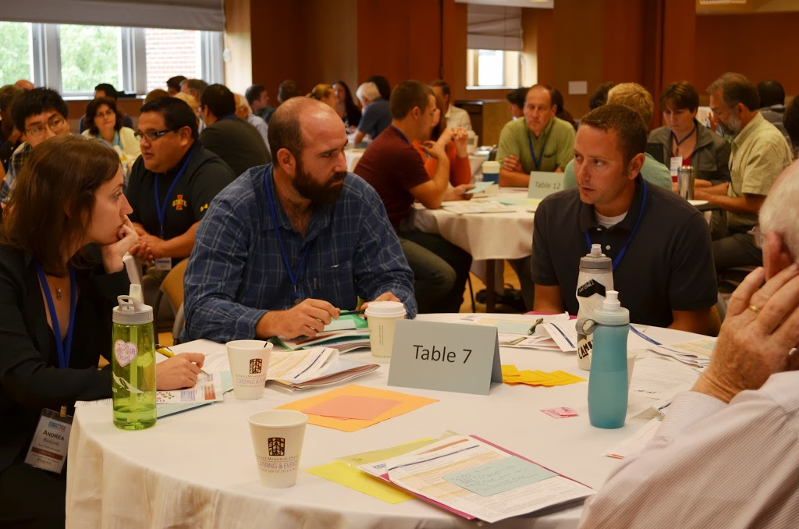
Extension Educator and Watershed Specialist Ross Behrends (Minnesota) participates in table discussions with CSCAP researchers, evaluators and graduate students- 2013 Climate and Corn Systems CAP Annual Meeting, West Lafayette, IN
Iowa Cover Crop Workshop Youtube Videos

Plot Design Options for On-Farm Cover Crop Trials
http://www.youtube.com/watch?v=yjTWzp_ZMN0

Cover Crop Selection & Management PART 1 of 3

http://www.youtube.com/watch?v=XqN4GX_DR3Y

Cover Crop Selection & Management PART 2 of 3

http://www.youtube.com/watch?v=jcB-Bh60DQs

Cover Crop "Selection & Management PART 3

http://www.youtube.com/watch?v=VMi0dzMXf-w

Nutrient Reduction Strategies
http://www.youtube.com/watch?v=Xn2McTwKxiE

