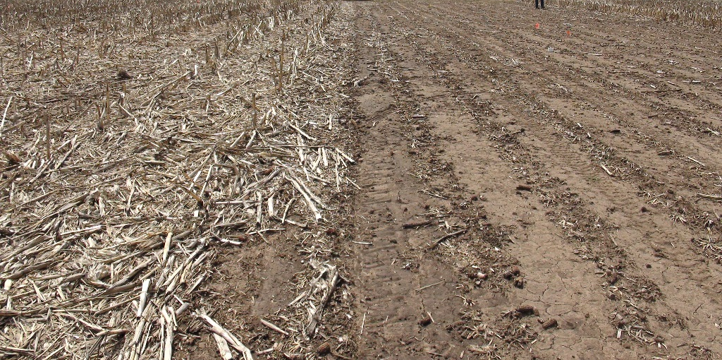

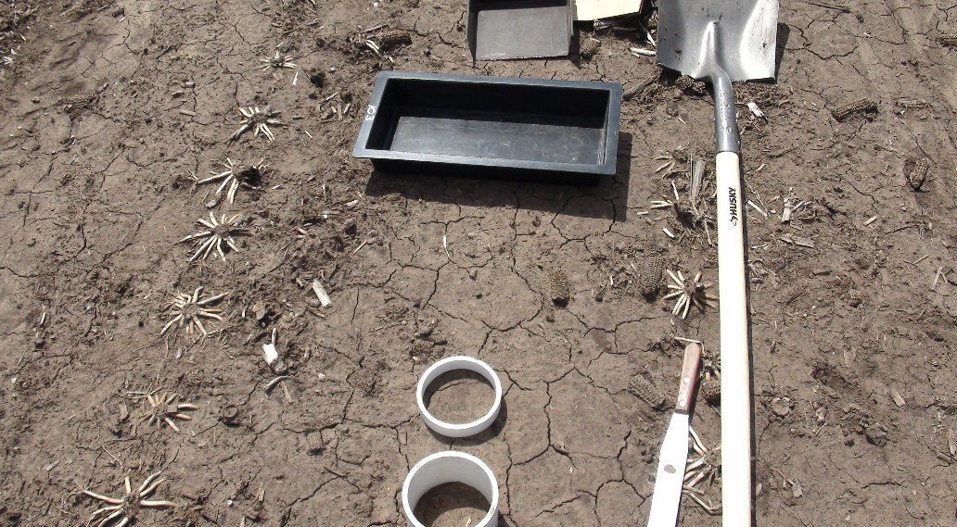
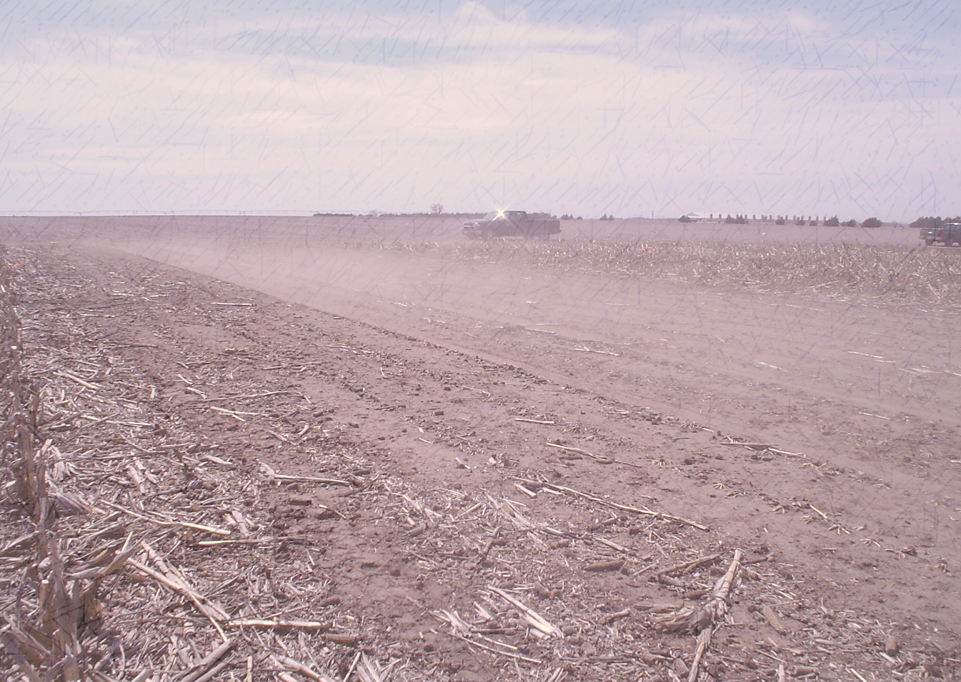
Fig. 5. Experiment at UNL’s South Central Agricultural Laboratory near Clay Center, NE. (Photos taken by the project PI: Humberto Blanco)

