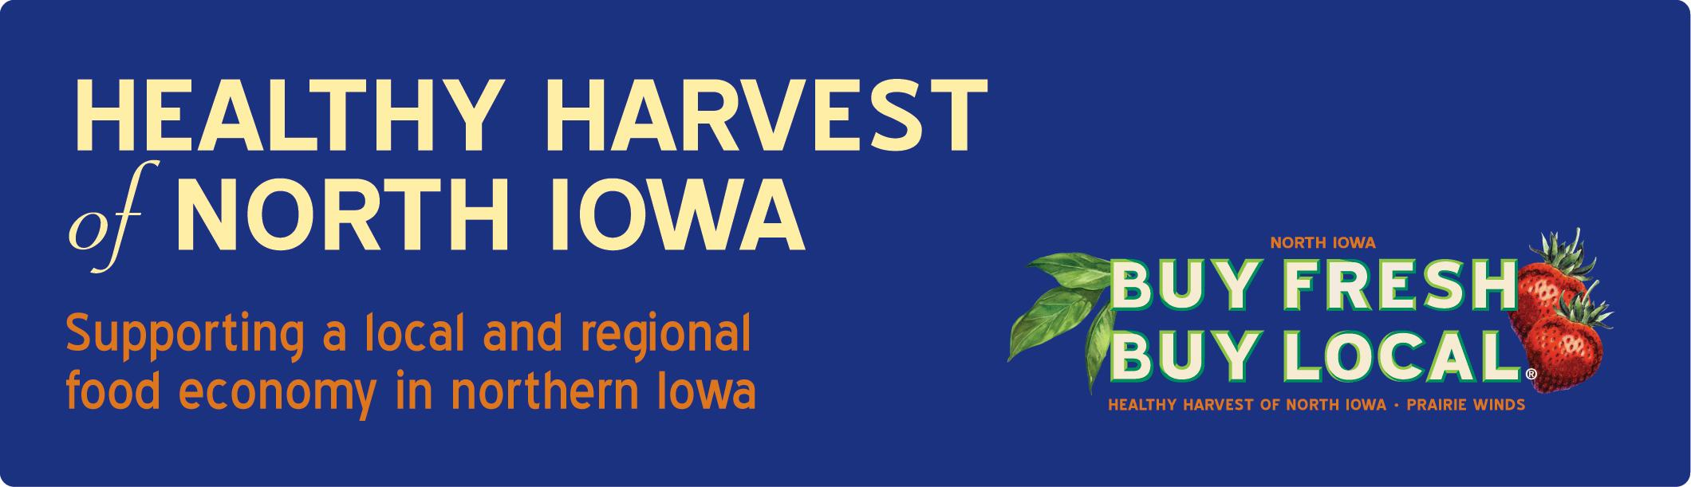

Checklist for Farms Selling Produce through Healthy Harvest Producer Collaborative
(to schools, grocers, restaurants, direct to consumer)

Name:__________________________________________________________ Farm Name: ____________________________________________________

Address:________________________________________________________________________________________________________________________________________________

Telephone: ____________________________________________________ Email: ___________________________________________________________

Total acres farmed: __________________________________________ Promotional materials available: YES NO

Available Products - circle all that apply - VEGETABLES/FRUIT/HERBS/ MEAT (processed at state or USDA inspected locker)/HONEY/FLOWERS./SMALL GRAIN/EGGS (egg handlers license required)/DAIRY

Is your facility licensed and inspected to process products? YES NO

Do you carry product liability insurance? YES; Dollar amount____________________________________________________ NO

For school sales: Are you available to visit school(s) and talk with students about how your product is grown? YES NO

Is your farm available for student field trips? YES NO

Other current school or local customers and contact information: _________________________________________________________________________

___________________________________________________________________________________________________________________________________________________________

What products (if any) are certified organic?____________________________________________________________________________________________________

If chemicals (i.e. pesticides/herbicides/fungicides) are typically used what products are used on crops and when are they applied?

___________________________________________________________________________________________________________________________________________________________

**The following checklist is meant to facilitate communication between farmers and food buyers), and give buyers background knowledge on the farms they may be purchasing from. Checking “no” on a given question does not penalize you and will not necessarily prohibit you from selling to institutional buyers. This is the start of the conversation, giving buyers a jumping off place from which to ask questions and learn more about your farm.

Production Practices | Yes | No | N/A
- What water sources are used for irrigation? (check all that apply):
___Well ___Municipal ____Pond ____Stream ____Other
- What water sources are used for product washing? (check all that apply):
___Well ___Municipal ____Pond ____Stream ____Other
- Are wells protected from contamination?
(e.g. wells are sealed, covered, secured, etc. )
- Please list the date of most recent well water test________________ (Please provide a copy of the most recent well inspection report)
- Are farm livestock and other wild animals restricted from growing areas?
- Are portable toilets and/or restrooms available to staff on the farm
- Are portable toilets used in a way that prevents field contamination from waste water?
(e.g. waste water is not uphill from, or in close proximity to growing areas)
- Is land use history available to determine risk of product or soil contamination?
(e.g. runoff from upstream, flooding, chemical spills, or excessive agricultural crop
application)
- Is field currently exposed to runoff from animal confinement or grazing areas?
(e.g. animals are not kept uphill from, or in close proximity to growing areas)
- Is land that is frequently flooded used to grow field crops? (If responded yes please answer number 11 if answered no please skip to number 12.)
- Are coliform tests conducted on soil in frequently flooded land? If yes, what are the results?

- Is raw manure incorporated at least 2 weeks prior to planting and/or at least 120 days prior to harvest?
- Is manure application schedule documented? (copy of application schedule may be requested)
- What types of manure are used?
____ Raw manure _____Composted _____Aged _____No manure used

Product Handling | Yes | No | N/A
- Is there a risk of contamination/recontamination with manure after harvest?
- Harvesting baskets, totes or other containers are (check all that apply):
___washed with potable water before use ___sanitized before use ___stored in areas protected from pets, livestock, wild animals, and other contaminants?
- Is harvesting equipment/machinery that comes in contact with products kept as clean as possible?
- Is potable water used to wash products?
- Is product protected as it travels from field to packing facility?
(e.g. product is packaged/covered/sealed to protect from contaminants)
- Are food grade packaging materials used?
- Are new packaging crates, totes, boxes used each time.
- Are packaging materials stored in areas protected from pets, livestock, wild animals, and other contaminants?
- Are temperature logs for coolers and refrigerators maintained?

Transportation | Yes | No | N/A
- Is product carefully loaded to keep product intact and to minimize physical damage and risk of contamination?
- Is transport vehicle well-maintained and clean?
(e.g. Trailers and containers must be free of visible dirt, odors, and food particles)
- Is transport vehicle designated to solely deliver food products?
If no, is vehicle properly cleaned prior to loading of food products?
- Are products kept at an appropriate temperature during transport?
(e.g. cold products to be held ≤ 40° Fahrenheit )

Facilities | Yes | No | N/A
- Storage and packaging facilities are separated from growing areas by approximately:
___less than 25 ft ___25-50 feet ___50-100 ft __greater than 100 feet
- Does the product packing area provide separate space for culling and storage?
(e.g. keeping culled products separate from good products)
- Is storage off of the floor or ground?
- Are packing areas covered from overhead contamination?
- Are surfaces that come in contact with food regularly washed, rinsed with potable water, and sanitized?
- Do workers have access to toilets and hand-washing stations with proper supplies?
(e.g. paper towels, soap, potable water, hand-washing sink)
- Are toilets and hand-washing stations cleaned and regularly serviced?
- Is a pest control program in place?

Worker Health and Hygiene | Yes | No | N/A
- Are workers trained about hygiene practices and sanitation?
- Are signs posted to reinforce hygiene practices?
- Are smoking and eating confined to designated areas separate from product handling?
- Are workers instructed not to work if they exhibit signs of infection?
(e.g. fever, diarrhea, etc.)
- Do workers practice good hygiene by:
  - Wearing clean clothing and shoes as appropriate for conditions?
  - Changing aprons and gloves as needed?
  - Washing hands as required?
  - Keeping hair covered and restrained?
  - Limiting bare hand contact with fresh products?
  - Covering open wounds with clean bandages?

I confirm that the information provided above is accurate to the best of my knowledge.

Signature of Seller: ______________________________________________________________________________ Date:________________________________

Reviewed by Food Buyer

Food Buying Authority (Printed):________________________________________________________________________ Date:__________________________________

Food Buyer’s Institution:__________________________________________________________________________________________________________

Food Buyers Contact Phone Number:_________________________________________________________________________________________________

Food Buyers Contact E-mail:_________________________________________________________________________________________________

