PROGRESS REPORT
North Central Region
Sustainable Agriculture Research and Education (SARE) Program

Progress Report Year: 2014

Project Title: Developing Profitable and Sustainable Fiber Markets in South Minnesota

Project Number: FNC 14-965

Producer/Project Leader: Jean Mueller

Address: 32741 County Rd. 17
City, State ZIP Code: Houston, MN 55943

Phone: 507.896.2354

E-mail: muellers@acegroup.cc

Website: naturalfiberalliance.com

1. Describe in detail your work activities and how you used your grant funds this year. (Use another sheet if necessary.)

We are proud of the work that has been accomplished in 2014. Our goals and objectives are on track and we are excited about 2015. It is all described with additional information below. Our hope is to be able to develop fiber markets that will give the opportunity to fiber farmers to sell more fiber. We have learned it is a slow but steady process.

Work Activities
- March 7, 2014. Awarded grant
- Job description developed for the coordinator’s position at $15.00 an hour @ 22 hours per month.
- Job description developed: Part-time, temporary position

The Fiber Farmers Alliance is seeking a part-time coordinator to assist with communications, event organizing, and office management.

Communications responsibilities: producing and editing press releases, blogs, and other written material; leading social media projects; managing and updating websites; data entry.

Event coordination responsibilities: Assist in planning and executing meetings and events, identify venues and coordinate logistics, set up and manage registration system, attend events on behalf of X.

Administrative responsibilities: Respond to phone and email inquiries, develop and manage database, make phone calls, assist in writing grant reports, manage evaluation process.

- Detail oriented and organized
- Excellent written and oral communication skills
- Proficient in Microsoft Office
- Valid driver’s license and transportation
- Photoshop and InDesign experience helpful
- Experience planning public events preferred
- Experience with Google Drive, WordPress, and social media a plus
- Knowledge or experience with farming, conservation, or fiber culture helpful.
- Applications received interviews and hired May 9, 2014 & June 2, 2014.

- Goal 1 Progress in 2014
Conduct feasibility study of markets for products from fiber animals.
Objective 1: Survey fiber animal owners to understand how their animals are being used, markets, marketing, economics, and their interest in expanding their business and collaborating with others.
- Survey completed June 1, 2014.
1. Survey results at: www.naturalfiberalliance.com.
2. Complete survey available per request.
B. Booth at Shepherd’s Harvest on May 3 & 4, 2014 to promote the Sheep & Fiber Farm Tour and discussion with fiber farmers attending regarding survey, interests, etc.
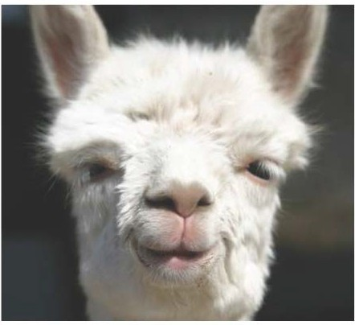
Thank you for your participation in our survey. We appreciated, as fiber farmers, the time you gave us during the busy spring season. Thank you!
We are thrilled that 91% of the participants in the survey expressed a desire for updates from the Alliance.
THE BEGINNING
The story of the Alliance began with the Sheep & Fiber Farm Tour, www.fiberfarmtour.com, in 2011. The fiber farmers who came to the tour indicated they enjoy raising the fiber animals but were storing the fiber or selling to the fiber buyer/shearer. Others felt that adding more value was an interest but found the marketing challenging.
Grants were applied for in 2013-14, based on needs expressed during the tour and others. Hence the survey/research and efforts to expand the fiber industry began. You have assisted in this effort! Thank you!
To find out more about what we are doing to help YOU sell YOUR fiber, visit our website, www.naturalfiberalliance.com (under construction as we speak)!
And Duncan (the alpaca) thanks you once again!
The NFA
Copyright © 2014, Natural Fiber Alliance, all rights reserved.
You responded to a survey of fiber farmers.

Our mailing address is:
Natural Fiber Alliance
32741 County Road 17
Houston, MN 55943

- Goal 2 Progress in 2014
Develop and implement a fiber farmer learning network.
Objective 1: Use local networks and media to identify and develop a list of fiber animal farmers interested in fiber farming.
- Mail Chimp is used to list the farmers from above study, with their permission, as well as the list of attendees at the Sheep & Fiber Farm Tour 2011-14 for email, newsletters, and to identify other farmers through social and news media.
- Development of web site: www.naturalfiberalliance.com
- Development of Facebook page: www.facebook.com/naturalfiberalliance/group
- Utilization of the website: www.fiberfarmtour.com and Facebook page: www.facebook.com/sheepfiberfarmtour/page
Objective 2: Development of the foundation for an organized group of natural fiber farmers and others to sell more fiber. Natural Fiber Alliance was started.

Vision and Mission
Natural Fiber Alliance
Vision
The Natural Fibers Alliance (NFA) is an alliance of independently-owned and managed farms dedicated to producing exceptional fibers for use in a broad range of commercial, fashion, household, leisure, and industrial applications. NFA is committed to be the preferred choice of regional and national users. In that regard, NFA will identify and define the unique characteristics of fibers produced in Southeast Minnesota.
Mission
NFA will discover, and share among its members, best practices that improve the individual operations of member farms. It is recognized that members represent virtually every segment of the natural fiber industry with farms populated with sheep, llamas, yaks, goats, alpacas, angora rabbits, and others. Individual
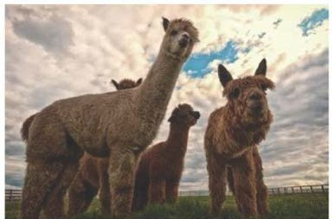
members will provide leadership in evaluating and communicating best practices in his/her areas of specialization and expertise. This will be especially true with topics dealing with animal procurement, farm layout, shelter, animal nutrition, environmental management, marketing, and other topics. In every way possible, operational effectiveness and innovation will be emphasized.

NFA will explore and share business opportunities that exist across the entire supply chain between fiber producers and end-users. User markets will be segmented in order to clearly define the specific needs and requirements of each segment. Members will be informed of those requirements to ensure the fiber producer can/will conform to all standards and specifications. Methods of improving competitiveness will be shared with the individual members. Market and applications research will be conducted by knowledgeable volunteers. Benchmarking will begin with regional assessments and then expanded to include national and global assessments. This will involve consideration of integrating value-adding steps in processing fibers into more acceptable and useful forms for use by manufacturers of finished products. A process of analyzing Strengths, Weaknesses, Opportunities, and Threats will likely be utilized by the researchers.

NFA will be a leader in quality improvement practices that enhance the reputation of the organization as the supplier of choice among diverse buying groups.

NFA will research, share, and execute best practices in educating the general public about the intrinsic value of sustainable fibers when used broadly in society. Focus on audiences in K-12 institutions will be a priority, as will the continuation and further development of “Farm Tour” programs. NFA will speak with “one voice” to develop an enduring message about natural fiber farming and fiber use. In this regard, the organization will continually listen to the “voice of the customers” of sustainable fibers to ensure that NFA is knowledgeable of current and, as importantly, future needs. Promotional material that is developed to support the Alliance will have member input and approval.

NFA will work with universities and other research institutions to learn and share knowledge about emerging technologies that are relevant to fiber farming.

NFA will represent all members among the state legislature, and Departments of DEED, Agriculture, and Commerce.

NFA members understand that effective implementation of a plan that captures the spirit of this vision and this mission will be good for everyone concerned and in many ways improve the quality of life of all participants.

Organization
NFA has no intention or desire to have an inflexible, unwieldy bureaucracy to manage the Alliance. We will rely principally on member participation and volunteers from supply chain partners who see the benefits of this enterprise. From time to time, we will seek grants from public and private sources to aid in specialized research and best practices evaluation. Execution of quality improvement efforts and best practices will be left up to the individual farm members.

NFA will consider Associate Members as part of the organization.

Objective 3: Hold two network meetings to share how members are working with their animals, managing their land, and marketing their products.

1st Network Meeting: 9 attendees
July 11, 2014 Network Meeting of Fiber Farmers & others involved in fiber farming and development of the Natural Fiber Alliance.

Agenda:
- Vince: Alliance Critical Items (order of items may change)
- Discussion of vision post survey
- Prioritize mission objectives – critical member input
- Discussion of member expectations expressed in the mission
- Type of organization preferred, i.e., member organization, 502.c.3, informal. If member, what level of fees are acceptable? Grants?
- Discussion/plan for “deliverables.” How and with what human resources?
- Management/administration…volunteer board, “managing member,” volunteers
- Frank discussion of inevitable member competition for customers in the same region
- Strategic implementation plan – what does it look like? Who will participate?
- Jean: Current Big Picture
- Tour/Janice Arnold’s addition
- Committees – Please review committee job descriptions sent earlier – Thanks!
- Marketing
- All media and social networks relating to the tour and Janice
- Brochures, posters, postcards, etc.
- Other
- Signage
- Demonstrations
- Evaluation
- Farm/farmers & mill needs during tour weekend
- Volunteers
- Demo times, etc.
- Other
- Alliance
- Expanding fiber markets
- Committees
- Grant writing
- Network meetings
- Topics in the areas requested from the fiber farmers
- Setting up the meetings, presenters, etc.
- Marketing
- Events
- Tour 2015
- Dinner on the Farm
- Other
- Fiber Farm Market
- Local Fibers in Food
- The Story/Local/Fiber Farmers/Sustainable/Natural Fibers
- Marketing
2nd Network Field Day: 25 attendees

NATURAL FIBER ALLIANCE
- FIRST NETWORK & FIELD DAY -
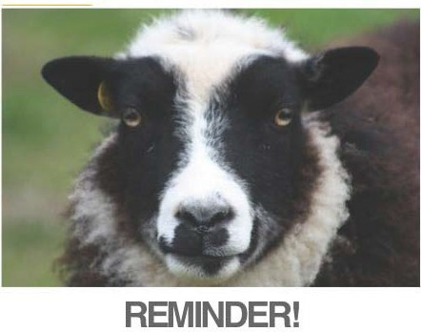
NETWORK/FIELD DAY! SEPTEMBER 13, 10 am until 5 pm @ GALE WOODS FARM 7210 County Road 110 W., Minnetrista, MN

The Natural Fiber Alliance and Sheep and Fiver Farm Tour (www.fiberfarmtour.com) together would like to invite you all to our first Network/Field Day! The fee is $20 and lunch will be provided. Download registration @ www.naturalfiberalliance.com.

Featured Speaker Bob Padula – Getting More Return for Your Wool Through Value-Added Ventures
- Quality Wool Is Necessary
- Know What Product Can Be Made from Your Wool
- Value-Added Product Examples
- YOU Must Be Part of the Value-Added Process
- Key Points to Consider for a Successful Value-Added Venture
- Before Jumping In, Ask Yourself
Farm Tours:
Gale Woods Farm – Tour the Farm and Meet the Flock (Finnsheep & Crossbreds)
- Learn about Gale Woods Farm’s fiber program
- www.threeriversparks.org/parks/gale-woods-farm.aspx
Judy Lewman – The Customer Is Always Right
- The first to introduce Ashford spinning wheels to the U.S. market, Judy has been providing fleece to handspinners for more than 40 years.
- Today most of Spring Creek Farm’s long, curly, lustrous Border Leicester wool goes into designer handspun that’s marketed worldwide.
- Learn how management practices evolved to suit market needs, and how the flock overwinters on large round bales in easy-to-build self-feeders.
- While her current focus is on small ruminant health, Judy is pleased to have the opportunity to assist with the start-up of the Alliance.
- www.springcreekleicesters.com

Sue Simonton & Margaret Long – The Ceaseless Pursuit of Perfection
- Today we have many fine, heavy suri alpaca fleeces to send to the mill to be made into luxurious suri yarn that has no competition here in the U.S. or elsewhere!
- By working with a good mill, such as Rach-Al-Paca Fiber Processing, and with lots of trial and error, we have created good suri alpaca yarn that does not shed!
- With value added and through careful breeding, we have increased both the quality and the quantity of suri fleece we produce!
- We have worked hard at marketing our yarns nationwide.
- Our yarn now appears in Knitting Traditions, an international magazine. The front cover shawl designed by Galina Khmeleva with our 100 % suri laceweight yarn.
- Consistent, reliable quality yarns is what our customers expect! It’s a start!!
- www.lfgsuris.com
SURVEY:
We received 3 surveys back. They were positive. We also received positive comments during the day from the attendees.

IV. Goal 3 in 2014
Conduct a two-day Sheep and Fiber Farm Tour
Objective: Raise awareness and support for the fiber industry.
Implement by: planning, engaging 5 farms, marketing, conducting, and evaluating the event.
Completed on October 12, 2014

Brochure at: www.fiberfarmtour.com
Social Media:
- www.facebook.com/sheepfiberfarmtour/page
- www.facebook.com/naturalfiberalliance/page
- www.twitter.com Sheep/FiberFarmTour
- www.instagram.com sheepfiberfarmtour
- www.google.com Sheep Fiber Farm Tour for news media & other articles
Flyers & Postcards: (see previous page)

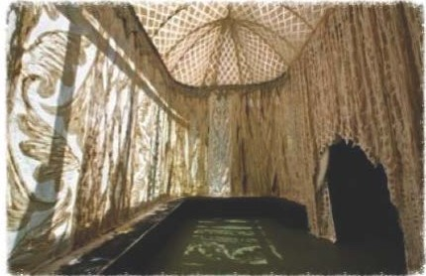
Sheep & Fiber Farm Tour
Oct 11 & 12
www.fiberfarmtour.com
Dear Past Visitors to the Sheep & Fiber Tour,

We have 1 spot left (1st come 1st serve) at a very special, full-day hands-on workshop this coming Saturday, November 3 in Winona. World-renowned felt artist Janice Arnold will be teaching this workshop. Janice Arnold, International Artist, teaches the use of sustainable fiber. This is a very special opportunity to learn felting in a small class setting. The cost for the workshop is $175 including supplies. This rate is possible due to the generous support through a grant from the Southeastern Minnesota Arts Council, thanks to a legislative appropriation from the arts and cultural heritage fund.

And if that’s not enough to get you excited, you can also join us for a great weekend of endless fiber and all things connected! Fiber farmers, fiber farms, fiber animals, Faribault Woolen Mill’s beautiful fiber products! Will see in Target soon! And to cap it all off, Janice Arnold will offer a presentation and reception FREE! Everything you need to know is at www.fiberfarmtour.com.
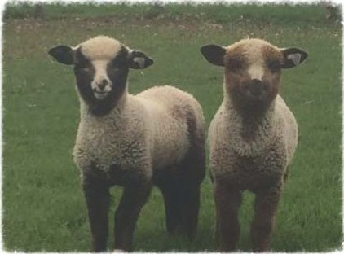
This product was developed with support from the Sustainable Agriculture Research and Education (SARE) program, which is funded by the U.S. Department of Agriculture-National Institute of Food and Agriculture (USDA-NIFA). Any opinions, findings, conclusions, or recommendations expressed within do not necessarily reflect the view of the SARE program or the U.S. Department of Agriculture. USSA is an equal opportunity provider and employer.

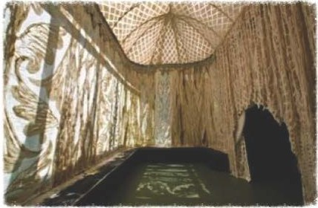
Sheep & Fiber Farm Tour
2014
We thought this year’s Sheep & Fiber Farm Tour, on October 11th & 12th was a success but we’d like your feedback!
Please take 2 minutes of your valuable time to fill out this survey. Your feedback will help us improve the experience for everyone on next year’s tour!

What have we learned and attendance from our 2014 projects.
- Survey. The survey was essential in establishing if there was an interest in additional markets as well as what is out there as to natural fibers. We learned that there is an interest as well as a willingness to participate in a learning network and in more fiber markets. We learned more about the needs of the farmers and specifics regarding their fiber farming. We were pleased. Number of farmers who took the survey is above as well as the survey itself being available in a summary form on our website. The full survey is available at request.
- Network/Field Days. They were terrific. The number of attendees was higher than other agriculture field days and we were excited that the farmers would spend the entire day. We learned there was great value in the opportunity for the farmers to gather. There isn’t an opportunity to learn from each other regarding specific fiber needs and fiber farming. They enjoyed the opportunity. We learned they are interested.
- Developing an organization: Natural Fiber Alliance. It is a slow process and transforming from a small tour to an alliance to assist fiber farmers in more markets for their fiber product is a big step. We are grateful to our mentor who is a past CEO of 3M in Australia and has been a great help in building a foundation to help with success.
- Sheep & Fiber Farm Tour. We learned individuals have an interest in local sustainable natural fibers and will come to experience and to learn about the farmers, farms, fiber animals, and fiber. There is an interest in obtaining a local, sustainable fiber product. There is a market.
3. Describe your work plan for next year.
Natural Fiber Alliance
ACTION PLAN – ALWAYS ASK: DOES IT HELP SELL FIBER?
QUARTER/MONTH
PROJECTS/ACTIVITIES
PERSON RESPONSIBLE
PRIORITY – H High M Medium
COMPLETION DATE
- Sheep & Fiber Farm Tour 2015
Melodee
H
October 10-11, 2015
1a. Tour’s 5th Year Anniversary Dinner with www.outstandinginthefield.com
Melodee, Jeanine
August 2, 2015
1b. Sheep and Fiber Farm Tour with Dinner on the Farm
Melodee, Jeanine
October 10-11, 2015
- Grant to work with Faribault Woolen Mill on producing a local wool product
Jean, Jan, Vince
H
December 31, 2015
- Pilot Project – U TX example: Getting product into Whole Foods or Co-ops (Fiber Kits)
Rachel, Margaret, Jean, Jan
H
December 31, 2015
- UM Pilot Project (Fashion) example: Alpaca Owners fashion designer project (www.alpacafashion.com)
Brittany, Margaret
M
December 31, 2015
- Sue’s Project: Organic and Sustainable Feasibility
Sue
M
December 31, 2015
- Seminar/Field Day on shearing basics, skirting fleeces, grading fleeces, and a “raw fleece” public sale
Rachel
H
April 17-18, 2015
- Seminar/Field Day on marketing
Jean, Vince
H
December 31, 2014
- Create NFA Fact Sheet on sustainable practices
Sue
M
December 31, 2014
- Communication Plan (electronic newsletter, social media)
Margaret, Jean
H
December 31, 2015
- Identify and obtain financial resources for various aspects of the project
Jan, Jean
H
December 31, 2014
- Explore the California Fibershed Approach
Rachel
M
November 21, 2014
- Continue development of an organized group for fiber farmers, Natural Fiber Alliance
Jean, Vincent, Margaret
H
December 31, 2015

4. How did you share information from your project with others? (Include the number of people who attended field days or demonstrations.) What plans do you have for sharing information next year?
We shared the information from our project with the attendees of our monthly Natural Fiber Alliance meeting with an average attendance of 6.

We also hared our information during the Network Field Days and the Sheep & Fiber Farm Tour with the attendant numbers above.
Our websites and Facebook pages have been helpful in sharing information.

I have our work/action plan attached above in #3. We will continue with the projects we did this year in 2015 and add the new projects per work plan above.

We are excited about the possibility of working with the UM Regional Partnership in developing our next state of research and sharing with a larger network through the extension offices of the regional partnership.

BUDGET
Personal $6300.00
Material Support $400.00
Direct Costs
Advertising $615.90
Room Rental $334.91
Brochure $550.00
Road Signs $432.87
Web Design $768.00
Food $465.57

TOTAL $9,867.25

Send completed report by e-mail (e-mail is preferred) or mail to:
E-mail: benjaminj@lincolnu.edu, or mail to:
Joan Benjamin
NCR-SARE Associate Regional Coordinator
Lincoln University
900 Leslie Blvd, Room 101
Jefferson City, MO 65101

Call Joan Benjamin with questions at: 573-681-5545.

