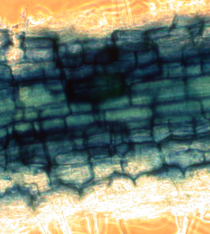
Figure 1. AMF mycelium and arbuscules stained with trypan-blue dye at 400x magnification.

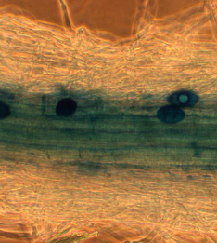
Figure 2. AMF vesicles stained with trypan-blue dye at 400x magnification.

