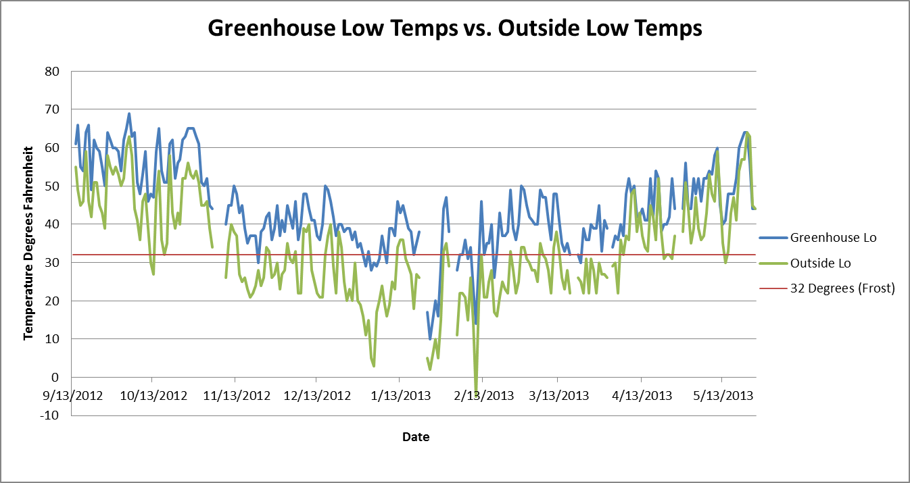
Graph showing daily low air temperatures from both inside the greenhouse and outside. Gaps in the lines show missing data from those days.

