A survey was administered by the LCOOCC Extension Department in December 2013 – March 2014. Participation was voluntary. Surveys were handed out in the respective communities of Lac Courte Oreilles, Red Cliff, St. Croix, and Lac du Flambeau. An electronic version was also emailed to all LCOOCC students and listserv of extension programming participants. The email was sent to over 1,800 people. One hundred and thirty-nine surveys were returned. A synopsis of the results is found below.

Demographic Data for Respondents:

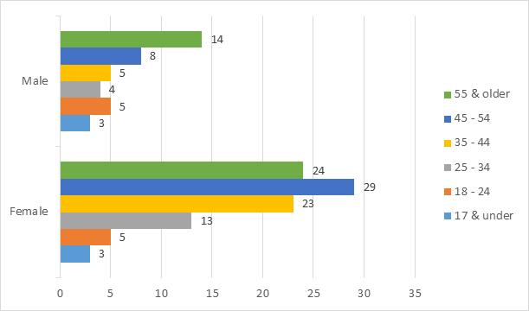
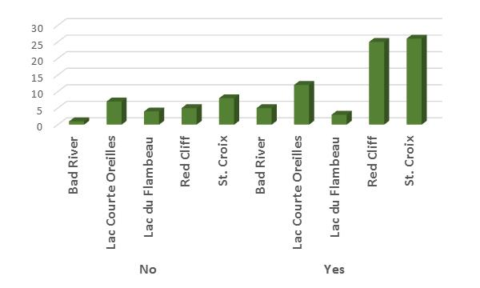
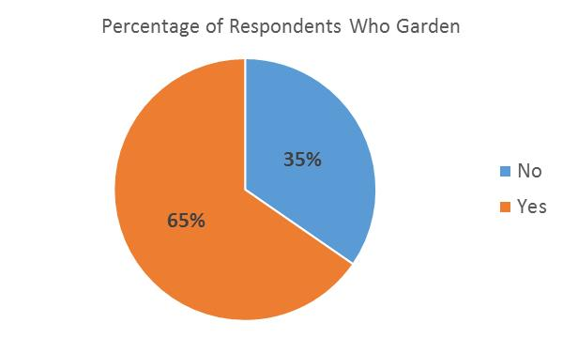

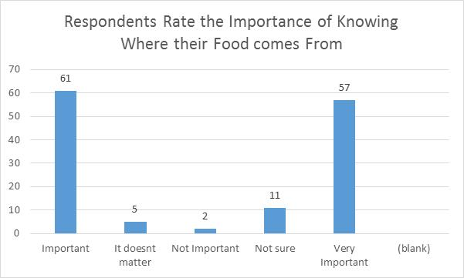
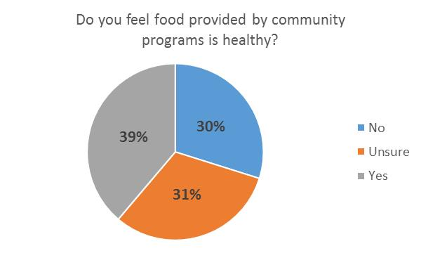
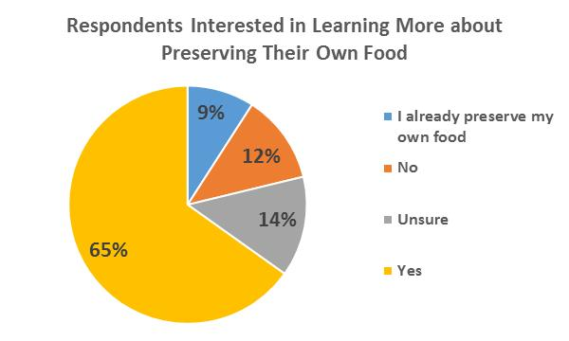

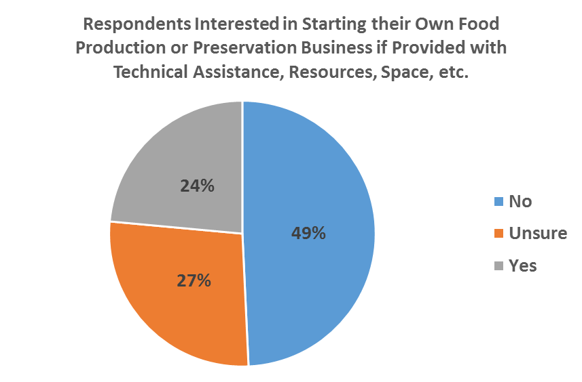

If there were a community program that assisted with tilling and provided necessary supplies, would you garden?
