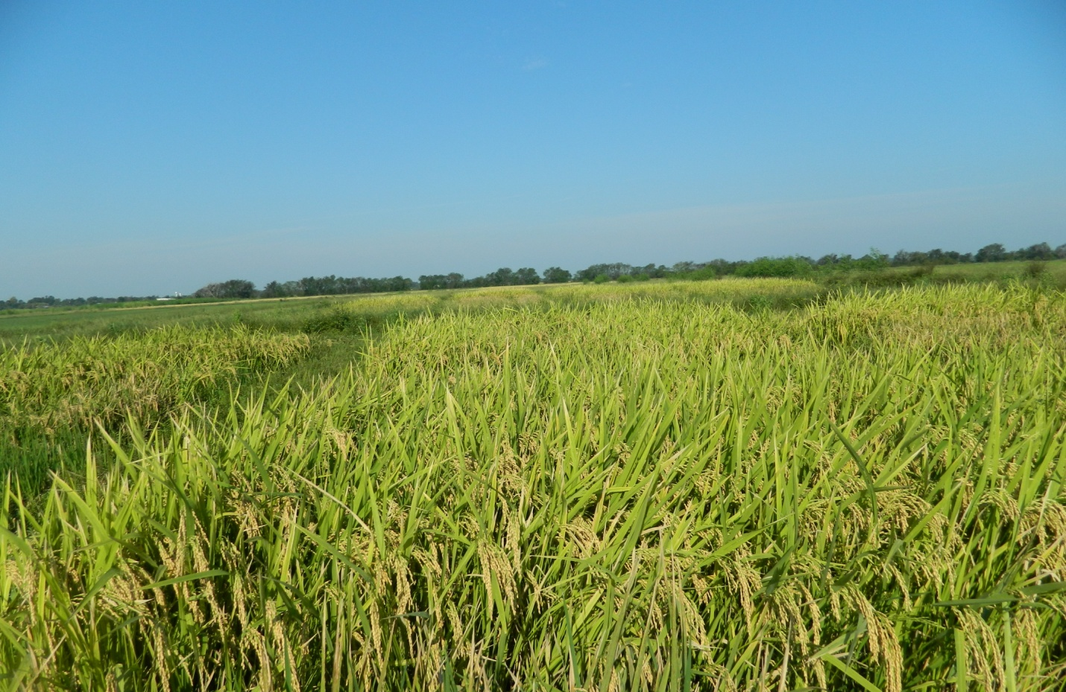
Photo 1. Organic Rice Field

