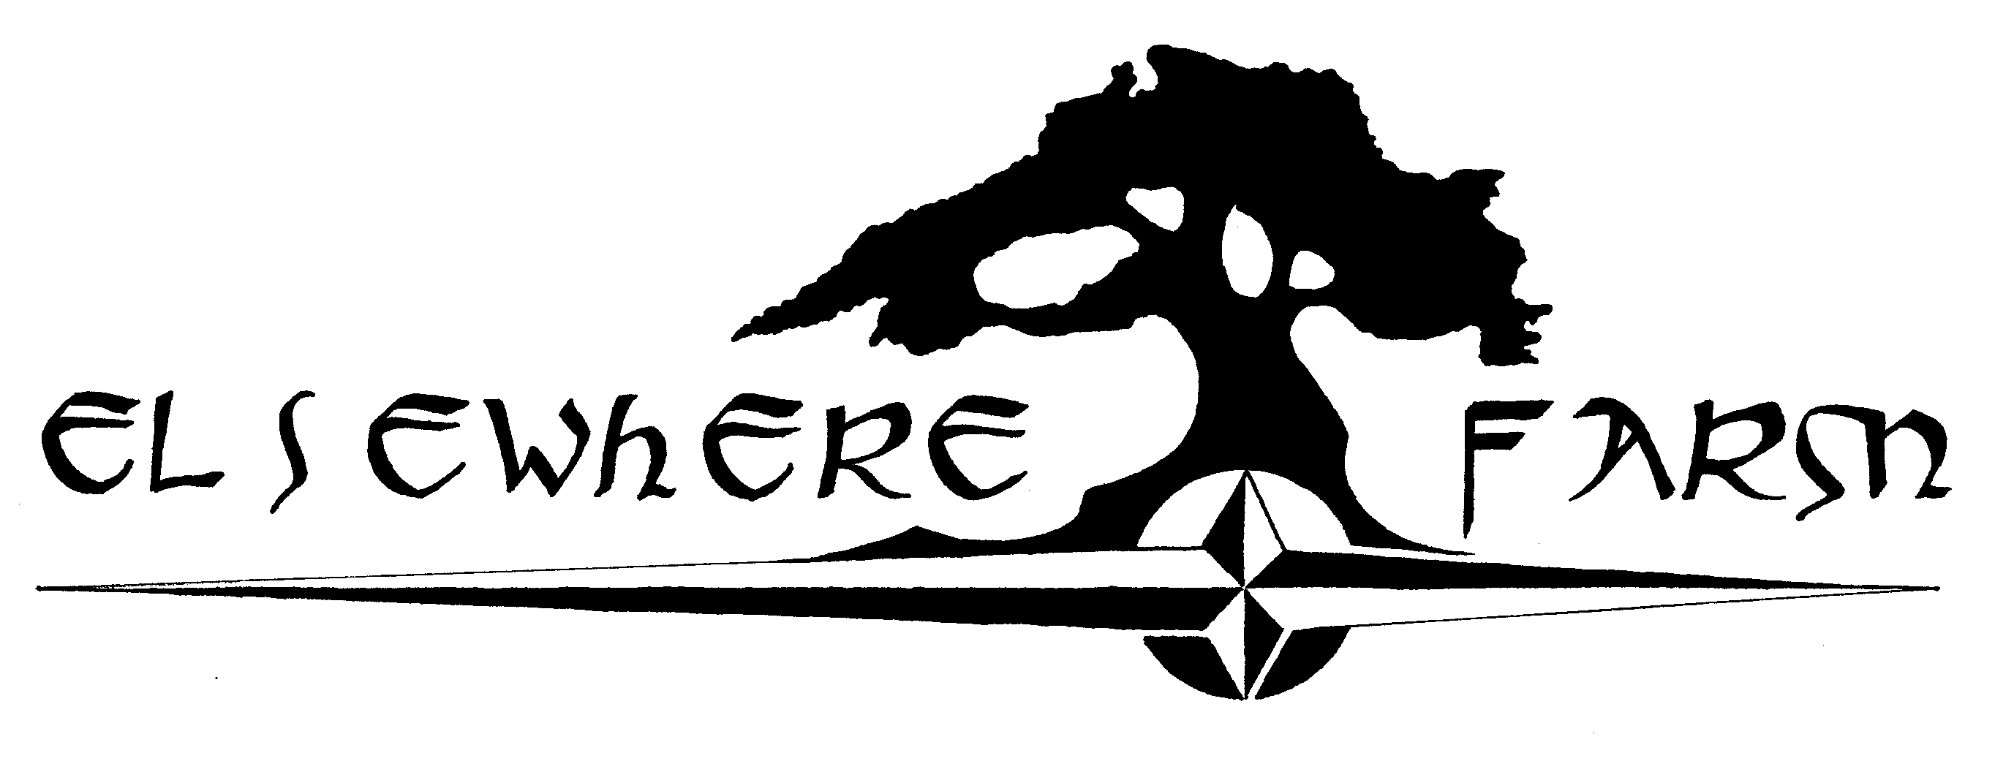**Elsewhere Farm**

**presents**

**Northern Woods Baklava**

🙡

20 pieces

**Ingredients**  
1 (8 oz) pkg phyllo dough, thawed

1 lb hazelnuts, ground

¼ c flax, ground (optional)

6 -8 oz dried currents, aronia berries, figs (or other dried fruit) finely chopped

1 stick butter, melted

1 t ground cinnamon

1 c water

1 c unrefined sugar

1 vanilla bean (optional – can also add a splash of vanilla extract if desired)

4 whole cardamom pods (optional)

½ c honey



**Method**

1. Preheat oven to 350˚F.

2. Finely chop nuts and toss with flax seed, dried fruit and cinnamon. Set aside.

3. Butter the bottoms and sides of a 9x13 inch pan. Unroll phyllo dough. Place a sheet of dough in pan, butter thoroughly. Repeat until you have about 6 sheets layered.

4. Sprinkle about 1/3 of the nut mixture on top. Top with phyllo dough, brush with butter and repeat with another 6 sheets of phyllo. Add another 1/3 of the nut mixture and repeat. The top layer should be about 6 - 8 sheets of phyllo.

5. Using a sharp knife, cut into diamond or square shapes all the way to the bottom of the pan.

6. Bake for about 50 minutes until baklava is golden and crisp.

7. Make sauce while baklava is baking. Boil water, sugar and cardamom pods until sugar is melted. Add vanilla and honey. Simmer for about 20 minutes. Remove pods.

8. Remove baklava from oven and immediately drizzle sauce evenly over the top. Let cool.

9. To help the baklava retain it crispness, leave it uncovered.

10. Serve. Enjoy.