Farmer Rancher Grant Program

Final Report Form

Please fill out the final report form and post it on MySARE. If you do not have Internet access, return the form to the North Central Region-Sustainable Agriculture Research and Education (NCR-SARE) Missouri office. The report may be prepared on a computer or handwritten (please write or print clearly) but electronic reports are preferred. The final payment of your grant will be awarded when the final report and final budget report are received and approved.

Use as much space as needed to answer questions. You are not limited to the space on this form. The more details the better.

I. PROJECT IDENTIFICATION
- Name: Jeff Hafner
- Address: 2425 Willow Ave
- City, State, Zip Code: Panora, Iowa 50216

- Phone: 641-757-0106
- Website: earlymorningharvest.com
- Project Title: Economic Evaluations of Aquaponics
- Project Number: FNC 12-861
- Project Duration: 2 years
- Date of Report: April 2014

II. PROJECT BACKGROUND
1. Briefly describe your operation (i.e. how many acres, what crops, types of cropping systems, type of livestock or dairy production, grazing systems, family operation, etc.)

I have a degree in Agricultural education from Iowa State University and was active in 4-H and FFA. After college I moved back home and started farming with my father. Dad and I have farmed together for almost 20 years. We have a diverse operation of corn, soybeans, and small grains (oats, wheat, rye, and buckwheat), hogs, chickens and cattle. We converted the crops and cattle to organic beginning in 2000. And, we have been certified organic thru the Iowa Department of Land and Stewardship (IDALS) since 2000. The operation includes about 2000 acres of crops and pasture all certified organic. The 200 head cow/calf operation is also certified. Dad and I have always understood the stems approach to farming with the value of crop rotations, cover crops, and livestock management in a holistic and sustainable operation. Converting to organic additionally showed us the value of eliminating pesticides in a sustainable holistic operation. Rotational grazing has added sustainability to the cattle operation. I am looking at vegetable production as an expansion of the farming operation to add more diversification and stability to our operation. While overseas with the military, I was exposed to aquaponics (aquaculture is raising fish. And, hydroponics is raising plants without soil. Aquaponics is combining the two to form a system in which the fish provide nutrients for the plants and the plants “clean” the water for the fish in a circulating enclosed system.) Aquaponics seems to be an efficient and holistic system that can produce vegetables without pesticides and/or lots of labor and meets our values to be part of our operation.

2. Before receiving this grant, did you carry out any sustainable practices? If so, briefly describe what they were and how long you had been practicing them.

Yes, We have used cover crops in crop rotations. We plan crop rotations around soil type and slope and are not afraid to include small grains, clover and alfalfa in the rotation. We soil test regularly; Not only for Nitrogen, potassium and Phosphorus but also for micro nutrients. By eliminating pesticides and petroleum based fertilizers we have seen an increase in soil biology and tilth

The cattle are rotationally grazed and we continue to upgrade watering systems to improve its efficiency. Clovers are frost seeded in pastures as needed.

We view our farm as one holistic operation where the cattle and livestock benefit the crops and the crops benefit the livestock both of which benefits the next generation.

III. PROJECT DESCRIPTION
This is the core of the report. Consider what questions your neighbors or other farmers or ranchers would ask about what you did with this grant. Describe how you planned and conducted your research or education activities to meet your project goals and discuss the results.

GOALS
List your project goal(s) as identified in your grant application.

My goal was to study the start up costs of a year-round aquaponics greenhouse and monitor the operational inputs and outputs for the first couple years. I planned on monitoring everything that effects cost and production including electricity, water, labor, and capital. And make this available thru Practical Farmers of Iowa, Extension Services and local Youth organizations using tours, publications and field days. The goal is to provide information on the economics and production during the start up phase and thru the first couple of years, so other farmers (new and established) can use my information to make solid informed decisions.

PROCESS
Describe the steps involved in conducting the project and the logic behind the choices you made. Please be specific so that other farmers and ranchers can consider what would apply to their operations and gain from your experience.

The start of this project (13 April 2012) was roughly one year from when I received my first fish (March 2011). To understand some of the decisions, my explanation will start in 2011.

The decision to start an aquaponics greenhouse was based around the idea of the local foods movement and the fact that I enjoy gardening but with the time requirements and timing requirements of the farm the garden usually failed. It failed, mainly because of the time commitment for weeding. As mentioned above aquaponics also seemed to fit the holistic and conservation values of our farm.

I converted a small, old open front hog shed into a greenhouse. The fish tanks were under the shed to prevent algae growth and the open front slab was covered with double plastic with a pvc and wood frame. I attended a Nelson and Pade Inc aquaponics workshop and decided to buy two of their prefabricated systems instead of building my own. Although this was more expensive, it also gave me a support center I could call and ask question. I knew I had very little experience and would have many questions, but would have little time to research and experiment. I purchased a 4/50 and a 4/300 system from Nelson and Pade. Respectfully, these systems have four 50 gallon fish tanks and four 300 gallon fish tanks with the appropriately sized grow beds for each. These have been very good systems and are the basis of my greenhouse. 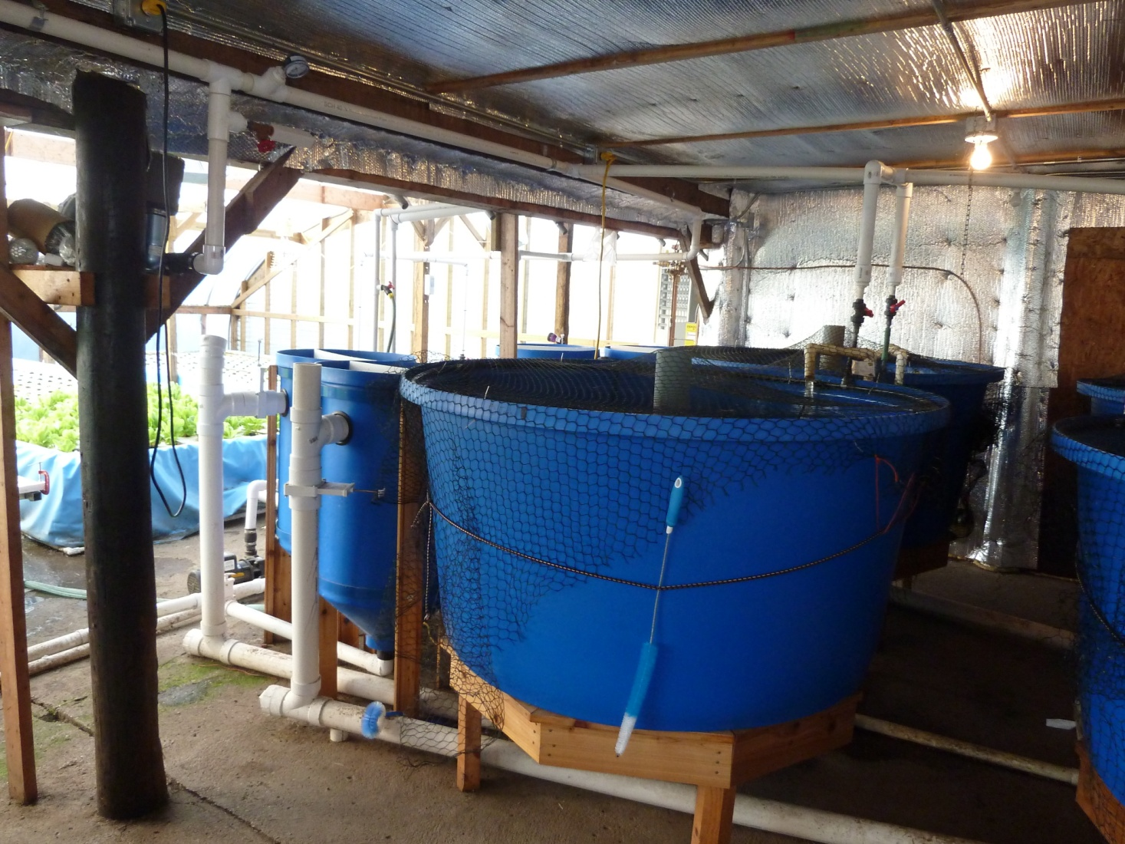
Picture of the Nelson and Pade Inc 4/300 aquaponics system in 2012.

I had two mistakes my start up year (2011).

1. In theory, the only way water should leave my greenhouse is by evaporation and transpiration. I developed my own way to say water (different from what Nelson and Pade were doing). However, I got some of my ratios wrong and began to have solids building up and water quality issues.
2. Also, my greenhouse only opened on the south side (the shed was on the north). This did not allow enough cross ventilation. Not only did I have trouble getting rid of the heat buildup in the greenhouse but it also did not allow a hard south wind from doing damage to the greenhouse roof.

The start of this project and 2012 involved structural changes to fix the problems mentioned above. This included expanding the media bed system and expanding the greenhouse itself with a FarmTec kit. This additional capital investment, fixed both problems. No grant funds were used for capital. Water tests showed in 2012 that my theory was correct and redoing and adding media beds resulted in better water quality and healthier fish and plants. Grant funds were used to monitor water and tissue samples. Adding more greenhouse square footage improved the ventilation and air flow in the summer but hurt the heating efficiency in the winter. Although water temperature was maintained at 72 degrees and air temperature maintained at 50 degrees, plant growth rates seemed to slow for all plants and all production went down. I felt there was something missing environmentally. It also increased LP usage. I should mention that most of the greenhouse expansion was managed as a high tunnel with a dirt floor.

In the fall of 2013, I added an additional aquaponic system in the greenhouse. I converted some of the high tunnel area to a media bed aquaponic system by burying a 1500 gallon tank. My theory was by adding more water (maintained at 72 degrees) would help heat the greenhouse and boost production. This was not the case. I still had the same issues with slow growth and lower production for the second winter in a row. We are currently researching different varieties that may perform better in our greenhouse conditions. No grant funds were used for capital purchases.

To add quantifiable data to the project we record electricity monthly with an E-Mon-D-Mon. I also record water readings monthly from a separate greenhouse water meter. LP usage was also tracked. Additional water and tissue samples were sent to an outside lab source.

By 2014, the existing greenhouse is roughly 135 feet by 32 feet with an attached 45 feet by 12 feet shed. 34 feet by 34 feet is managed as a high tunnel with no heat or aquaponics. The aquaponic part of the greenhouse has approximately 7000 gallon of water moving thru the aquaponics all the time. The water is heated with a boiler system, with a closed loop. The pex is in loops underneath and around the water tanks and raft beds.

Fish/fingerlings are acquired by next day from Americulture in New Mexico. Most seed and plants come from our local greenhouse or Johnny’s.

It should also be noted that all organic certifiers in Iowa will not certify an aquaponics operation organic. They quote a National Organic Program (NOP) rule that it “must have a soil building program” Since there is no soil they will not consider it. I tell my customers I worry about the “system” that what I do to the fish effects the bacteria and plants. And, what I do to the plants affects the bacteria and fish.

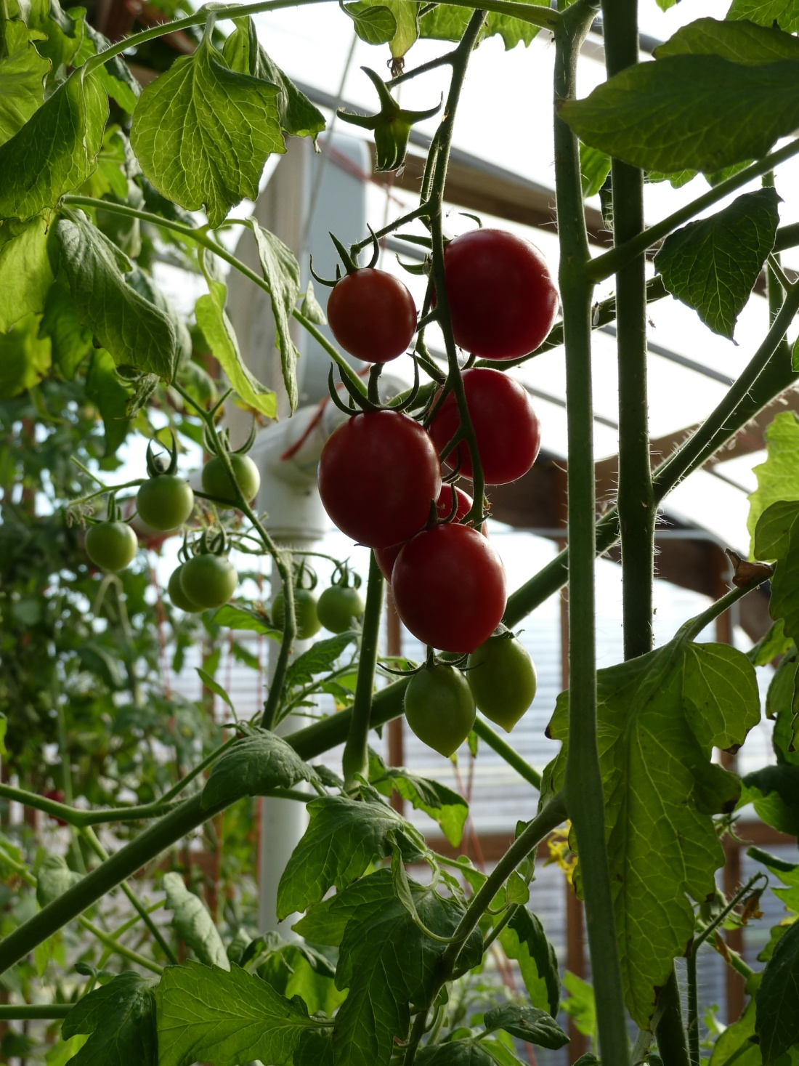
Cherry Tomatos grown in the aquaponic media bed.

PEOPLE
List farmers, ranchers, or business people who assisted with the project and explain how they were involved. List any personnel from a public agency, such as the Extension Service, Natural Resources Conservation Services or Soil and Water Conservation Districts who assisted with this project. List people from non-profit organizations who helped you.

This list also includes websites that I used that were helpful (even if I did not talk to anyone from that business or group)

Nelson and Pade Inc---Montello, WI, http://wwwaquaponicsjournal.com/
Provided aquaponic systems,supplies, knowledge and guidance.

S and S aquafarms in West Plains, Missouri. http://www.townsqr.com/snsaqua/
Provided aquaponic systems,supplies, knowledge and guidance.

Practical Farmers of Iowa (PFI)
Is an organization devoted to sharing ideas and knowledge among farmers thru fielddays, newsletters, emails and other events. PFI helped with field days and networking.

Julie Weidenthaler
Panorama High School Biology Teacher

Derek Kirpalani
Panorama High School Biology Teacher

Mike Terrones
Helped with repairs, construction and field day activities
Cliff Jensen
Helped with repairs and construction

Paula Terrones
Helped with vegetable harvest, data gathering and field day activities

Ginny James
Helped with vegetable harvest, data gathering and field day activities

Rachel Fett
Helped with vegetable harvest, data gathering and field day activities

Ben Johansen
Helped with vegetable harvest, data gathering and field day activities

Andrew Hansen
Helped with vegetable harvest, data gathering and field day activities

Andrew Clark
Website designer

Earl Hafner
Helped with tours, data gathering and field day activities

Ronda Hafner
Helped with tours, record keeping, data gathering and field day activities

Micro/Macro Lab
Water and tissue testing

http://www.aquaponic.com.au/backyard.htm
http://www.aquaponic.com.au/index.htm
http://aquaponicsaustrailia.wordpress.com
http://wwwbackyardaquaponics.com
http://www.uvi.edu/sites/uvi/Pages/Research.aspx?s=RE
http://sweetwater-organic.com/

RESULTS
What results did you achieve and how were they measured? For production projects, include yields, field analysis, and related data. How do these compare with conventional systems used previously? For education projects, include outcomes achieved and how you measured them through surveys, attendance, or other methods. Were these results what you expected? If not, why not? What would you do differently next time?

It should be noted that this data only involves the aquaponics part of the greenhouse. To help improve overall efficiency and productivity of the greenhouse other non-aquaponic crops and systems were established. Workers were asked to track their hours separately and utilities were tracked separately. Labor devoted to marketing and distributing product was a lot more than anticipated. I did not measure this separately because a non-aquaponic greenhouse would have the same problem and percent of time. For this size of greenhouse/high tunnel considerable less time is spent weeding vs planting and harvest as compared to my aquaponic greenhouse. I say “this size” because larger greenhouse/high tunnels would allow for more automation which would decrease labor.

I was expecting the greenhouse to be more productive. I attribute some of this to my lack of experience as a gardener. The two biggest things that needed to be addressed before starting this project and the greenhouse was the size of the greenhouse. Currently we are bigger than a hobby or family greenhouse and smaller than a whole sale greenhouse. This “gray” area makes marketing and labor tough because we are not big enough to produce for the wholesale restaurants and distributors, and we are not big enough to add more automation to reduce labor. However, we are too big for just a hobby. Secondly, I needed to do more research on my ratios to insure they were right before starting the aquaponics project. This mistake resulted in almost two years of finding and correcting the mistake--- costing time, productivity and money.

Figure 1. Cost of monthly utilities compared to total sales in dollars

Figure 2. cost of labor compared to sales over the 36 month period between March 2011 and February 2014

I continue to search for ways to increase efficiency. I have not reached the levels of production other aquaponics systems have demonstrated. Because of this I have deviated from some of the bio-security that other aquaponics systems have. My reasoning has the following elements. First, when my roof left the summer of 2011, a lot of bio-security left with it. The University of Virgin Islands (UVI) system is outside. Also, there seems to be a lot of wasted space. So potted herbs above the NFT, crops planted under the media beds, and plants planted under the NFT all increase the productivity of the greenhouse, but not necessarily of the aquaponics system. All of the data presented is from the aquaponics systems and not necessarily the whole greenhouse. I would also like to incorporate more wind or solar to help decrease the electricity and LP bills. However, I have not yet found a system I like that is also cost effective.

Figures 3-8 and charts 3-8, compare the nutrients found in chard, basil and tomato leaves from plants grown in both high tunnel garden and an aquaponics system garden. It is tough to draw any conclusions from this data. For this reason, more research needs to be done. As far as, non-scientific taste tests among family friends and co-workers, no difference could be identified in taste.

 | Figure 3: Chard Macro Nutrient %
 |  | Nitrogen | Phosphorus | Potassium | Calcium | Magnesium | Sulfur
 | High Tunnel | 5.29 | 0.48 | 4.49 | 1.16 | 1.03 | 0.12
 | Aquaponic | 4.71 | 0.48 | 3.62 | 0.64 | 0.67 | 0.17
 | Chart 3: Chard Maro Nutrients % (raw data for Figure 3)
 | Figure 4: Chard Micro Nutrients in ppm
 |  | Iron | Manganese | Boron | Copper | Zinc | Molybdenum | Nickel
 | High Tunnel | 50.12 | 36.17 | 41.29 | 7.6 | 38.05 | 0.55 | 0.15
 | Aquaponic | 142.93 | 29.97 | 59.38 | 10.04 | 64.29 | 0.22 | 0.4
Chart 4: Chard Micro Nutrients in ppm (raw data for Figure 4)

Figure 5: Basil Macro Nutrients in %

 | Nitrogen | Phosphorus | Potassium | Calcium | Magnesium | Sulfur
High Tunnel | 4.27 | 0.77 | 3.42 | 1.91 | 0.41 | 0.19
Aquaponic | 4.85 | 1.04 | 3.38 | 2.24 | 0.7 | 0.17
Chart 5: Basil Macro Nutrients in % (Figure 5 raw data)

Figure 6: Basil Micro Nutrients in ppm

 | Iron | Manganese | Boron | Copper | Zinc | Molybdenum | Nickel
High Tunnel | 178.9 | 36 | 30.86 | 14.89 | 78.57 | 0.02 | 0.32
Aquaponic  Chart 6: Basil Micro Nutrients in ppm (Figure 6 raw data) | 137.05 | 33.39 | 37.74 | 15.98 | 52.47 | 0.33 | 0.11

Figure 7: Tomato leaves Macro Nutrients in %

 | Nitrogen | Phosphorus | Potassium | Calcium | Magnesium | Sulfur
High Tunnel | 4.93 | 0.35 | 3.36 | 3.26 | 0.63 | 0.21
Aquaponic | 3.17 | 0.38 | 1.13 | 2.66 | 0.97 | 0.3
Chart 7: Tomato leaves Macro Nutrients in% ( Figure 7 raw data )

Figure 8: Tomato leaves Micro Nutrients in ppm

 | Iron | Manganese | Boron | Copper | Zinc | Molybdenum | Nickel
High Tunnel | 332.14 | 41.73 | 79.19 | 10.79 | 31.84 | 0 | 0.93
Aquaponic | 165.23 | 28.86 | 60.32 | 14.86 | 21.81 | 1.78 | 0
Chart 8: Tomato leaves Micro Nutrients in ppm (Figure 8 raw data)

In conclusion, even though the data and comments do not always look favorable, I do believe in aquaponics and that it is a good move for families to make a little income. Or aquaponics could supplement an existing operation. However I do caution those looking into it do a lot of research in utility conservation (especially heating in the northern climates), ratios of the aquaponics system, and marketing of their products.

DISCUSSION
What did you learn from this grant? Like most things in agriculture, starting an aquaponics system takes a lot of planning. The things that need to be considered are the ratios in the system, the size of the system and your markets. Marketing has been a bigger factor than I anticipated. Producing the product is easy compared to marketing and distributing the product.

How has this affected your farm or ranch operation? The aquaponics has increased labor as I look at the whole operation. This would be expected any time you add another enterprise.

Did you overcome your identified barrier, and if so, how? No. I have not overcome my barrier. The greenhouse is not as efficient as I was hoping. I am continuing to look for ways to increase production and efficiency.

What are the advantages and disadvantages of implementing a project such as yours? The advantage is healthy local food .The biggest disadvantage is that aquaponics is new and there is not a lot of data and information available. However, there is information out there; it just takes a lot of time and research.

If asked for more information or a recommendation concerning what you examined in this project, what would you tell other farmers or ranchers? If asked for more information about my project I would say “come out and walk thru, and start asking questions”.

IV. PROJECT IMPACTS
Evaluate the economic, environmental and social impacts of this sustainable practice by completing the Benefits and Impacts form. Also, if possible, provide hard economic data.

The biggest economic impact has been the creation of jobs. When we made the greenhouse bigger to fix my mistakes from my first year, I could not keep up with the labor requirements for the greenhouse along with my other duties on the farm. The greenhouse takes about 6 hours a day. This would also include most of the marketing and deliveries also. I have covered this by utilizing a combination of full-time and part-time workers. This being said, figure 2 above shows that right now sales do not cover labor. Labor figures also include my labor.

The environmental impacts of the project are mixed, in my opinion. At the beginning of this report I mentioned “in theory the only way water leaves the greenhouse is thru evaporation and transpiration”. At its current size, mainly thru observation and operating the systems, the greenhouse looses about 100-200 gallons a day or 3000 to 6000 gallon per month that way. This depends on the season, temperature, humidity and other factors. As you can see from Figure 8 below, that makes the greenhouse very efficient on water usage. The other way water leaves the greenhouse is thru human error (leaving valves open, leaks, etc), although there have been large one time losses, nothing has disrupted the system, or caused production loss. Water usage and waste water disposal is important for the people such as Growing Power in Detroit, Sweet Water in Milwaukee, and the young eutnponours thinking of doing aquponics in downtown Omaha Nebraska (these guys visited in the summer of 2013).

Figure 8: gallons of water used by month

My biggest concern environmentally is also my biggest concern financially. That is the amount of LP, and the cost of LP to heat the greenhouse in the winter (see figure 1). I continue to research ways to fix this including solar, and compost heat.

V. OUTREACH
What methods did you use for telling others about: 1. Your project, 2. Project events or activities, 3. Project results? How and to whom did you communicate this information? Be sure to include details on how many people attended field days or demonstrations, and how information was further disseminated by media covering any events. What plans do you have for further communicating your results? Include press releases, news clippings, flyers, brochures, or publications developed during this project. Also include photos which might be helpful in telling your story to others. (Mail items separately if you cannot send them electronically.)

Outreach has been a huge part of this project. There is a lot of interest in aquaponics, especially at the hobby/family and part-time business level. Although no grant funds were used, the website currently generates a tour, phone call or email a week from people interested in starting their own system or just interested. This is up from a year ago when I estimated two per month. These individuals vary in their interest and knowledge level. However, many are interested in how big a system, how much labor, how much money, and what does and does not work.

Several groups go thru, each year, usually 10 to 20 people. Every high school biology class in Panorama High School goes thru the greenhouse. There are two classes per semester and 12-18 students per class. In 2012, the Des Moines Area Community College (DMACC) Horticulture Production class toured. In the last year (2013), I have had the Water Garden Club from Des Moines, The Women for Panora’s future (WFPF), Growing Food for Profit group, Wichita Wildcats 4-H club, Cass Pioneers 4-H club, Ankeny High School arts/photography class. I have also helped several FFA groups and classes including the Atlantic High School, and East Sac High School, Dowling High School Environmental class, Dallas Center-Grimes Horticulture class, by selling fish, giving tours, or advice on starting their systems. I have worked with Simpson College students on their project. In 2014, I have already scheduled a Girl Scout Group, an Active Older Citizens Group, and planning a field day thru Practical Farmers of Iowa (PFI). I have not charged for any of these tours although I do sell the fish to them if they are starting their own system. Again most of these groups find us thru the internet or website.

Another opportunity for outreach has been interns and schooling. In 2013 I had a horticulture intern that worked 5-10 hours a week in the greenhouse. This intern was exposed to many aspects of aquaponics. This spring (2014), I have a high school senior, who was being home schooled, that is working 4-6 hours a week in the greenhouse as credit toward his high school education. His goal is to sometime have his own aquaponics greenhouse.

2013 also seemed to attract the media. Channel 11, Iowa Public television (IPTV) did a story, on us for their Market to Market show. Des Moines, Iowa Channel 8 and Channel 5 did short personal interest segments on us and aquaponics for their 6pm news.

Almost by accident, my aquaponics greenhouse has turned into a place where people can see several different types of aquaponic systems in operation. I have the totally media bed system built in the fall of 2013 where it is one fish tank, one pump and gravity flow media beds. There is a Nutrient Film Techniques (NFT) system. The Nelson and Pade Systems have floating raft beds, clarifiers and minerization tanks. Water is saved from the clarifiers uses a media bed with both expanded clay pellets and pea gravel. This has been beneficial to those thinking of building their own system because they can see different types of systems in operation and ask me details about each.

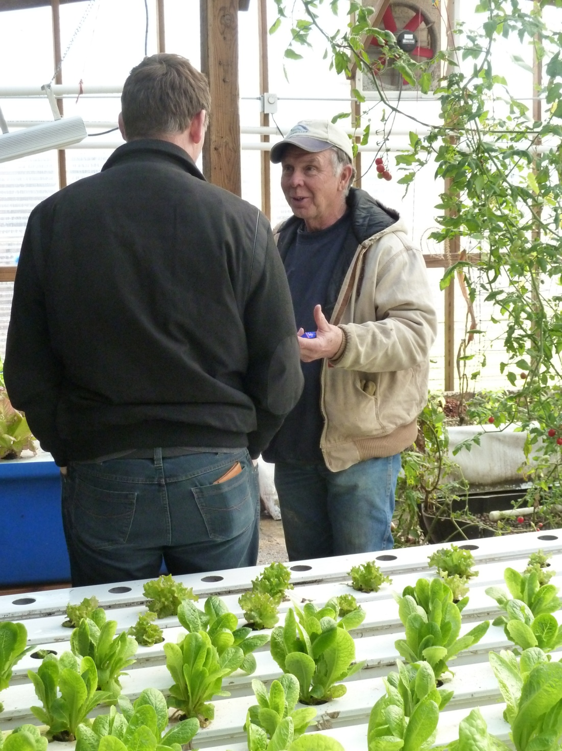
Earl Hafner giving a tour to a farmer from Germany in 2012. The German farmer was part of a PFI activity.

VI. PROGRAM EVALUATION
This was the twenty-first year the North Central Region SARE Program sponsored a farmer rancher grant program. As a participant, do you have any recommendations to the regional Administrative Council about this program? No

Is there anything you would like to see changed? No Please fill out the Evaluation form.

VII. BUDGET SUMMARY
Complete the final budget form and return it with your report. You will only be reimbursed for expenses incurred and items purchased for conducting your project. If you made significant changes to final expenses listed by budget category ($1,000 or more), please include an explanation for the changes. Call Joan Benjamin with questions at: 573-681-5545.

Submit your final report to:

E-mail: BenjaminJ@lincolnu.edu or mail to:
Joan Benjamin
NCR-SARE Associate Regional Coordinator
Lincoln University
900 Leslie Blvd, Room 101
Jefferson City, MO 65101

