HOW IT WORKS

FarmRaiser is similar to a traditional fundraiser, except you can buy healthy, local farm products for your family while supporting our school. Choose as many of the farm products as you like on the order form inside, and pick up your fresh food on the dates noted below!

DETAILS

Order by
Wednesday, September 11. (A second chance to order will happen in October!)

Pick up your order at the school
Friday, September 27, between 3-6pm.

We are raising money for
An outdoor pizza oven at Sharon Elementary School!

Questions?
Call Keenan Haley
802.763.7425 x23
keenanhaley@hotmail.com

Sharon Elementary School
FarmRaiser Sept. 2013

Support our school, local farms, and healthy eating,
all at the same time!
www.vitalcommunities.org
Brochure art & design by Luke Howard and the Center for Cartoon Studies
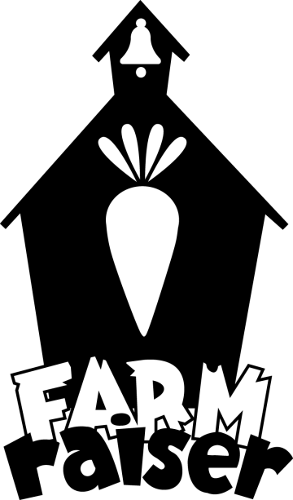 |  |  | Cedar Mountain Farm | Clay Hill Corners Farm | Clay Hill Corners Farm | Clay Hill Corners Farm | Clay Hill Farm | Oak Wood Farm | Oak Wood Farm | Side Track Farm & Cedar Mountain Farm | Side Track Farm
 |  |  | $20 certificate to the farmstand at Cobb Hill | Homemade granola, 1 lb | Washed salad greens, 5.6 oz | Tomatoes, 1 lb | Ground beef, 1 lb | Butternut winter squash, 1 | Carrots, 1 bunch | Garlic, 1 bulb | Thanksgiving turkey.  Ten fresh turkeys are available, approx 17-20 lb final weight at cost of $4/lb, for on-farm pickup (Depot Rd) weekend of 11/23. $48 is a deposit to the farm plus the HES profit, remainder of cost due on pickup day. Call office to reserve turkey.
 |  |  | $26 | $7.80 | $4.75 | $2.60 | $5.50 | $2.25 | $3.25 | $1.30 | $48 deposit
Paid | Customer Name | Email or phone | Qty. | Qty. | Qty. | Qty. | Qty. | Qty. | Qty. | Qty. | Qty. Call HES office 1st! |  | Amount Paid
 | 1.
 | 2.
 | 3.
 | 4.
 | 5.
 | 6.
 | 7.
 |  | Total Quantities:
Order Form: Sharon Elementary FarmRaiser, September 2013

Student Name: _____________________________ Student Home Phone: _____________________________

Proceeds will support an outdoor pizza oven at Sharon Elementary School.
Orders are due Wednesday, September 11th. Pickup for items will occur Friday, September 27th, 3 - 6 pm.
Families: Please have customers pay for items at the time they order and mark “paid” next to their name.
After you have filled an order sheet, please calculate the total quantities of each item order and record the total amount paid.

