Using a Grazing Wedge in Beef Cattle Operations

Justin Sexten
State Extension Specialist – Beef Nutrition

The need for efficient resource utilization and synchronized animal / forage production systems continues to grow as production input prices increase. Key input costs for beef producers have increased at a significantly greater rate than the value of weaned calves. The difference in price increases for input costs and market value of weaned calves is shown in exhibit 1. Relative input price inflation is significantly greater than increased weaned calf value.
Exhibit 1. Beef operation input and weaned-calf prices
Item | 2002 | 2010 | % increase
Fertilizer
Nitrogen, $ / ton Urea | 191 | 448 | 134.6
Phosphorus, $ / ton DAP | 227 | 508 | 123.8
Potash, $ / ton KCl | 164 | 511 | 211.6
Feed
Hay, $ / ton all hay | 92.40 | 112.00 | 21.2
Corn, $ / bu, Kansas City | 2.43 | 3.55 | 46.1
Soybean Meal $ / ton, Central IL | 181.58 | 311.27 | 71.4
Fuel
Diesel, $ / Gallon, Nov | 1.17 | 3.53 | 201.7
Gasoline, $ / Gallon, Jan | 1.11 | 3.54 | 218.9
Calves, $ / cwt, Missouri | 92.30 | 119.00 | 28.9
ERS 2011; USDA 2003, 2011.

Historically beef producers practice grazing management to reduce input costs. Management ranges from turning cattle into one large pasture all summer to minimize labor and capital costs to moving cattle to new pastures several times daily to minimize feed and fertilizer costs. Both options are managed grazing systems, with significantly different goals and intensities.

Grazing management has been through several name changes with little practice modifications. Originally pastures were small and cattle were moved around the farm throughout the summer. As pasture size increased internal fences were required to restrict cattle from grazing the entire pasture. Cattle were rotated through pastures allowing rest and re-growth of previously grazed pastures. This was termed rotational grazing, later intensive grazing and most recently management intensive grazing. Fundamentally these management systems differ only in name; in all systems cattle are restricted from grazing the entire pasture.

Mob grazing has increased in popularity recently where large stocking rates are employed in small pasture areas. Mob grazing has two forms, grazing quality pasture for short durations or grazing and trampling mature, low-quality pasture quickly to incorporate rejected plant material into soil structure. Regardless of grazing system utilized the grazing wedge can be utilized to monitor current and historic pasture conditions while addressing feed, fuel and fertilizer costs.

The grazing wedge is a visual picture of the available farm forage resource. This visual picture illustrates forage quality and quantity available for grazing now and in the future (Kallenbach 2008). A grazing wedge for a SW Missouri grazing dairy is shown in exhibit 2. Grazing wedges use weekly forage growth data collected using a rising plate meter. Plate meter readings entered into a grazing wedge are used to illustrate which pastures are next to graze, were grazed too long, should be hayed or need fertilized. The grazing wedge permits feed budgeting by giving producers advance warning of pasture over and under production.

Exhibit 2. Grazing wedge for South West Missouri.
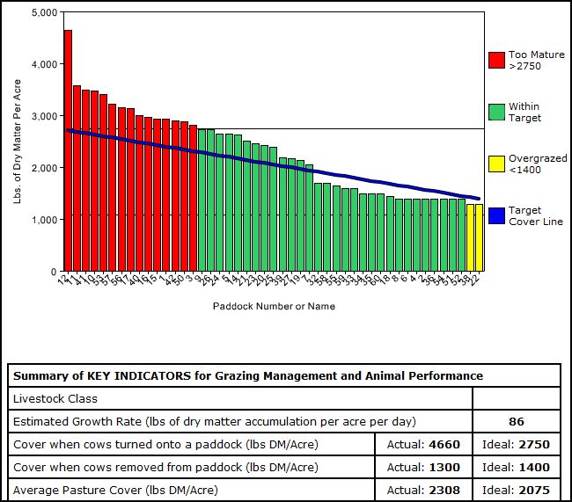

To guide management decisions a grazing wedge uses two “threshold” numbers. The first threshold is the minimum required pasture residual cover. In exhibit 2 the minimum required cover is 1,400 pounds of dry matter per acre. Pastures grazed or hayed below this threshold will require greater recovery periods due to overgrazing.

The next threshold is where forage becomes too mature to support desired animal performance. In exhibit 2 this threshold is 2750 pounds dry matter per acre. Pastures exceeding this threshold are set aside to accumulate growth for haying or are alternatively grazed by cattle with lower nutrient requirements.

Pastures under 2,750 and greater than 1,400 pounds of dry matter are within the target quality range and are ready to be grazed. Within these threshold values the desired target cover line indicates forage excess and deficiencies. Pastures beyond the line represent excess forage while paddocks under the line represent potential forage deficiencies.

The grazing wedge also reports estimated forage growth rate for the previous measurement period. Period growth rates illustrate the need to match seasonal stocking rate and/or nutrient demand with forage growth. During the spring of the year many operations are stocked at 1/3 capacity relative to current growth rates. Using the forage growth rates from the grazing wedge producers can observe opportunities to harvest excess forage or increase seasonal stocking rates.

Using available forage, current growth rates, target cover line and paddock rotation length producers can plan to address future forage excess or deficiencies using strategic pasture rotation, fertilization, supplementation or hay harvest. Whereas under current rotational grazing systems many producers simply move through each pasture without regard for re-growth quality and availability in previously grazed pastures.

Using the grazing wedge Missouri pasture-based dairy producers have planned pasture rotation, feed supplementation and fertilizer application rates and timing in accordance with dynamic forage availability and quality (Kallenbach 2002).

Using grazing wedge data over time allows producers to document pasture productivity and growth patterns year-to-year or season-to-season. Using pasture productivity data producers can improve forage management and resource utilization by targeting livestock nutrient demand or fertilizer resources to specific pastures.

Producers who keep grazing records and/or pasture species inventories have improved pasture management and utilization (Duesterberg 1999; Schroeder 1994). Beef producer resource monitoring and utilization of the resulting data often determines operation success (Wells 2004). Feed planning on pasture-based dairies is cited as an important management strategy for improved profitability, with practical methods to assess farm-based feed resources representing a significant barrier to implementation (Bosworth 2007).

To address the farm-based feed resource barrier producers can utilize the grazing wedge as one practical tool assess the pasture resource while minimizing input costs. For those interested in developing their own grazing wedge visit http://grazingbeef.missouri.edu/ and set up your farm. Producers need not have a rising plate meter to participate, walk each pasture you want to measure and collect forage availability measurements using a grazing stick.

Literature Cited

Bosworth, S. 2007. Assessing on-farm pasture availability and forage quality for dairy feed planning. SARE Project number ONE06-052. http://www.sare.org/reporting/report_viewer .asp?pn=ONE06-052&ry=2007&rf=1. Accessed Oct 24, 2008.
Duesterberg, K. 1999. Expanding Profits for Sheep Production Through Intensive Pasture Management. SARE Project number LNE95-054. http://www.sare.org/reporting/report_ viewer.asp?pn=LNE95-054&ry=1999&rf=1. Accessed Oct 24, 2008.
Economic Research Service. 2011. Fertilizer Prices: Table 7 – Average U.S. farm prices of selected fertilizers for 1960-2011. http://www.ers.usda.gov/Data/FertilizerUse/. Accessed July 6, 2011.
Economic Research Service. 2011. Feed Grains Database: Yearbook Tables. http://www.ers.usda.gov/data/FeedGrainsNEW/yearbook/FGYearbookTables-Recent.pdf. Accessed July 6, 2011.
Kallenbach, R. L. 2002. Developing Pasture-based Dairy Systems for Family Farms. SARE Project number: LNC00-173. http://www.sare.org/reporting/report_viewer.asp?pn= LNC00-173&ry=2002&rf=1. Accessed Oct 22, 2008.
Kallenbach, R. L. 2008. Grazing wedge. University of Missouri Extension. http://plantsci.missouri.edu/grazingwedge/. Accessed Oct 22, 2008.
Schroeder, L. 1994. Farmer-to-Farmer Transfer of Knowledge About Rotational Grazing. SARE Project number: FS94-015. http://www.sare.org/reporting/report_viewer.asp?pn= FS94-015&ry=1994&rf=0. Accessed Oct 24, 2008.
USDA. 2003. Agricultural Prices: 2002 Summary. National Agricultural Statistics Service. http://usda.mannlib.cornell.edu/usda/nass/AgriPricSu//2000s/2003/AgriPricSu-07-24-2003.pdf. Accessed Oct. 22, 2008.
USDA. 2011. Quick Stats. National Agricultural Statistics Service. http://quickstats.nass.usda.gov. Accessed July 6, 2011.
Wells, A. 2004. Whole Farm Planning for Grass-fed Beef. SARE Project number: LS00-113. http://www.sare.org/reporting/report_viewer.asp?pn=LS00-113&ry=2004&rf=1. Accessed Oct 24, 2008.

