Yards with area of effect for foraging (3 mile radius)
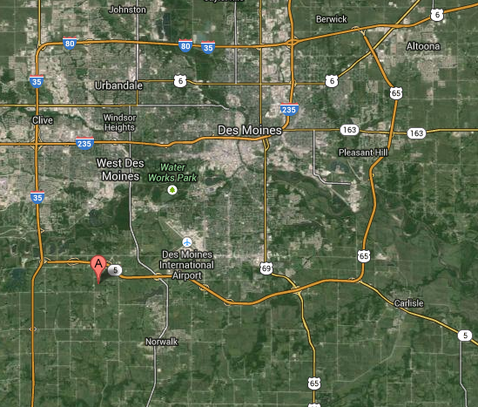

Mating Yard Effect:
blue is representative of the drone’s typical flight distance from its hive, red and orange represent how far the queen can travel for mating. Typically she will fly a minimum distance of the outer edge of the orange area, up to the outer edge of the red zone.

Closer-up of main breeding area. Data is just for drone and queen flights. (original)
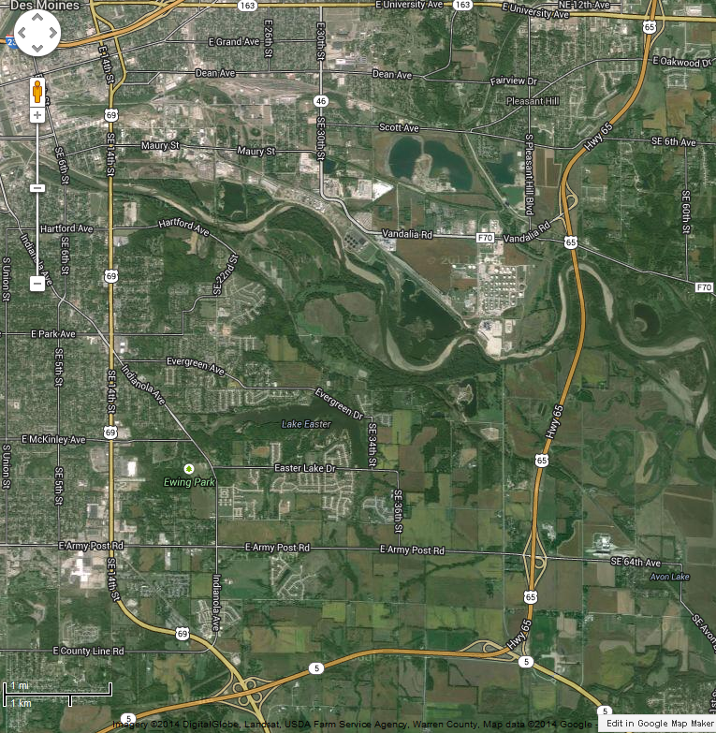
Drone effective range of ¼ mile (blue), Queen typical range of 1 mile to 2 mile. Orange represents boarder of typical distance, boarder of red indicates maximum.

Adjusted to .31 to .75 drone, & 1.24 to 1.55 queen

