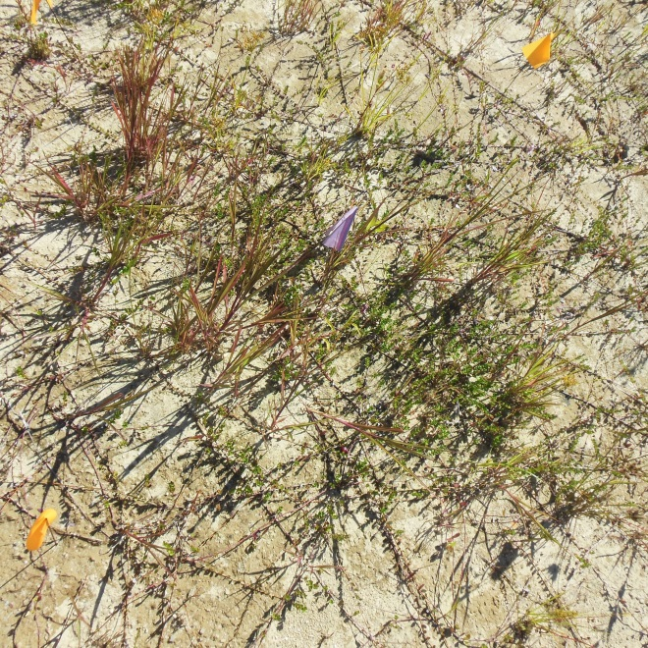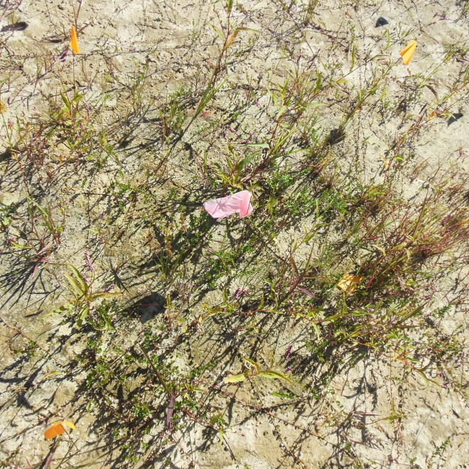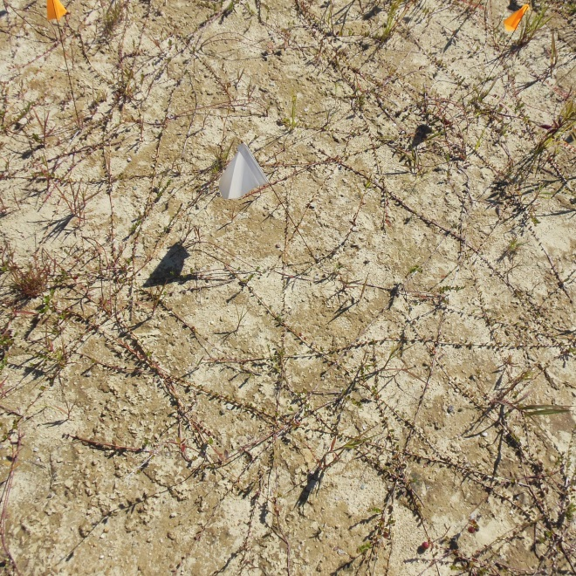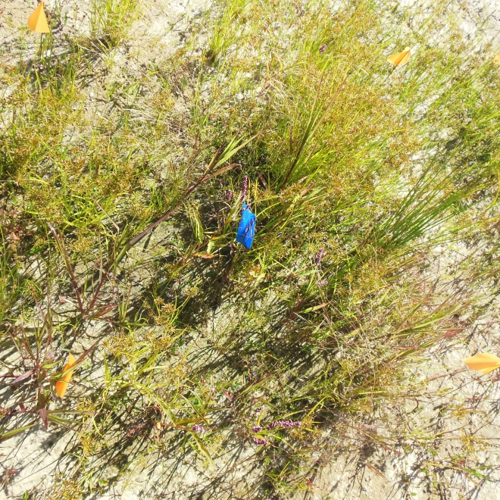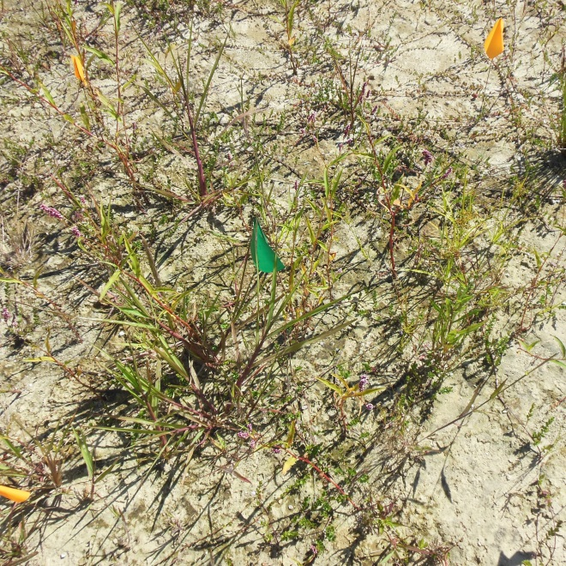

Pictures of plots treated with corn gluten mean four months after initial treatment with (0 = none, low = 20 lbs/1000 ft2, low with follow up application = 20 lbs/1000 ft2 followed by 10 lb/1000 ft2 four weeks later, high = 40 lbs/1000 ft2, high follow up application = 40 lbs/1000 ft2 followed by 10 lb/1000 ft2 four weeks later).

Low CGM w/ follow up app

High CGM w/ follow up app

High CGM

Low CGM

Untreated