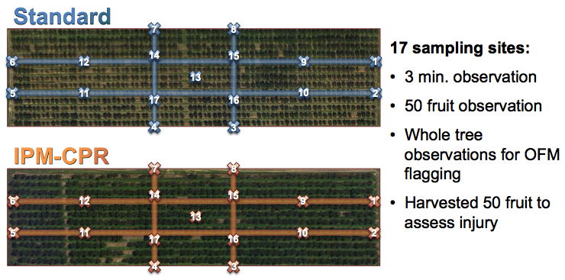

Figure 1. Sampling scheme for test plots.