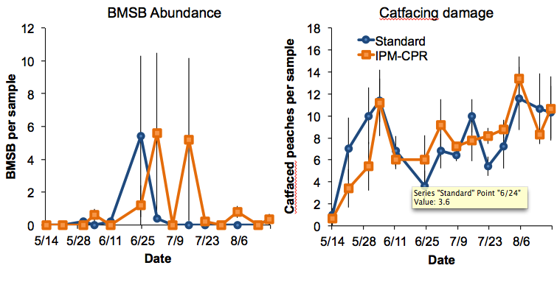

Figure 2. BMSB abundance and catfacing damage throughout the season.