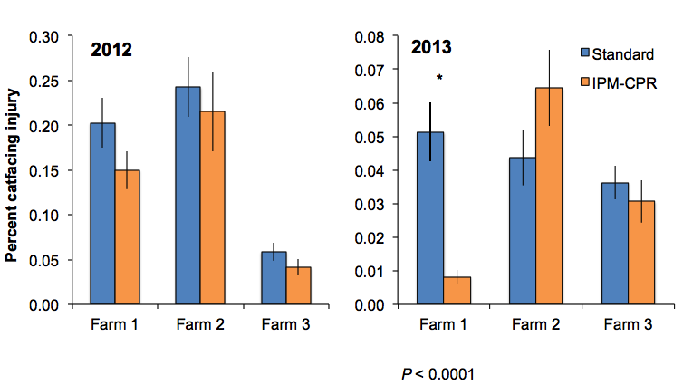

Figure 3. Catfacing damage (w/BMSB), at harvest showing no difference between treatments.