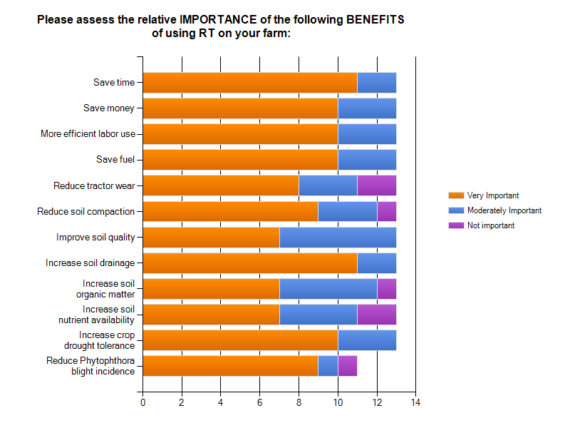
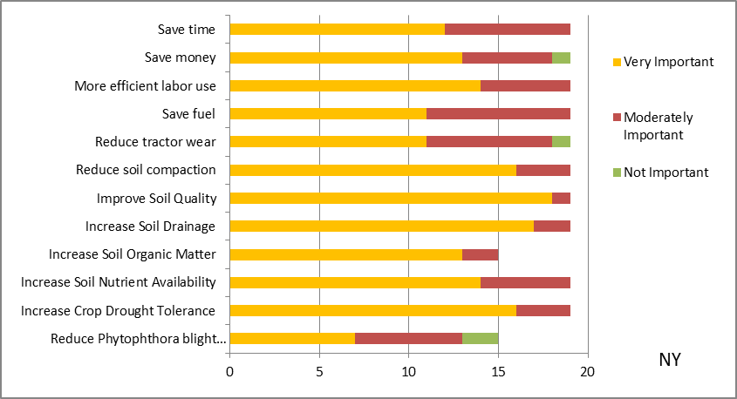
Figure 3. Grower response (MA and NY) to relative importance of various benefits to their decision for using RT on their vegetable farm.

