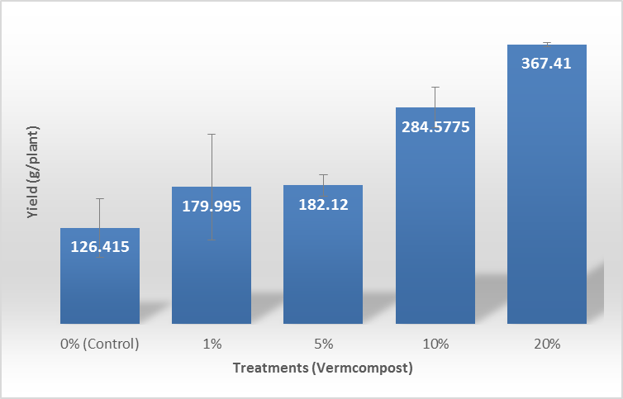
Figure 1. Average weights of non-symptomatic ginger inoculated with R. solanacearum and grown in pots substituted with vermicomposts.

