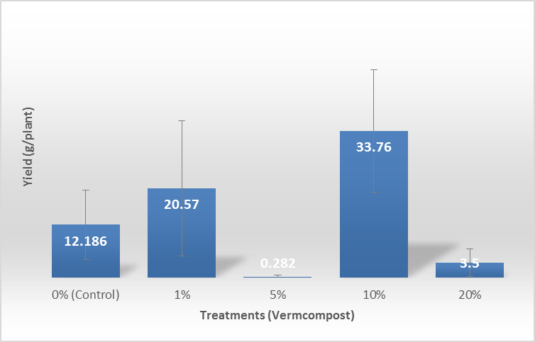
Figure 2. Average weights of symptomatic ginger inoculated with R. solanacearum and grown in pots substituted with vermicomposts.

