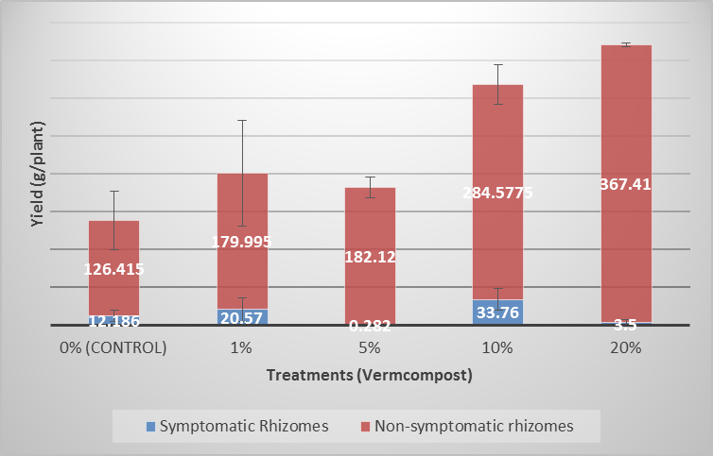
Figure 3. Total weight of ginger inoculated with R. solanacearum and grown in pots substituted with vermicomposts

