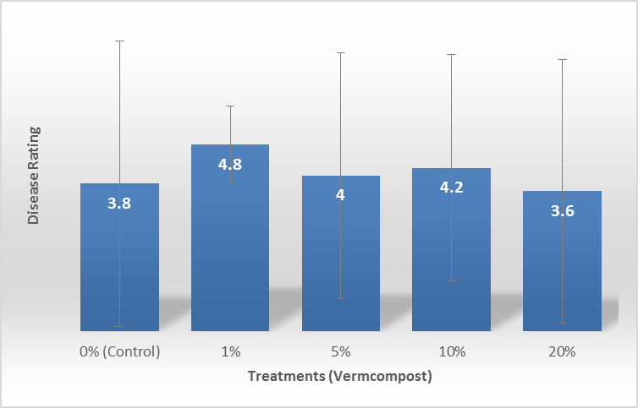
Figure 4. Disease ratings (0: no symptoms – 5: 100% of foliage showing symptoms) before harvest of ginger inoculated with R. solanacearum and grown in pots substituted with vermicomposts.

