Sustainable poultry education

Getting Started With Chickens—Presenter’s Guide

Introduction
This series of presentations is intended to teach the audience how to raise and care for chickens, whether in a rural or urban setting, whether for private consumption or as a commercial enterprise. This is a basic, entry-level course, designed for the beginning poultry enthusiast or for those who have some experience already, but feel they could benefit from more information about poultry production. Other domestic species, such as ducks, geese, and turkeys, are not included in this discussion. Those presentations will be developed at a later time.
This curriculum was developed as part of a grant from the North Central Region of SARE. As such, it was developed with Midwestern/Northern States growing conditions (climate) in mind, but many of the principles are universal in nature and could be applied anywhere in the USA or another country.
The PowerPoint has speaker’s notes which should be consulted prior to presenting unless the presenter is already familiar with the subject matter. I would say that even if the presenter is comfortable with the topic, the notes provided with each slide will help launch the presentation and may lead to questions from the audience that result in a discussion on some aspect of the information delivered.
This first series will help the student think about their interest in raising chickens, to determine what breeds to raise and why. Some basic terminology will be introduced. Nutrition of both broilers and layers will be discussed. A brief session on egg production will be included.

Part one: Getting started with Chickens
Educational objectives
After completing the lesson, the student will be able to:
- Participants will consider some of the reasons as to why raise poultry.
- Participants will be introduced to some of the basic Poultry Terms
- Participants will be introduced to the most popular breeds of broilers and layers.
- Participants will learn the basic steps to getting started.
- Participants will possess an understanding of the nutritional needs of broilers and layers.
- Participants will understand layer needs for egg production.
Activities and discussions
Slide 9
There is a brief discussion of candling eggs. Demonstrate to the class how that is done.
Slide 23
Discuss the slide, then show 3 videos that are available on the Small Farms U website, at: http://www.extension.umn.edu/food/small-farms/livestock/poultry/. Each one is two minutes or less in length, and they discuss various aspects of getting the recently-arrived chicks off to a good start.

Resources
This slide show was developed by Extension Educators Jim Stordahl and Wayne Martin, with help and encouragement from producers Kathy Zeman and Cindy Hale, and Extension Educator Christian Lilienthal.
Information used in the slide show was gleaned from:
- Storey’s Guide to Raising Chickens
- http://www.poultryu.umn.edu/
- http://www.extension.umn.edu/food/small-farms/livestock/poultry/
- http://hoovershatchery.com/
- http://www.welphatchery.com/

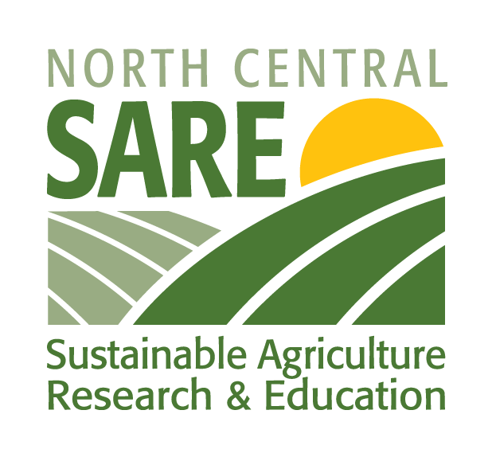

This product was developed with support from the Sustainable Agriculture Research and Education (SARE) program, which is funded by the U.S. Department of Agriculture — National Institute of Food and Agriculture (USDA-NIFA). Any opinions, findings, conclusions or recommendations expressed within do not necessarily reflect the view of the SARE program or the U.S. Department of Agriculture. USDA is an equal opportunity provider and employer.

© 2014 Regents of the University of Minnesota. All rights reserved. University of Minnesota Extension is an equal opportunity educator and employer.
In accordance with the Americans with Disabilities Act, this material is available in alternative formats upon request. Direct requests to efans@umn.edu.
Printed on recycled and recyclable paper with at least 10 percent postconsumer waste material.

