Sustainable soils education

The Dirt on Dirt: Soils Management Plan for Junior Sample Farm

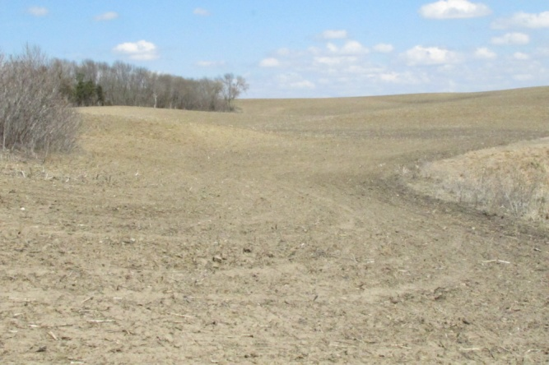
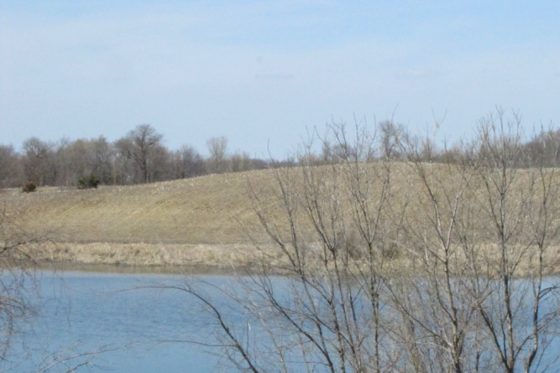
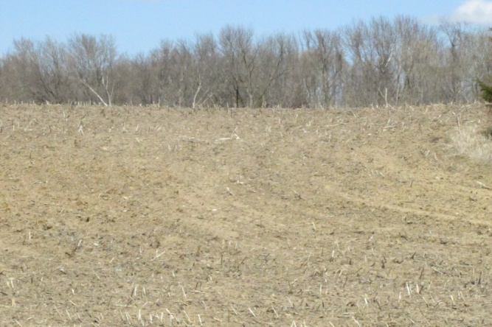
LE SUEUR CO., MINNESOTA

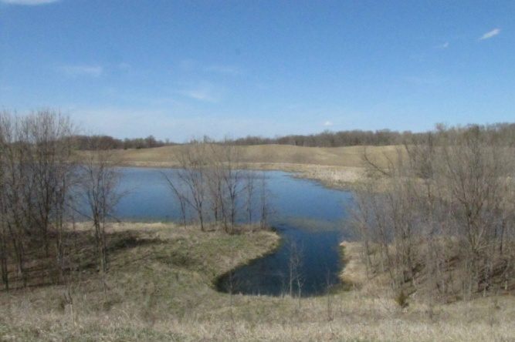
Site assessment
Size: 50 acres
Area currently cropped: 26 acres
Predominant field soil types: Lester loam, Cordova clay loam, Glencoe clay loam, Le Sueur clay loam, Hamel clay loam
Field topography: 29% class A (0% - 2%) 59% class C (6% – 12%), 12% class D (12% - 18%)
Crop history: Continuous corn for past five years
Manure history: received swine manure 3 years ago
pH: 6.1 – 7.5
Fertility: P medium to very high, K high to very high
Organic Matter: 2.5% - 3.6%
Drainage: one tile line passing through area of Hamel clay loam to Northwest corner of woodlot, depositing into wetland; one tile line extending from wetland into lobe of Glencoe soil

Narrative
There are 50 acres in the Junior Sample farm, of which slightly more than half is cropped. Non-cropped area is both woods and wetland. The cropped area is 26 A, and consists of five predominant soil types. The largest area is Lester Loam (the Minnesota State Soil), which is an Alfisol, formed under hardwood forest. The rest is Cordova, Glencoe, Le Sueur and Hamel clay loams. These soils are Mollisols with slow infiltration rates, and frequently benefit from artificial drainage. The average Crop Productivity Index for the cropped area is 79, which subjectively rates as good farmland, but not excellent. The primary factor limiting productivity on the site is the presence of steep slopes, with some risk of ponding on the Glencoe soils adjacent to the wetland.
The current operator has grown corn for the past five years. There was swine manure applied three years ago. A mulch-till system is used that maintains approximately 30% residue cover at the time of planting. The operator prior to the current one used a crop rotation that included alfalfa for three out of six years. The farm was in that rotation for approximately 40 years prior to the current operator. The current operator reports a five year average of 170 bushels per acre of corn, compared to his whole farm average of 190 bushels per acre.
There are no visible signs of erosion, although the Lester soils on the steeper slopes have a very light color indicating that erosion did occur at some time in the past. These areas give the appearance that there is no topsoil. It should be noted that a Lester soil would normally have a lighter soil color as it is an Alfisol. Soil structure is typical for most fields that receive aggressive tillage annually.
Lester soils are well drained and usually do not need artificial drainage. The clay loam soils on the farm currently have two older cement tile lines running through them. The outlets of these tiles are known, but the exact location, depth and length are unknown. Glencoe soils are frequently classified as wetlands, with a slight chance that the other clay loam soils could be considered wetlands too. Field work is often delayed due to excessive moisture in the clay loam soils.

Management goals
- Improve soil structure
- Increase topsoil depth and organic matter content
- Improve pH and fertility where necessary
- Improve yields and thereby profits

Discussion
Junior inherited this farm from his father (Senior). He does not farm the land himself and is not sure he ever will. Despite this, he has no intentions of selling the land. He cares for it greatly, as it is, after all, “the family farm.” His current renter was identified based on economics (who would pay the highest rent), but lately he has been thinking that he might be willing to take less rent in exchange for management changes which lead to soil quality improvements. He has done a thorough assessment of the property for many characteristics. He took whatever data he felt was relevant from the Web Soil Survey. In addition, Junior took two soil samples. One was from the light colored Lester soil on a steep D slope, and the other was from the Glencoe clay loam soils adjacent to the wetland.
The Lester soil had 2.5% organic matter, which rates as normal by NRCS (see Web Soil Survey printout). The Glencoe had 3.6%, which is less than half of what the NRCS map indicated. Junior believes that increasing organic matter would be best for all soils. Measurements of P and K show medium to very high levels. Junior realizes that these two samples may not be adequate to represent the entire field, and has decided to have the field sampled on a grid so as to get a better handle on fertility levels.
The pH levels rate from slightly acidic (6.1) on the Glencoe to slightly alkali (7.5) on the Lester. Junior will also evaluate for pH when he has the field grid soil sampled and apply liming material wherever necessary.
He has identified that while the current mulch-till practices have kept soil erosion in check, the soils have poor structure and seem prone to compaction. The renter has complained to him that his yields are not up to his expectations, and that some tile drainage is necessary in the heavier soils. Junior is suspicious that some of this problem is related to the crop rotation and tillage, as these sites were not that bad when Senior farmed the land and had alfalfa in his crop rotation.

Based on his general goals and the above information, he has established the following action items:

- Identify a new renter that will:
  - Include alfalfa in the crop rotation
  - Regularly apply manure
  - Use strip-till or no-till for row cropping practices
- Conduct an investigation to map existing tile lines
- Have NRCS conduct a wetlands determination
- Pending wetlands determination, install some additional drain tile where there are clay loam soils
- Establish permanent perennial cover where there are D slopes
- Grid soil sample to better identify pH and soil fertility needs
- Lime the field as necessary and apply P and K fertilizer pending future management involving manure

This product was developed with support from the Sustainable Agriculture Research and Education (SARE) program, which is funded by the U.S. Department of Agriculture — National Institute of Food and Agriculture (USDA-NIFA). Any opinions, findings, conclusions or recommendations expressed within do not necessarily reflect the view of the SARE program or the U.S. Department of Agriculture. USDA is an equal opportunity provider and employer.

© 2014 Regents of the University of Minnesota. All rights reserved. University of Minnesota Extension is an equal opportunity educator and employer.
In accordance with the Americans with Disabilities Act, this material is available in alternative formats upon request. Direct requests to efans@umn.edu.
Printed on recycled and recyclable paper with at least 10 percent postconsumer waste material.

