Sustainable vegetable production education

Grower Profile: Ron Branch, Berry Ridge Farm

Alexandria, MN
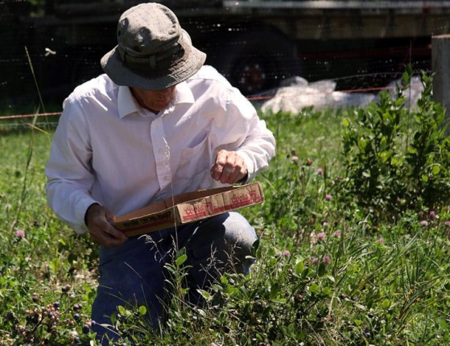
Berry Ridge Farm, run by Ron Branch and his family, is a diversified farm; successfully growing field blueberries, strawberries, raspberries, peas, cucumbers, pumpkins, squash, and high tunnel tomatoes, peppers, beans, cut flowers and herbs. Ron and his wife, Ann, were both raised on farms and enjoy the challenges and creativity of growing for market. Their farm is on eleven acres, with about six acres in production.
Berry Ridge Farm produced its first market crops in 1988. Before getting started, Ron attended workshops and visited other farm operations that raised specialty crops. He looked for practical ideas that he could adopt and develop for his own operation. His initial investments were mostly time to plan and develop business strategies. He started with a garden tractor and a small 20 hp tractor with homemade attachments.
The Branches currently market their produce by appointment at the Berry Ridge Farm Stand and at the Alexandria Farmers’ Market three days a week. Cropping over the past twenty-five years has been comprised of various rotations of assorted fruits and vegetables. Management practices have included the use of cover crops, mulches (including plastic), and lots of compost to minimize erosion, improve fertility and soil tilth, and conserve moisture.
Ron started using high tunnels in 1992 with a low tech structure. This experiment demonstrated the effectiveness of high tunnels in crop protection and season extension. He then went on to add more tunnels, several of which were built from scratch at minimal cost. Berry Ridge Farm currently has six high tunnels in production, one of which is operated by sons, Carl and Eric, who grow herbs, cut flowers and assorted vegetables.
Ron’s main tractor is 30 hp with a loader. The implements he regularly uses include a disk, a digger, cultivators, mowers, a chisel plow, a manure spreader and a mulch layer. In addition, trickle irrigation is used both inside and outside the high tunnels.
The biggest challenge Ron faces in successfully producing market vegetables is the time needed for weeding and harvesting. He attends annual conferences to keep up with the latest advances in vegetable production, weed control and marketing.
Ron has been an active member of the Minnesota Fruit and Vegetable Growers Association for over 25 years, serving on the board and two years as President. He is currently the treasurer of the Minnesota Farmers’ Market Association. From 2009-2011 he conducted research on his farm, in association with Steven Poppe at the West Central Research and Outreach Center, examining ways to extend the season of locally grown raspberries.
You can find Berry Ridge Farm at:
- http://www.youtube.com/watch?v=uDgLFK4H67Q Green Book: Ron Branch http://www.youtube.com/watch?v=p3OPfOx4vKk Why Grow Produce in High Tunnels with Ron Branch
- E-mail Address: berries@rea-alp.com
- https://www.facebook.com/media/set/?set=a.418175735063.192683.149001435063&type=3

This product was developed with support from the Sustainable Agriculture Research and Education (SARE) program, which is funded by the U.S. Department of Agriculture — National Institute of Food and Agriculture (USDA-NIFA). Any opinions, findings, conclusions or recommendations expressed within do not necessarily reflect the view of the SARE program or the U.S. Department of Agriculture. USDA is an equal opportunity provider and employer.

© 2014 Regents of the University of Minnesota. All rights reserved. University of Minnesota Extension is an equal opportunity educator and employer.
In accordance with the Americans with Disabilities Act, this material is available in alternative formats upon request. Direct requests to efans@umn.edu.
Printed on recycled and recyclable paper with at least 10 percent postconsumer waste material.

