Sustainable vegetable production education

Vegetable Production—Presenter’s Guide

Introduction
This series of presentations is intended to introduce the student to the basics of producing market vegetables in a sustainable way. The module is broken into three parts: An overview of best practices in marketing and production; an in-depth look at business practices and methodologies; and a review of Integrated Pest Management. This basic review of best practices and considerations in vegetable production is intended to provide the information needed to allow the student to begin a successful market vegetable enterprise.
This curriculum is intended for use in the Midwest, or “North Central Region.” It may be adaptable to other geographies, but if it is used outside the American Midwest, the presenter should be aware of local differences.
The PowerPoint presentations contain speaker’s notes, which should be consulted prior to presenting unless the presenter is already familiar with the subject matter.

Part 1
Educational objectives
- After completing the lesson, the student will be able to understand the pros and cons of different types of seeds.
- At the conclusion of this lesson, the student will be able to list several variables to consider when planning a market vegetable enterprise
- By completing the activities in this presentation, the student will be able to discuss soil types and methods for preparing a field for planting.
Activities and discussions
Activity 1
This is your first year selling vegetables at a local farmers’ market.
- What vegetables do you plan to grow?
- What factors do you consider when selecting vegetables types?
- What factors do you consider when selecting vegetable varieties?
- How are these different?

Notes:
- Divide class into several groups so students can share information and provide input for each other.
- Provide vegetable seed catalogs for students to look through to help them make their selections. Be sure to include organic, OP, heirloom and hybridized seed choices.
Activity 2
You have a new field in which you plan to grow vegetables.
- What do you do to prepare this field for production?
- You have a soil pH of 6.5. What vegetables would work best in this type of soil?
Notes:
- Divide class into several groups so students can share information and provide input for each other.
- Use a Vegetable pH preference chart to assist students in selecting vegetables for this activity. Use one from your state, or select one of these:
  - http://www.agiweb.org/education/aapg/invest/PreferencesforpH.pdf or
  - http://www.wvu.edu/~agexten/hortcult/homegard/pHpref.pdf

Part 2
Educational objectives
- Using the resources within this lesson, the student will be able to outline a basic business plan for their operation.
- At the conclusion of this lesson, the student will be able to identify local markets and make a basic marketing plan for their operation.
- By completing the activities in this presentation, the student will be able to analyze limiting factors that will affect their operation and discuss growing methodologies that will address these limiting factors.
Activities and discussions
- Do you have a business plan in place? If not, take 15 minutes to write a short outline of your business plan including goals for a season.
- Share your plan with a partner and get their input.
- Are goals realistic?
- What areas need more attention?
- What resources do you have currently, and what resources do you still need to research?

Part 3
Educational objectives
- Using the resources within this lesson, the student will be able to outline the Essential steps to Integrated Pest Management in Vegetable production
- At the conclusion of this lesson, the student will be able to list the steps required for IPM and how they fit with various approaches to vegetable production
- By completing the activities in this presentation, the student will be able to develop a basic IPM plan for use in their vegetable production operation.

Resources
- Bachman, Janet & Earles, Richard. Post-Harvest Handling of Fruits and Vegetables. Fayetteville, AR. Appropriate Technology Transfer for Rural Areas. 2000
- Berton, Valerie, ed. The New American Farmer. 2nd ed. Beltsville, MD: Sustainable Agriculture Network, 2005.
- Brandenburger, Lynn, Warren Roberts, Hailin Zhang. Soil Test Interpretations for Vegetable Crops. Stillwater, Ok.
- DiGiacomo, Gigi, Robert King, and Dale Nordquist. Building a Sustainable Business. College Park, MD: Sustainable Agriculture Research and Education, 2003. Print. Handbook Ser. Book 6.
- Diver, Steve. Resource Guide to Organic & Sustainable Vegetable Production. N.p.: Appropriate Technology Transfer for Rural Areas, 2001. National Sustainable Agriculture Information Service. National Center for Appropriate Technology, Sept. 2001. Web. Jan. 2010. Print
- Egel, Dan. Midwest Vegetable Production Guide for Commercial Growers. West Lafayette, IN: Purdue University, 2013.
- Grimsbo Jewett, Jane, Beth Nelson, and Derrick Braaten. Marketing Local Food. St. Paul, MN: Minnesota Institute for Sustainable Agriculture, 2007. Print
- Grubinger, Vernon P. Sustainable Vegetable Production from Start-up to Market. Ithaca, NY: Natural Resource, Agriculture and Engineering Service, 1999. Print.
- Hendrickson, John. Grower to Grower: Creating a Livelihood on a Fresh Market Vegetable Farm. Madison, WI: Center for Integrated Agricultural Systems, 2005. Print.
- Li, Changying, Precooling Fruits and Vegetables in Georgia. Athens, Georgia. University of Georgia Cooperative Extension. 2011
- Maynard, Donald N., and George J. Hochmuth. Knott's Handbook for Vegetable Growers. 5th ed. New York, NY: John Wiley, 2007. Print.
- Salatin, Joel. You Can Farm: The Entrepreneur's Guide to Start and Succeed in a Farm Enterprise. Swoope, VA: Polyface, 1998. Print.
- Salatin, Joel. Family Friendly Farming: A Multi-generational Home-based Business Testament. Swoope, VA: Polyface, 2001. Print.
- Simonne, E. (2003). Drip irrigation: the BMP era: An integrated approach to water and fertilizer management for vegetables grown with plasticulture. Gainesville, Fla.: University of Florida Cooperative Extension Service, Institute of Food and Agricultural Sciences, EDIS.
- University of Minnesota Extension, ed. Minnesota Fruit & Vegetable Growers Manual for the Beginning Grower. Ham Lake, MN: Minnesota Fruit and Vegetable Growers Association, 2004. Print.
- http://www.sare.org/Learning-Center/Books/Managing-Cover-Crops-Profitably-3rd-Edition/Text-Version/Crop-Rotation-with-Cover-Crops
- Midwest Vegetable Production Guide for Commercial Growers, Purdue http://www.btny.purdue.edu/pubs/id/id-56/ID-56.pdf
- http://www.lsuagcenter.com/en/lawn_garden/home_gardening/vegetables/Expected+Vegetable+Garden+Yields.htm
- Local farmers market boards, State Farmers Market Association http://mfma.org/
- Local SFA chapters http://www.sfa-mn.org/
- Minnesota Fruit and Vegetable Growers Association (MFVGA) http://www.mfvga.org/
- Minnesota Institute for Sustainable Agriculture (MISA) http://www.misa.umn.edu/
- Midwest Organic Sustainable Education Service (MOSES) http://www.mosesorganic.org/
- Minnesota Grown: Minnesota Department of Agriculture (MDA) http://www3.mda.state.mn.us/mngrown/
- http://www.roxburyfarm.com/
- http://www.epa.gov/opp00001/science/databases_pg.htm
- http://safety.cfans.umn.edu/
- http://harnerbrotherscsa.com/
- http://corn.agronomy.wisc.edu/Management/pdfs/IPMManual_7_WeedGuide.pdf
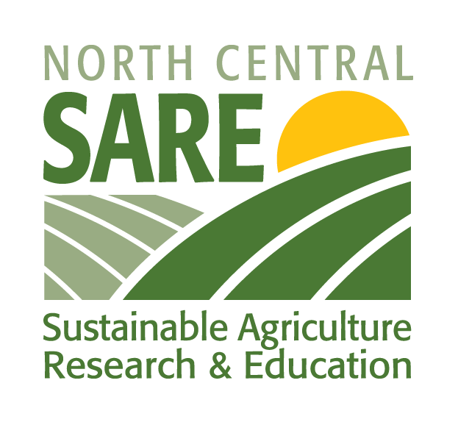
- http://www.iowaproduce.org/pages/production/files/high_tunnel/iowa_tunnel_guide.pdf

This product was developed with support from the Sustainable Agriculture Research and Education (SARE) program, which is funded by the U.S. Department of Agriculture — National Institute of Food and Agriculture (USDA-NIFA). Any opinions, findings, conclusions or recommendations expressed within do not necessarily reflect the view of the SARE program or the U.S. Department of Agriculture. USDA is an equal opportunity provider and employer.

© 2014 Regents of the University of Minnesota. All rights reserved. University of Minnesota Extension is an equal opportunity educator and employer.
In accordance with the Americans with Disabilities Act, this material is available in alternative formats upon request. Direct requests to efans@umn.edu.
Printed on recycled and recyclable paper with at least 10 percent postconsumer waste material.

