WILDLIFE DAMAGE CONTROL
FOR
ORGANIC FARMERS

Jim Knight, Extension Wildlife Specialist
Montana State University

Funding for this handbook came from a grant funded by
Western Sustainable Agriculture Research and Education

Table of Contents

Non-chemical control of Richardson’s and Columbian
ground squirrels 3
Non-chemical control of pocket gophers 7
Non-chemical control of voles 13
Non-chemical control of rabbits 17
Non-chemical control of woodchucks 20
Non-chemical control of birds 22
Non-chemical control of deer 26
Non-chemical control of skunks 30
Non-chemical control of raccoons 33
Non-chemical control of coyotes 35

Non chemical control of Richardson’s and Columbian ground squirrels
Jim Knight, Extension Wildlife Specialist, Montana State University

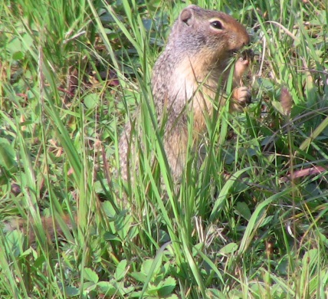

Because ground squirrels are primarily meadow and grassland rodents, farms can provide habitat for them. Unused portions of the farm often provide a reservoir of ground squirrels which lead to problems when dispersing juveniles set up housekeeping in garden areas. Damage from ground squirrels results from both their feeding and burrow digging activity.
More than a dozen species of ground squirrels reside in the U.S. This article covers the Richardson’s ground squirrel found in areas east of the Rocky Mountains and the Columbian ground squirrel which occurs in the west areas.
Ground squirrels primarily eat grasses, forbs and seeds. Ground squirrels live in extensive underground burrows with many entrances. Ground squirrels hibernate during the winter, but they store large quantities of food in burrow caches. Males become active in early spring, one to two weeks before females. Breeding takes place immediately after females emerge from their burrows. After a 28 day gestation period, 2-14 young are born. Densities of ground squirrels can range from two to 20 or more per acre. Ground squirrels begin hibernation early with some species in drier areas going into hibernation in August. Timing of emergence from hibernation is very important in developing optimum control strategies.
It is important to know the difference between ground squirrels and pocket gophers which are found throughout most of the same range. Ground squirrels look like squirrels, and pocket gophers have cheek pouches, external incisors and look more like short-tailed rats. Although these two species look very different, there is some confusion because ground squirrels are sometimes called “gophers.” Pocket gophers spend 99 percent of their life underground feeding on roots and tubers. Ground squirrels feed above ground. Pocket gophers plug their tunnel entry tightly with soil. Ground squirrels have an open entrance to their tunnel system.
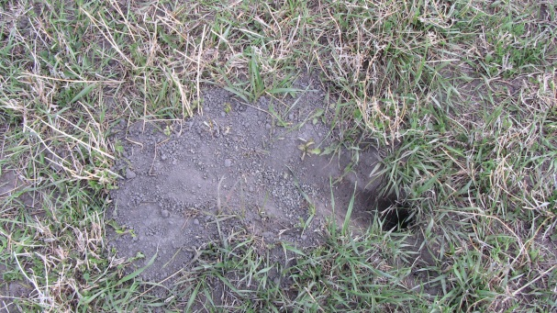
Ground squirrels are not protected in most states. Some species or subspecies, however are protected in some areas. For example, the Northern and Southern Idaho ground squirrels are a Species of Concern. Iowa, Pennsylvania and Missouri require special permits before controlling ground squirrels. Always check with your state wildlife agency before implementing control programs.
Ground squirrels are prey for many predators from coyotes and snakes to hawks, owls and weasels. However predators do not control ground squirrel populations.
Extent of Control
Farmers often ask if they should try to reduce the ground squirrel population or if they should try to eliminate it. It makes more economic sense to eliminate the population. Ground squirrels, with an average litter size of 10 and a maturity age of about 10 months, are very productive. One female has the potential to have offspring resulting in over 100 progeny in just 3 years. Luckily the juvenile mortality rate is about 85%. Most of this mortality occurs in late summer when the mother drives her offspring out of her burrow. They die of exposure, starvation, predation, etc. I if a population is just reduced, the multitude of burrows available results in extremely high juvenile survival and any reduction in population is immediately offset. The extra effort to eliminate the local population will result in less chance of reinfestation.
However, if neighboring property does not have a ground squirrel control program, farmers can expect to have a continual reinfestation as adjacent colonies redistribute when juveniles disperse.
Habitat Modification
Because of the above mentioned dispersal behaviors of ground squirrels, it is valuable to deep plow to cover burrows after control programs are completed. The ground should be revegetated and the area will be less likely to attract disseminating young animals.
Repellents and Frightening Devices
Repellents are not effective for managing damage by ground squirrels.
Ultrasonic devices have not proven to control, disturb or displace ground squirrels when tested in unbiased research trials.
Trapping
Trapping is an effective way to manage individual or small populations of ground squirrels. For most organic farmers this may be the most practical method of control. Body-gripping (also known as Conibear®) traps can be placed over the hole. All entrances to a burrow system should be covered. Several to dozens of the No. 110 size traps should be used so trapping can begin on one side of the colony and progress across the area. The traps should be staked to prevent scavengers from dragging them off. Body-gripping traps are available from hardware stores or there are many sources available online.
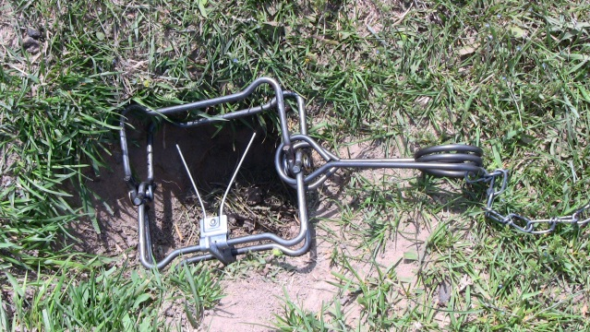

Timing of ground squirrel control is very important. Timing may be the most critical factor effecting success. Early spring is the target period for control. Control measures prior to the birth and emergence of young ground squirrels will be much more efficient.
Cage or box live traps can sometimes be used to remove a very small number of ground squirrels. The small 5 X 5 X18-inch traps work well. They are available from various on-line sources. Bait with nutty peanut butter. After a successful capture, people often desire to release the animal at a distant location. Research has shown this may not be a desirable nor humane option. If a ground squirrel is released, it will normally try to return to its home. They almost always die of exposure, starvation, predation, etc. Putting it with an existing colony will be futile because the resident animals will drive it away. The author recommends drowning as a convenient and safe way of disposing of live-trapped ground squirrels.
Other Methods
Shooting ground squirrels is seldom an effective method of control. Although it may be an enjoyable recreational activity for some people, shooting is expensive, time-consuming and the animals quickly become extremely cautious. At best, shooting reduces the population only until late summer when juveniles will repopulate the vacated burrows.
Propane exploding devices have been advertised to control ground squirrels. These injecting devices are meant to fill the burrow system with a mixture of propane and oxygen, which is ignited to kill the rodents. The resulting explosion is certainly significant and some operators have reported some degree of control. Because the devices are expensive, it is usually difficult to demonstrate they are an economically efficient method of ground squirrel control. Caution must also be taken if underground utilities might be present. There is also some question of whether propane gas is acceptable in an organic farming context.
Other methods have been proposed to control ground squirrels. Flooding the tunnel system with water from a hose will sometimes force the squirrel from a burrow if the burrow system is not extensive and soils are heavy. Avoid flooding burrows that are adjacent to foundations or structures that may be damaged by water. Gumballs have been reported to clog the intestinal track of ground squirrels. Most of the claims are antidotal and although individual ground squirrels may nibble on gumballs there is no evidence populations will consume enough to result in reliable control.
Acknowledgments
Much of the information presented here was adapted from S.E. Hygnstrom (1994) in Prevention and Control of Wildlife Damage, University of Nebraska, Lincoln, NE.
This information is for educational purposes only. Reference to commercial products or trade names does not imply discrimination or endorsement by the Montana State University Extension Service.

Non chemical control of pocket gophers
Jim Knight, Extension Wildlife Specialist, Montana State University
Pocket gophers are the burrowing rodents that leave soil mounds on the surface of the ground. Often confused with ground squirrels (often called “gophers”) and other small mammals, pocket gophers can be distinguished by their telltale signs as well as by their appearance.
Unlike ground squirrels, which have open holes leading to their tunnel system and are often seen outside their holes, pocket gophers spend almost all their time in their sealed tunnel systems. The mounds they create are usually fan shaped, and tunnel entrances are plugged, keeping intruders out of burrows.
Damage caused by pocket gophers includes destruction of underground utility cables and irrigation pipe; direct consumption and smothering of forage by earthen mounds; and change in species composition on rangelands by providing seedbeds (mounds) for invading annual plants. Research has shown that pocket gophers can reduce dry land yields by almost 50%. Pocket gophers damage trees by stem girdling and clipping, root pruning and possibly root exposure caused by burrowing. Gopher mounds dull and plug the sickle bars used in harvesting hay or alfalfa, and soil brought to the surface as mounds is more likely to erode. In irrigated areas, gopher tunnels can divert water, causing loss of surface irrigation water. Pocket gopher tunnels in ditch banks and earthen banks can hasten soil erosion and water loss.
Litter sizes range from 1 to 10, but average 3 to 4. In some portions of their range where two litters are born each year, litter size is usually smaller, averaging about two. The breeding season also varies, but births typically occur from March through June. The gestation period is 18 to 19 days.
Densities reported for various pocket gophers are highly variable. Densities of 6 to 8 per acre are considered high density. Average life span of gophers appears to change inversely with population density.
Many predators eat pocket gophers. These predators include weasels, coyotes, and several snakes including bull, and rattlesnakes.
Pocket gophers are not usually protected but always consult with your state wildlife agency before implementing a control program.
Identification
Pocket gophers are burrowing rodents, so named because they have fur-lined cheek pouches outside of the mouth, one on each side of the face. These pockets, which can be turned inside out, are used to carry food. Pocket gophers are powerfully built in the forequarters and have a short neck. The head is fairly small and flattened. The forepaws are large-clawed. Gophers have small external ears, small eyes, and lips that close behind their large incisors: all adaptations to their underground existence.
The pocket gopher's tail is sparsely haired and serves as a sensory mechanism that guides it while moving backwards through its tunnel system. The whiskers on its face are also sensitive, and help it to travel about in its darkened tunnel.
Pocket gophers are medium-sized rodents ranging from about five to nearly 10 inches long (head and body). Adult males are larger than adult females. Their fur is fine and soft, and highly variable in color. Colors range from nearly black, to pale brown, to almost white. This great variability in size and color is attributed to adaptations to local conditions that result from a low dispersal rate which limits gene flow.
Habitat
Pocket gophers occupy a wide variety of habitats. They occur from low coastal areas to elevations above 12,000 feet. They are also found in a wide variety of soil types and conditions, reaching their greatest densities on fertile, light-textured soils with vegetation, especially when that vegetation has large, fleshy roots, bulbs, tubers or other underground structures.
Soil depth and texture are important to the presence or absence of gophers. Tunnels are deeper in sandy soils where soil moisture is sufficient to maintain the integrity of the burrow. Shallow soils may be subject to cave-ins, and will not maintain a tunnel. Light textured, porous soils with good drainage allow for good gas exchange between the tunnel and the atmosphere. Soils with a high clay content, or those that are continuously wet, diffuse gases poorly and are unsuitable for gophers.
Burrow systems consist of a main burrow, generally 4 to 18 inches below ground and parallel to the surface, with a variable number of lateral burrows off the main. These laterals end at the surface with a soil mound or sometimes with only a soil plug.
Pocket gophers eat forbs, grasses, shrubs and even small trees. They are strict herbivores and any animal material in their diet is accidental. Pocket gophers feed on plants in three ways. They may go to the surface, venturing only a body length or so from their tunnel opening to feed on above-ground vegetation. They may feed on roots they encounter when digging. They frequently pull vegetation into their tunnel from below. Pocket gophers eat forbs, grasses, shrubs, even small trees. They are strict herbivores and any animal material in their diet appears to be accidental. Alfalfa is apparently one of the most nutritious foods for pocket gophers.
Damage Prevention and Control Methods
Habitat Modification
These methods take advantage of knowledge of the habitat requirements and feeding behavior of pocket gophers, to reduce or eliminate damage.
Crop varieties. In alfalfa, large taprooted plants may be killed or the vigor of the plant greatly reduced by pocket gophers feeding on the roots. Plant varieties of alfalfa with several large roots rather than a single taproot. These are more tolerant of damage by pocket gophers.
Crop rotation. Annual grains do not establish large underground storage structures, and therefore are not capable of sustaining pocket gophers. The transition of land to annual crops will eliminate pocket gophers in that area.
Grain buffer strips. Planting buffer strips of grain around hay fields provides unsuitable habitat around the fields and can minimize immigration of pocket gophers into sensitive areas.
Exclusion
Because of the expense, exclusion is feasible only for exceptionally valuable crops such as ornamental shrubs or landscape trees. Bury 1-inch mesh wire mesh at least 18 inches into the soil and leave 6 inches above the soil.
Repellents and Frightening Devices
There are no repellents or frightening devices available for pocket gophers that have proven to be efficient in research trials. Those that do work are effective in such a small area that their use is not practical. Noise-making and vibration devices and plants reported to repel pocket gophers have not been proven effective. Ultrasonic and other electronic devices have also not proved effective in University research.
Trapping
Trapping is usually the best way to control pocket gophers without chemical use.
Effective and efficient trapping of pocket gophers requires three key elements. First, use plenty of traps. You want to have at least one trap for every fresh mound in your field. Second, careful inspection of the property to determine the location of the newly constructed mounds. Newly constructed mounds tend to be taller, have more granulated soil that is less compacted, and darker color. Mounds that are flattened with light tan coloration are old mounds and should be avoided. Third, trapping requires patience and effort. A fair amount of labor must be expended to both set traps and to check them on a daily basis. Most trapping failures occur because people give up too quickly.
Once you have identified the areas with fresh mounds, you must decide how you plan to trap them. To have two methods. The first method sets the trap in the lateral tunnel. The second method sets traps in the main tunnel. Both have their advantages and disadvantages. Placement of traps in the lateral tunnel requires less work, but requires proper traps to prevent frequent misfires as pocket gophers plug the opening. Placement of traps in the main tunnel may have a higher capture rate but requires a great deal of effort in digging the hole and requires a trap pointing in each direction in the tunnel.
The key to the efficient and effective use of main tunnel trapping methods is locating the main burrow system. The main runway generally is found 12 to 18 inches away from the plug on the fan shaped mounds. Push a ¼ -inch solid rod into the ground to locate the main burrow, which will be 6-18 inches deep. As you push the rod into the ground, it will become easier to push when the tip enters the runway.
After locating the main runway, dig a small hole and remove all dirt from the tunnel. Place traps in each direction and attach them to a stake at the surface with a wire (Fig 1.).
Place a piece of plywood or cardboard over the hole and pack dirt around the edges to prevent light or air from entering the tunnel system. Holes should be flagged.

Fig. 1. Placement of a solid pan trap in main pocket gopher tunnel.
An easier way to trap pocket gophers is with an open-pan trap (DK Gopher Trap®), which is triggered by the pocket gopher attempting to plug the hole. This type of trap can be used very effectively in the lateral runway (Fig. 2.). This eliminates the need to probe and dig to access the main runway.
Fig. 2. An open pan trap placed in a lateral runway.
When using a trap with an open trigger pan, you must first locate and open the plug of a fresh mound. Use your finger to poke around and find the softer dirt of the entrance. Clean out the loose dirt and make the opening only large enough to insert the trap. The trap jaws should be 8-12 inches down into the lateral tunnel. Stake the trap. Do not plug the hole. The light and air will attract the pocket gopher. When the gopher tries to plug the hole he will get caught.
Check the traps daily and leave them in place for a day or two after you catch a pocket gopher during spring and early summer when young may be with the adult females. If a trap is not sprung within 48 hours, move it to a new location.
Closed-pan traps are available from hardware and garden supply stores. Open pan traps are available from P-W Mfg. Co. (888-278-2186) and from several online sources.
Other Methods
In flower gardens or other areas where landscape disturbance is not desirable, some success has been achieved by flooding pocket gophers out with a garden hose. Insert the hose into the lateral tunnel and pour water into the tunnel system until the gopher is flushed out. This method can only be used in new tunnel systems, and only where other damage from the water will not be a factor.
Fumigation of pocket gopher holes with gasoline, propane or exhaust from an automobile has been reported but is NOT RECOMMENDED because of safety hazards. These methods could result in serious explosions or the placement of toxic fumes in undesirable areas.
Benefits of Pocket Gophers
Although in many cases the damage caused by pocket gophers is the overriding factor, the benefits of pocket gophers should be recognized. Some of these are:
- Increased soil fertility by adding organic matter such as buried vegetation and fecal wastes.
- Increased soil aeration and decreased soil compaction.
- Increased rate of soil formation by bringing subsoil material to the surface of the ground, subjecting it to weatherization.
- Increased water infiltration
Acknowledgments
Much of the information presented here was adapted from S.E. Hygnstrom (1994) in Prevention and Control of Wildlife Damage, University of Nebraska, Lincoln, NE.
Figure 1 is adapted from E.K. Boggess (1980), “Pocket Gophers”, in Handbook on Prevention and Control of Wildlife Damage, Kansas State University, Manhattan.
Figure 2 is courtesy of P-W Manufacturing Company.
This information is for educational purposes only. Reference to commercial products or trade names does not imply discrimination or endorsement by the Montana State University Extension Service.

Non chemical control of voles

Jim Knight, Extension Wildlife Specialist, Montana State University
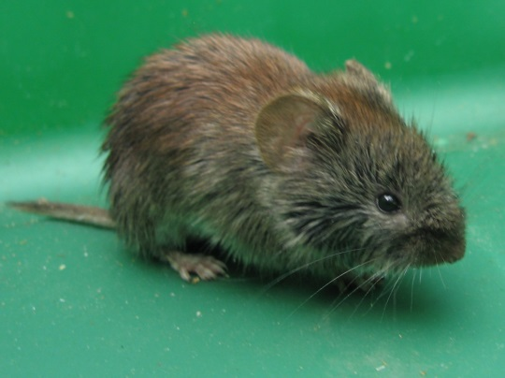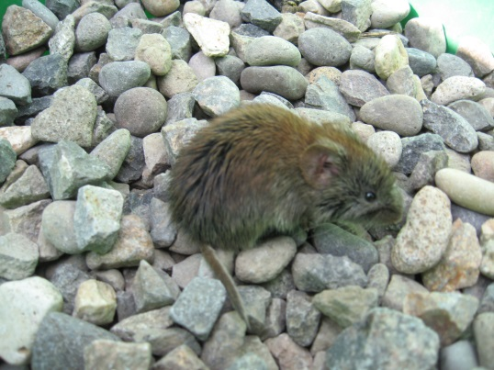

In just six months a female vole (Microtus spp.) has the biological potential to have over 40,000 grandchildren. Luckily the average vole lives less than a month and natural mortality factors keep them from reaching their full reproductive potential.
But every spring, homeowners and farmers receive a surprise when snowmelt reveals little trails scattered along grassy areas. The voles have been at work all winter under the snow; removing green vegetation down to the soil and creating a maze of runways and bare patches. Vole control is a never ending task and a never ending frustration for many farmers. During summer, voles will often eat plant leaves, stems and pods in gardens.
Through persistence and creativity it is possible to offset vole damage. Even the frustrating failures will be interspersed with satisfaction resulting from the large natural population fluctuations that are characteristic every two to five years.
Voles are found throughout the United States. There are over 20 vole species and all of them cause widespread and significant economic damage to gardeners and farmers. Voles occupy a wide variety of habitat but they are normally found near areas with heavy ground cover of grass or other dense vegetation. Generally the damage that occurs in gardens and lawns is adjacent to natural areas where long-term vole habitat exists.
Voles eat a wide variety of plants but most frequently they eat grasses and forbs. In the summer and fall they store seeds, tubers, bulbs and rhizomes. Occasional foods include small animals such as snails, insects and animal remains.
Voles are active day and night throughout the year. They do not hibernate. Their home range is usually a quarter acre or less but varies with the season, population density, habitat and food supplies. Voles construct many tunnels and surface runways with several burrow entrances. One burrow system may contain several adults and their young.
Voles breed throughout the year but the most commonly in the spring and summer. They generally have one to five litters per year and the litter size ranges from one to eleven but is usually three to six. The gestation period is 21 days and females usually mature in 35 to 40 days. Under ideal conditions females may breed as early as 2 weeks of age. Life span is short ranging from two to sixteen months once adulthood is reached.
Population densities of voles are variable. Research has shown populations range from about two to more than 50 per acre in normal grasslands. Populations in alfalfa are often over 100 voles per acre. The highest reported density was during a 1957 population irruption in Oregon where voles numbered 4000 per acre.
Voles are prey for many predators from coyotes and snakes to hawks, owls and weasels. Encouraging predators often is considered as a method of vole control. Many predators feed on voles because they are relatively easy to catch, they are active day and night, and they are abundant. But because of a high reproductive rate of voles, populations are unlikely to be controlled by predators.
Voles are classified as nongame mammals that can be controlled when causing damage. Always contact your state wildlife agency for details regarding local codes and regulations.
Voles may cause damage as they girdle trees and seedlings and damage roots. Tiny marks from vole incisors can be seen which help differentiate vole damage from other causes of bark removal or root damage. On lawns, most damage results from the vole’s extensive runway and tunnel system. Turfgrass is damaged when the well-traveled runways and adjacent areas are clipped close to the ground. Feces and small pieces of vegetation are usually evident in the runways. Excessive urine and feces can sometimes make re-establishment of grasses a challenge.
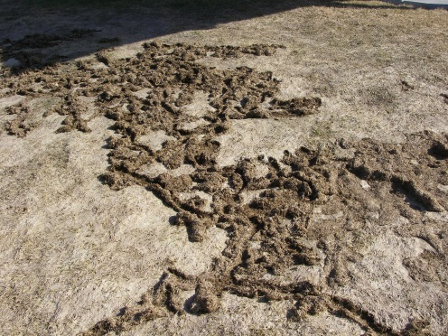
When controlling vole damage, success will be higher if a variety of methods are used to address the problems.
Habitat Modification
Employ cultural methods that eliminate weeds, grass, litter and loose mulch which provide voles cover and sources of food. Mowing grass short around trees will reduce the ease of vole travel.
Clearing a 10-foot area around gardens by burning and/or tilling will discourage voles from crossing the open area. Soil tillage is effective in reducing vole damage because it removes cover and destroys vole tunnels.
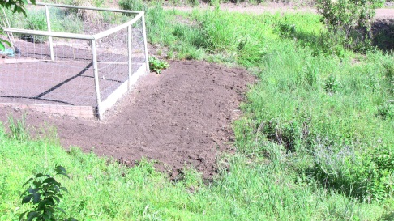
The shorter the grass, the more difficult it will be for voles to move from one area to another during winter. Cutting grass as short as possible in a 10 foot swath next to native grass areas will make it difficult for voles to move into other areas under the snow. Voles travel very well under snow if they can move freely through vegetation or loose material between the soil and snow. Eliminating this layer is the key to preventing vole movements during the winter.
Exclusion
Exclusion is often the best method to protect seedlings and young trees. Hardware cloth cylinders and some commercially made plastic cylinders are very effective when used properly. The mesh should be ¼ inch or smaller and must be buried 6 inches to keep the voles from burrowing under the cylinders. Be sure the cylinders extend above the expected snow level.
Repellants and Frightening Devices
Repellents, with capsaicin as the active ingredient, are registered for meadow voles and may provide some short term protection. Because repellents must be reapplied often, the logistics of using them to prevent vole damage is usually not practical.
Frightening devices are not effective in reducing vole damage. A large variety of frightening devices claim to keep rodents away. Lights, sounds and numerous ultrasonic devices have been tested and none have proven effective in controlled experiments.
Trapping
Trapping is not usually effective in controlling large vole populations because the time, labor and number of traps used can be the excessive. However, for small populations, snap traps (mouse traps) baited with nutty peanut butter will work. Place the traps in small boxes with 1 inch holes cut on each side. Use 3-4 traps in each box to better attract other voles after the first ones are caught. Check traps every 48 hours.
Spring-loaded, multiple-catch traps may be useful in some situations. Freezing weather and rain may sometimes reduce their effectiveness.
Placing 2- inch PVC pipe at ground level under the snow will provide a travel corridor for voles. These pipes can provide entry to multiple-catch traps or boxes where snap traps are placed. Cutting 1-inch holes in the PVC every 2 feet will further encourage the voles to enter the pipes.
Other Methods.
Packing snow can obstruct vole movements between native grass areas and lawns or gardens. It has been found that voles are reluctant to go over the top of packed snow areas they cannot burrow through. To maintain these packed areas some farmers have used snowmobiles or developed cross country ski trails along edges.
Some people think that cats can provide good control of voles. While cats to kill voles, they will not kill a sufficient number to provide adequate control. Also, they will kill a variety of other species that would be beneficial to your garden and landscape.
Acknowledgments
Much of the information presented here was adapted from S.E. Hygnstrom (1994) in Prevention and Control of Wildlife Damage, University of Nebraska, Lincoln, NE.
This information is for educational purposes only. Reference to commercial products or trade names does not imply discrimination or endorsement by the Montana State University Extension Service.

Non chemical control of rabbits
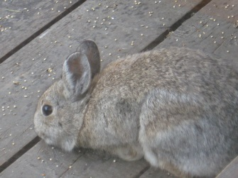
Jim Knight, Extension Wildlife Specialist, Montana State University
There are 9 species of cottontail rabbits in the US. They tend to concentrate in brushy areas where food and cover are suitable. Rabbits only live 12-15 months but with the ability to have 2-6 litters per year their numbers can surge when conditions are favorable.
Rabbits eat flowers and vegetables in spring and summer. In fall and winter the diet switches to woody materials. During severe winter conditions, their concentrated browsing can be intense enough to kill bushes.
Rabbit damage can be distinguished from deer browsing by the sharp angled cut on twigs and gnawing on the lower portions older woody growth.
Habitat Modification
Clearing brushy cover, removing brush piles, weed patches, stone piles and other debris will make an area less attractive to rabbits.
Exclusion
The only permanent way to prevent rabbit damage to crops is by exclusion. Exclusion is most often accomplished by the construction of fences and gates around the area to be protected. Woven wire or poultry netting should exclude all rabbits from the area to be protected. Use wire mesh smaller than 1 ½ inches, 30 to 36 inches high (higher in deep snow areas), with the bottom 6 inches buried below ground level. Bending the bottom 6 inches out from the garden and tacking it to the ground will usually be as effective as burying the fence. Poultry netting made of 20-gauge wire can provide protection for 5 to 7 years or more. Remember to spread the initial cost over the expected life of the fence when comparing fencing with other methods. Exclusion by fencing is desirable for small areas of high-value crops such as gardens, but is usually impractical and too expensive for larger acreages of farmland.
Protect the trunks of young trees or vines by installing cylinders made from woven wire netting. Cylinders should be 24 inches high (or 15 inches above maximum snow depth), anchored with steel rods and braced away from the trunk to prevent rabbits from pressing them against the trees and gnawing through them.
Types of tree protectors commercially available include aluminum, nylon mesh wrapping, and treated jute cardboard. Aluminum foil, or even ordinary sacking, has been wrapped and tied around trees with effective results.
Repellants and Frightening Devices
Dogs can be located along boundaries of crop fields or near gardens to deter rabbits.
Lights and ultrasonic devices provide no benefits as long-term rabbit scare devices.
Motion activated scare devices work well to keep rabbits out of an area. Several manufacturers such as Havahart® and Guardener® have models that work well.
Various organic repellents are commercially offered as a means of reducing or preventing rabbit damage to trees, vines, or farm and garden crops. Currently available commercial repellents include soaps, hot sauce, dried blood, and putrefied eggs. Repellents are limited by the necessity to reapply them after significant amounts of wet weather and the inability to apply them to plant parts meant for human consumption.
Trapping
Trapping with box-traps is an effective way to remove rabbits. The smaller, 4X4X15-inch traps work well. Carrots or leafy alfalfa make good cold-weather baits. Fresh apples, carrots, cabbage and other fresh vegetables are good baits in warmer weather. Be sure to replace the bait if it dries out. It helps to prebait the trap site to get the rabbits used to the bait before placement of the trap.
When an animal is live-trapped, there is often a desire to release the animal at a distant location. Research has shown this may not be a desirable nor humane option. If a rabbit is released, it will normally try to return to its home. They almost always die of exposure, starvation, predation, etc. Putting it with an existing population will be futile because the resident animals will drive it away. The author recommends drowning as a humane way of disposing of live-trapped rabbits.
Snares can be placed in rabbit runways or at the entrance to holes they are using. Small mammal snares are available online. Use snares with self-locking mechanisms to keep the snare from loosening on the rabbit. Check for tracks on runways in snow or dirt surfaces and suspend the anchored snare from a support wire so the bottom of a 3-inch loop is suspended 1 inch above the ground.
Be sure to check with local wildlife officials on the legality of trapping and snaring rabbits.
Other Methods
Where safe and legal to do so, shooting rabbits may suppress or eliminate damage.
Natural enemies of jackrabbits include hawks, owls, eagles, coyotes, bobcats, foxes, and weasels. While predation will not eliminate the population, presence of predators will provide some useful assistance in rabbit control. Even without actual killing of the rabbits, predators may make rabbits stay closer to cover and away from more open garden areas.

Acknowledgments
Much of the information presented here was adapted from S.E. Hygnstrom (1994) in Prevention and Control of Wildlife Damage, University of Nebraska, Lincoln, NE.
This information is for educational purposes only. Reference to commercial products or trade names does not imply discrimination or endorsement by the Montana State University Extension Service.

Non chemical control of woodchucks
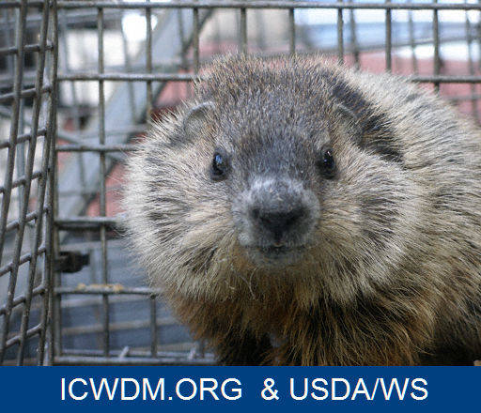
Jim Knight, Extension Wildlife Specialist, Montana State University
Woodchucks are also known as ground hogs and whistle pigs and are one of 14 species of marmots. Woodchuck problems usually relate to burrowing under buildings or damaging garden crops. Digging under buildings can lead to problems with weakened foundations and unwanted water drainage.

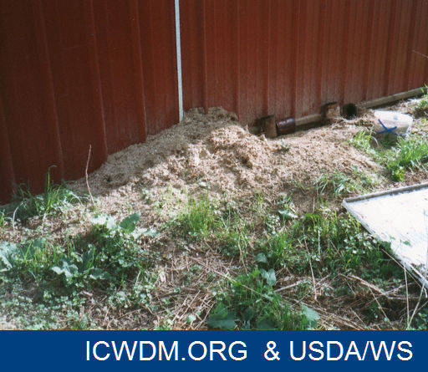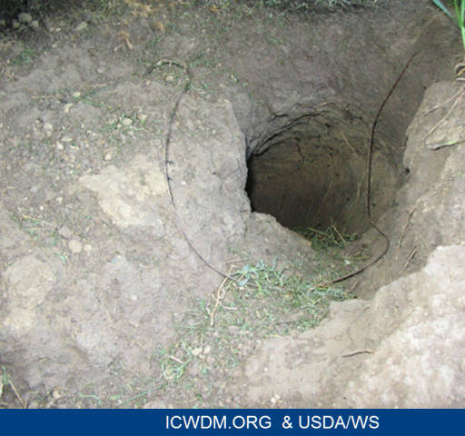

There is a great deal of variation between states regarding the legal status of woodchucks. Be sure to check your state’s regulations before employing control methods.
Exclusion
Fencing can sometimes exclude woodchucks. They are, however, good climbers and can easily scale wire fences if electric wire is not included in the design. Fences should be at least 3 feet high and made of heavy poultry wire or 2-inch mesh woven wire. To prevent burrowing under the fence, bury the lower edge 10 to 12 inches in the ground. Place an electric wire 4 to 5 inches off the ground and 4 to 5 inches away from the fence.
Repellents and Frightening Devices
There are no repellents effective for woodchucks.
Scarecrows and other effigies can provide a few days relief from woodchuck damage. Move them regularly and incorporate a high level of human activity in the susceptible area.
Trapping
Cage trapping can sometimes be effective for small-scale woodchuck problems. Live traps should be at least 10 by 12 by 32 inches. Bait traps with apple slices or vegetables such as carrots and lettuce, and change baits daily. Locate traps at main entrances or major travel lanes. Place guide logs on either side of the path between the burrow opening and the trap to help funnel the animal into the trap. Check all traps twice daily, morning and evening, so that captured animals may be quickly removed. A captured animal can be relocated at least 10 miles away if regulations allow. Drowning is an effective method of dispatch.
When non-target animals are not concern, body-gripping traps (also known as Conibear® traps) are effective in some situations. Place the traps over the main entrances of the burrow system. No bait is necessary. Conibear® 110’s will handle young, small animals, while 160s and 220s will also handle larger adults.
Conibear® traps are designed to kill the animal. Care should be taken to avoid trapping domestic animals such as cats and dogs. Some state or local laws prohibit the use of Conibear® traps and some allow their use only in water. Consult your state wildlife department for regulations regarding the control of woodchucks.
Other Methods
Shooting is a way to kill a few woodchucks but it is seldom an effective method of population elimination. If state and local regulations allow, and if conditions provide a safe shooting situation, a .22 rimfire rifle or a shotgun can be used to dispatch woodchucks.
Acknowledgments
Much of the information presented here was adapted from S.E. Hygnstrom (1994) in Prevention and Control of Wildlife Damage, University of Nebraska, Lincoln, NE. Ideas from Colorado State University Extension were also included.
This information is for educational purposes only. Reference to commercial products or trade names does not imply discrimination or endorsement by the Montana State University Extension Service.

Non chemical control of birds
Jim Knight, Extension Wildlife Specialist, Montana State University
Because of the large number of bird species that can pose problems for organic farmers, this article will deal with bird control in general. Detailed information about the habitat and biology of specific bird groups or species can be seen at http://www.extension.org/pages/9035/wildlife-species-information.
Before removing birds, it is important to check with local wildlife officials to determine if targeted bird species are protected. Even if the birds are protected, permits for removal can generally be obtained if significant damage is occurring or if human health is a concern.
Most bird damage occurs when large numbers of birds feed on crop or garden products. Removal and damage to grain, fruits, seedlings and other produce can be significant, especially when large numbers of birds attack a garden. In some situations bird droppings pose a health hazard. Diseases associated with bird feces can be a human health concern.
Prevention and Control of Damage
As with other wildlife species, prevention and control of bird damage requires looking at a variety of tools. Organic farmers have restrictions on the tools they can use so they must use persistence and creativity more often.
Before going to the effort and expense of controlling the birds, try to determine if the damage the birds are causing is really significant. Excluding the birds from a small section of the crop with netting will allow you to inexpensively determine if the damage outside the netting, when compared to the damage inside the netting, is really worth controlling.
Habitat Modification
Consider eliminating habitat that might attract birds. Often a nearby hedge providing cover, a dense tree providing a roosting site, spilled grain or some other attraction may be luring birds to the area.
Exclusion
Protect crops with bird netting. This approach can be economical if netting is used for several years to protect the site. Leave no openings at the bottom of netted crop areas. Birds that get into fields through such openings and are unable to find their way out can cause considerable damage.
Although more expensive, livestock panels covered with poultry wire can be arranged so they can be folded open to allow easy access for harvesting berries or other bedded crops.
If the problem is a continuous one, it is often worth the investment to implement permanent solutions rather than stopgap measures. For example if sparrows can be expected to be a problem in your garden continuously, it may be worth the investment to construct supports so poultry wire can be used to cover the entire garden area rather than draping nylon netting after the problems start.
Repellents and Frightening Devices
Because chemical repellants are not appropriate for organic farmers the only recommended repellent is monofilament line.
Research has shown many species of birds are repelled by the presence of clear monofilament fishing line when it is stretched between 2 points. Apparently the appearing and disappearing of the line is what repels the birds. The line is not a barrier because it is still effective when used with large spaces between strands.
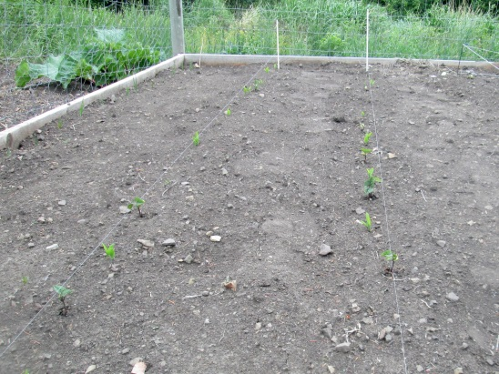
Line with 20 lb. breaking strength provides the best combination of visibility, resistance to UV damage and durability. The line should be spaced 12 inches and placed directly over berry patches. Line can be stretched above a row of vegetable sprouts and raised as they emerge from the soil. A pole can be placed along the trunk of fruit trees and monofilament line can be stretched from the top of the pole to the ground in a “maypole” fashion.
Frightening is effective in dispersing birds from roosts, fruit crops, and some other troublesome sites. Frightening devices include recorded distress or alarm calls, gas-operated exploders, battery-operated alarms, pyrotechnics (shell crackers, bird bombs), lights (for roosting sites at night), bright objects, and various other stimuli. Some novel visual frightening devices with potential effectiveness are eye-spot balloons, hawk kites, and Mylar® reflective tape. However birds usually get used to these novel devices and they lose their effectiveness.
Ultrasonic (high frequency, above 20 kHz) sounds have not proven to be effective in research trials because, like humans, birds do not hear these sounds.
Harassing birds throughout the evening as they land can be effective in dispersing bird roosts if done for three to four consecutive evenings or until birds no longer return. Spraying birds with water from a hose or from sprinklers mounted in the roost trees has helped in some situations.
Some motion activated water sprayers have been developed that spray birds when they break the motion detecting barriers. These work well because they activate only when the bird is in close proximity which prevents the birds from getting used to the scare device.
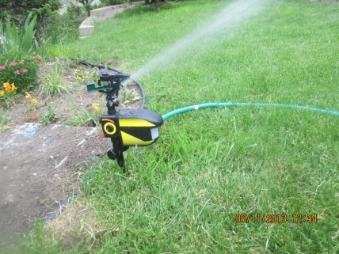
Beating on tin sheets or barrels with clubs also scares birds.
Green lasers have proven to be good scare devices for many species of birds. When birds are scared repeatedly from an area they tend to avoid that area.
A combination of several scare techniques used together works better than a single technique used alone. Vary the location, intensity, and types of scare devices to increase their effectiveness. Two additional tips for successful frightening efforts: 1) begin early before birds form a strong attachment to the site, and 2) be persistent until the problem is solved.
Trapping
When unprotected birds are causing damage, trapping can often be the best solution. Trapping is probably the most widely used method in attempting to reduce problem bird populations. Most bird traps are live traps so nontarget species can be released unharmed. There are many types of traps available but some are suitable only for certain species.
Funnel traps are the most commonly used traps. Small, portable funnel traps can be easily constructed and deployed using poultry wire supported by a wood frame. The principle is similar to minnow traps. Birds are baited through an opening which leads them to the center of the trap. When they attempt to escape they go to the edges rather than back to the center opening.
The best locations for traps are major loafing areas. Consider prebaiting areas for several days before beginning the actual trapping. To prebait, place attractive baits, such as corn or milo, around the outside of the traps. Then place the bait inside but with the funnel removed so the birds can easily go in and out. After 3 to 4 days, the funnel can be replaced with the baits inside the trap.
Visit traps at least every other day. If “trap-shyness” develops, traps can be left open for 2 to 3 days and then reset again for 4 to 5 days. Select another site if traps fail to catch a sufficient number of birds.
The disposal of trapped birds should be quick and humane. The act of inducing painless death is called euthanasia. Options to select from include inhalant agents and physical methods. For large-scale control projects, the most cost-effective and humane method is to use a carbon monoxide (CO) or carbon dioxide (CO₂) gas chamber.
Releasing birds back to the “wild” is impractical. They are likely to return even when released 50 or more miles from the problem site, or become pests in other communities.
Automatic traps are counter-balanced multicatch traps usually designed for sparrows. Birds enter a compartment alone to feed on bait that is placed on a shelf in the trap. Their weight causes an “elevator” to drop to the lower level where the bird “escapes” into a closed cage. Without the bird’s weight, the counterbalanced “elevator” springs back into the original position ready for another passenger.
Other methods
Shooting with air guns or low-powered firearms can be used with some success where state laws and local ordinances permit. Birds quickly become wary of a human holding anything resembling a firearm, so shooting from a blind is recommended whenever possible. Even then birds quickly become wary and shooting seldom reduces a population but may make them avoid the area.
Nest Destruction. Where legal, birds can be discouraged from using an area by removing nests and destroying the eggs. This operation must often be repeated at 2-week intervals throughout the breeding season. Use a long insulated pole with a hook attached to one end to remove nests that are located in high places. The nesting materials should be collected and removed to make it harder for the birds to find materials for new nests.
Predators. Encouraging predators is often attempted but will not control bird populations.
Acknowledgments
Much of the information presented here was adapted from S.E. Hygnstrom (1994) in Prevention and Control of Wildlife Damage, University of Nebraska, Lincoln, NE.
This information is for educational purposes only. Reference to commercial products or trade names does not imply discrimination or endorsement by the Montana State University Extension Service.

Non chemical control of deer
Jim Knight, Extension Wildlife Specialist, Montana State University
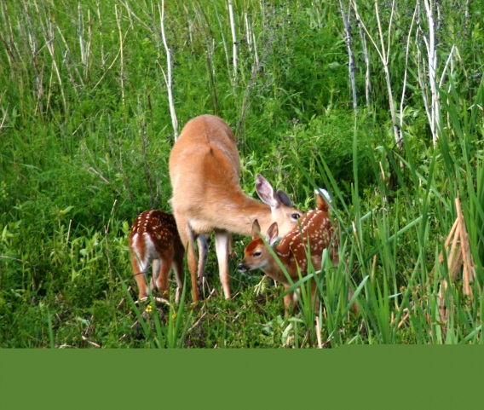
Deer are probably the most widely distributed and best recognized large animal in North America. Deer habitat includes wildlands, agricultural areas and residential areas. Deer favor early vegetation stages that keep brush and sapling browse within reach. Dense cover is used for shelter and protection. Because deer are so adaptable, residential areas sometimes provide suitable habitat and deer can pose challenges to homeowners.
Damage identification is not difficult. Because both mule deer and white-tailed deer lack upper incisors, deer often leave a jagged or torn surface on twigs or stems that they browse.
Homeowners can be frustrated in keeping these pests away from their trees or garden plants. Scare devices, exclusion and repellents have a place in deer damage control. Initial selection of plantings may provide the best remedy to prevent deer damage to ornamentals
.
Habitat Modification
Choose plants that are less favorable to browsing deer. While no plant is deer-proof if a deer gets hungry enough, it is clear deer prefer some plants over others. Harvest garden crops as early as possible to reduce the period of vulnerability to deer. Planting susceptible crops as far as possible from wooded cover will also reduce deer damage.
Exclusion
Protect young trees from browse and scrape damage by wrapping them with Vexar®, Tubex®, plastic tree wrap or woven-wire cylinders. Usually a four foot high woven wire cylinder will keep deer from rubbing tree trunks with their antlers.
Permanent Woven-Wire Fencing
Woven-wire fences are best for year-round protection of areas subject to deer pressures. Initial cost is high but they last a long time and they are easy to maintain. Cost, excluding labor, is about $2 to $4 per linear foot.

Research at Montana State University has shown a six foot high fence is sufficient to keep deer out of a garden.

Modify existing fences that are 48 inches high by extending them to 6 feet. Height of fence posts can be extended by welding rebar to steel fence posts or by drilling 3/8 inch holes for rebar in the top of wooden posts. (http://store.msuextension.org/Products/Modifying-Fences-to-Protect-High-Value-Pastures-from-Deer-and-Elk__MT201401AG.aspx)

Electric Fencing
Electric fences are effective at protecting gardens and orchards from moderate to high deer pressures. Because of the prescribed wire spacing, deer either attempt to go through the fence and are effectively shocked or they are physically impeded by the barrier. A wide variety of fence materials, wire spacings and specific designs are available. Costs, excluding labor, range from $0.75 to $1.50 per linear foot.
To build an 8-wire electric deer fence (see Figure 1 below), follow the steps below.
- Install rigid corner assemblies where necessary.
- String a 12-gauge high-tensile wire around the corner assemblies and apply light tension.
- Set 8-foot line posts along the wire at 33-foot intervals.
- Attach a wire to insulators at 8 inches above ground level and apply tension.
- Attach the remaining wires to insulators at the spacing indicated in Figure 1 and apply tension.
- Connect the second, fourth, sixth and eighth wires from the top to the positive (+) post of a well-grounded, low-impedance fence charger providing at least 2000 volts.
- Connect the top, third, fifth and seventh wires directly to ground. The top wire should be negative for lightning protection.
- Clear and maintain a 6- to 12-foot open area outside the fence so deer can see the fence.
- Apply a molasses-peanut butter mixture to the hot wires using a mop glove. This will encourage deer to touch the fence with their noses or tongues.
Maintenance includes weekly fence inspection and voltage checks.

Repellents and Frightening Devices
Some types of deer repellent are organic. Contact repellents are applied directly to plants, causing them to taste bad. Area repellents are placed in a problem area and repel by their foul odor. Repellents are generally more effective on less preferred plants.
Apply repellents on a dry day with temperatures above freezing. Treat young trees completely. Older trees may be treated only on their new growth. Treat to a height 6 feet above the maximum expected snow depth. Deer browse from the top down. Hang or apply repellents at the bud or new growth level of the plants you wish to protect.
A spray of 20 percent whole eggs and 80 percent water is one of the most effective repellents. To prevent the sprayer from clogging, remove the chalaza or white membrane attached to the yolk before mixing the eggs. The egg mixture is weather resistant but must be reapplied in about 30 days.
Home-remedy repellents are questionable at best. These include small, fine-mesh bags of human hair and bar soap hung from branches of trees. Deer have been reported to eat the soap bars. Materials that work in one area or for one person may not work at all in an area more highly frequented by deer.
Tying a dog near garden areas will often repel deer.
Ultrasonic devices have not proven to be effective deer repellents in research trials.
Motion activated scare devices work well to keep deer out of an area. Most spray water from a connected hose or a water reservoir. They are solar or battery powered. Several manufacturers such as Havahart® and Guardener® have models that work well.
Other Methods
Regulated hunting should be considered as a method of deer population control in areas where it is legal. Landowners should be intricately involved in harvest decisions such as hunter numbers, hunting locations, safety rules, and sex and age of harvested animals. Remember: harvest of a buck removes one deer from the population; harvest of a doe removes that animal, her future offspring and her offspring’s offspring.

Acknowledgments
Much of the information presented here was adapted from S.E. Hygnstrom (1994) in Prevention and Control of Wildlife Damage, University of Nebraska, Lincoln, NE. Ideas from Colorado State University Extension were also included.
This information is for educational purposes only. Reference to commercial products or trade names does not imply discrimination or endorsement by the Montana State University Extension Service.

Non chemical control of skunks
Jim Knight, Extension Wildlife Specialist, Montana State University
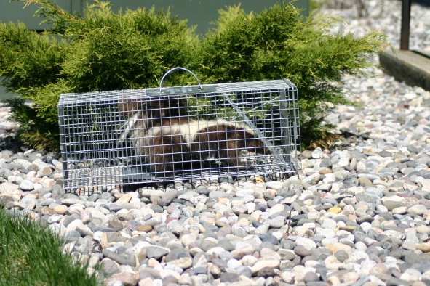
Skunks are primarily carnivores. Insects are their preferred food, but mice make up most of their winter diet. Skunks begin breeding in late February and, after a gestation period of seven to 10 weeks, a litter of four to six is born. The normal home range has a diameter of between ¼ mile and two miles. But during breeding season, males may travel four to five miles each night. Skunks are dormant for about a month during the coldest part of winter. Skunks usually live in open lands bordering forests or brushy draws.

Skunks become problems when they visit homes or damage garden crops. They may burrow under porches or buildings, and they dig in gardens and lawns searching for insects and grubs. They make 3-4 inch cone-shaped holes when digging for grubs. Skunks occasionally kill poultry and eat eggs. They are a primary carrier of rabies in much of the country. A skunk acting unusually aggressive and active during the day may have rabies and should be approached with caution.

Certainly, the most common concern about skunks is their discharge of scent when they confront potential danger. Skunks have distinctive tracks with five toes on both the front and hind feet. Claw marks are usually visible. You can usually identify skunk droppings by the undigested insect parts they contain.

Habitat Modification

Skunks are often attracted to an area because of the availability of food or shelter. Remove pet food, garbage and any other food attractions such as compost piles and bird seed. It may be necessary to implement a rodent control program to eliminate this important food source.

Stack lumber at least two feet off the ground to discourage skunks from using them as shelter.

Exclusion

Plug all openings under buildings with wire mesh, sheet metal or concrete after you are certain that it is not being used by an animal.

Bury fencing 1 foot into the ground where skunks might gain access by digging. Bend the bottom six inches outward to make the buried fence more effective. Be sure to close doors at night and cover window wells or similar pits with mesh fencing.

If a skunk is already established under a building, you must take care not to enclose it inside. Sprinkling a layer of baking flour in front of the entrance the night before it is closed off will allow you to observe tracks. Close off the hole if there are no tracks or if the tracks are exiting only.
Another way to determine if an animal is using a building is to place a “soft plug,” such as a paper towel or crumpled newspaper, in the hole and check the next day to see if it has been pushed out. If the soft plug is still intact, you can assume the skunk is not using the hole.

In spring be cautious about blocking young, non-mobile skunks inside the building. It may be necessary to delay trapping until the young skunks are moving about.

Repellents

There are no registered repellents for skunks. Mothballs and ammonia soaked clothes have been used as temporary repellents for skunks. Because of the great amount needed and the necessity to replace often, these are only very temporary solutions at best.

Trapping

Skunks can be removed from an area by trapping them. Because of the odor problems inherent in trapping skunks, cage and box traps are usually preferred to foothold traps. Remember to check your state’s regulations before using any type of trap.

Canned, fish-flavored cat food is the best bait for skunks. Before setting the trap, cover it with canvas (or other non-transparent material) to reduce the chances of the trapped skunk discharging its scent.

Always approach a trap slowly and quietly so you don’t upset a trapped skunk. If you plan to release a trapped skunk, take it at least 10 miles from the trap site. Skunks can be dispatched by drowning them while they are still in the cage trap.

Skunks that fall in window wells or pits should be allowed to remove themselves by climbing a cleated board. Nail one-inch by two-inch cleats, six inches apart to a board and slowly lower it into the well.

Skunks are mild-tempered and very tolerant of activity if it is very, very slow. Before discharging their scent, skunks usually provide a warning by stamping their forefeet and arching their tails over their backs. If a threat occurs, simply retreat quietly and slowly. Obviously, you should avoid loud noises and quick, aggressive actions.

Scent Discharge

The scent discharged by a skunk is persistent and difficult to remove. A formula has been developed to neutralize skunk odor. Mix one quart of three percent hydrogen peroxide with one-quarter cup baking soda and one teaspoon of liquid soap. Hydrogen peroxide is available from pharmacies. Soak the area, or pet, to be treated with water, scrub with the mixture and then rinse again in warm water. This solution may cause bleaching. Use cautiously because it may turn your black lab into a chocolate lab. Also DO NOT STORE this mixture as it could explode. Always mix in an open container. Keep away from eyes and mouth.

If the scent is discharged in a room or under a building and the yellow discharge cannot be washed away, ventilate the area to speed up dissipation of the scent. Use ventilation fans to improve air circulation.

Acknowledgments
Much of the information presented here was adapted from S.E. Hygnstrom (1994) in Prevention and Control of Wildlife Damage, University of Nebraska, Lincoln, NE. Ideas from Colorado State University Extension were also included.
This information is for educational purposes only. Reference to commercial products or trade names does not imply discrimination or endorsement by the Montana State University Extension Service.

Non chemical control of raccoons
Jim Knight, Extension Wildlife Specialist, Montana State University
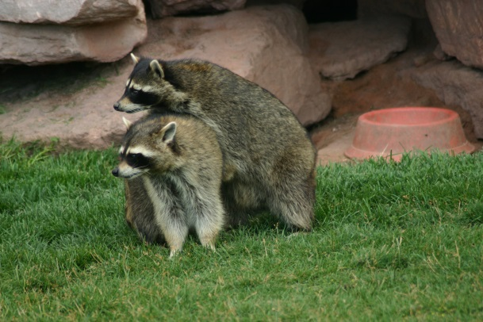

Raccoons can be large animals weighing as much as 50 pounds, although most are between 10 and 30 pounds. They are normally found around water but raccoons can travel quite far from naturally occurring water sources. Raccoons are omnivorous. Their diet consists of fruits, berries, nuts, corn, other grains, crayfish, clams, fish, frogs, snails, insects, eggs, mice, rabbits and the eggs and young of ground-nesting birds. Raccoons breed mainly in February and March. After a gestation period of 63 days, three to five young are born.
Raccoons leave distinctive, five-toed tracks. The damage they inflict varies from killing poultry and scattering garbage to devouring sweet corn and preying on ground-nesting birds and waterfowl.
Habitat Modification
Reducing raccoon problems by modifying or making changes to the habitat is usually only possible by eliminating food or shelter sources in areas around homesteads.
Exclusion
Exclusion is usually the best method of coping with raccoons. Electric fencing at the top of a poultry-yard fence will prevent them from climbing, but gates and fencing must be tight to the ground. Raccoons are capable of digging but usually try to gain access in other ways. Electric wire can also be effective in stopping coon damage to melon and sweet corn patches. A single or double hot wire six to 10 inches above the ground works best. Use wire or clamps to keep raccoons out of garbage cans that do not have tight-fitting lids. Place aluminum flashing or galvanized sheet metal around trees or poles to prevent raccoons from climbing.
Repellents and Frightening Devices
Frightening devices for raccoons have not proven to be effective in the long term. Lights, radios, dogs, pie pans and plastic windmills are only effective temporarily. There are no repellents, toxicants or fumigants currently registered for the control of raccoons.
Trapping
Trapping is often the most logical way to stop raccoon damage. They are relatively easy to trap, but because they are extremely strong and persistent, the trap must be sturdy.
Be sure to check state and local regulations before using traps to catch raccoons.
A cage trap is often the most logical trap to use around homesteads. These traps need to be at least 10 by 12 by 32 inches and well-constructed with heavy materials. Bait the trap with a fish-based, canned cat food. Place a thumbnail-sized piece at the entrance, another on the treadle and a larger amount in a paper cup broken off to one inch. Place the cup in the center of the trap’s back section. If the raccoon is to be released, take it at least 20 miles from the trap site.
Conibear®, or body-gripping traps, are very effective as long as there is no risk of capturing a pet or some other animal you don’t intend to trap. Place these kill-type traps in trees in a way that makes the raccoon go through the trap to get to the bait. Remember the risks to non-target animals when using body-gripping traps. Be sure to check regulations before using any type of traps.
Foothold traps are an effective way to catch raccoons. Again, be sure you will not trap any animal you do not wish to harm. A number 1 or 1 ½ size trap works for raccoons. Make a set by placing bait in a small hole and concealing the trap under a light covering of soil in front of the hole.
Encapsulated foot traps (also known as dog-proof traps) are designed to catch only raccoons and greatly reduce the chance of catching non-target animals. They use a trigger mechanism that requires the raccoon to reach into a steel cylinder and grasp the bait When the raccoon attempts to pull the bait out the trap is triggered and the paw of the raccoon is entrapped.
When using any foot traps, always locate them at least 3 feet away from sensitive items the raccoons will damage if they can reach them.
Acknowledgments
Much of the information presented here was adapted from S.E. Hygnstrom (1994) in Prevention and Control of Wildlife Damage, University of Nebraska, Lincoln, NE.
This information is for educational purposes only. Reference to commercial products or trade names does not imply discrimination or endorsement by the Montana State University Extension Service.

Non chemical control of coyotes
Jim Knight, Extension Wildlife Specialist, Montana State University
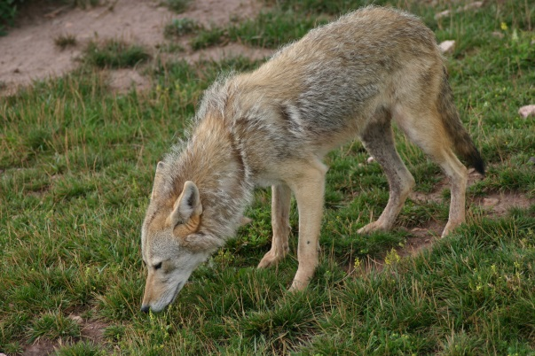
Coyotes are opportunistic feeders with a diet that includes mice, rabbits, fawns, insects, fruit, berries and other vegetative matter. Landowners become concerned when coyotes prey on livestock. Livestock loss is usually greater in the spring and summer because the demands on coyotes are greater due to pup-rearing and the fact that wild prey are not as vulnerable as they were in deep snow conditions. During this time, young livestock are most vulnerable.

Just because coyotes are present or you see them feeding on carcasses does not mean they are preying on your livestock. Dogs kill more livestock than is commonly believed.

Coyotes are frequent scavengers, so landowners must look for evidence of livestock killing before making conclusions. Look for signs of a struggle and blood around the site. Look for blood hemorrhage under the skin at the point of attack. Bites to a dead animal do not hemorrhage because the heart is not pumping blood. Coyotes usually kill by biting the throat and compressing the trachea of sheep-size animals. Their prey usually dies of strangulation, but there is a great deal of damage under the skin in the throat area.

Coyotes usually begin feeding at the flanks or behind the ribs, consuming the liver, heart and lungs first. Coyotes usually kill calves by attacking the hind end.

Be sure to check state regulations relating to various types of coyote control.

Cultural Methods

Many ranchers minimize coyote predation by reducing the exposure of vulnerable animals. For example, shortening lambing or calving periods may reduce predation.

Keeping lambs and calves close to the house or hiring a herder until the young gain some size has worked for some producers. Confining sheep at night is one of the most effective means of reducing losses to predation.

Removing dead sheep and cattle is an important practice that eliminates attractions for coyotes and keeps them from getting accustomed to feeding on livestock. A study in Canada showed that removing livestock carcasses significantly reduced over-winter coyote populations and shifted coyote distributions out of livestock areas.

Exclusion

Coyotes can be kept out of corrals or livestock pens by a net-wire fence attached tightly to the ground. You can prevent climbing by adding a charged wire to the top of the fence. You can discourage digging by placing barbed wire at ground level or burying a wire apron.

Electric fencing has met with limited success as a coyote barrier. In addition to being expensive, the 10 to 13 strands of wire become difficult to maintain. Coyotes pass under the fences at low spots. If the fence is tight to the ground, it may cause a short.

Frightening Devices

Frightening devices work for short periods of time. These devices are primarily useful to deter coyote predation until other practices can be put into place. Lights over corrals are one of the most effective short-term frightening devices. Propane exploders and sirens will scare coyotes but their use is limited because of the disruption to livestock.

Radios tuned to stations with human voices rather than music will temporarily deter coyotes.

A parked vehicle may deter coyotes in rural areas, especially if it is occasionally moved. When coyotes get used to it, it makes a comfortable coyote hunting blind.

Trapping

The most common method of controlling a coyote problem is through foothold traps or snares. Traps hold coyotes by the foot until they can be dispatched. Snares are placed in trails or at places coyotes crawl through fences. When the coyote passes through, the snare tightens on their neck and strangulation occurs. Landowners should contact an experienced trapper if they employ these methods because there are complex and detailed techniques that will make these methods most effective.

If you’re going to trap, taking time to learn how to properly trap or snare coyotes is a worthwhile undertaking. There are excellent DVD’s available through trapping supply sources online. Without a doubt, the best way to learn to trap or snare is through training from an experienced trapper.

The Collarum® is designed to capture coyotes and other canines by throwing a cable loop over their head and around the neck. The end of the capture loop is anchored in the ground and the animal is held like a dog on a chain. This trap may be desirable in areas where people, pets and other domestic animals may come in contact with it.
Other Methods

If they are properly selected and trained, guardian animals such as llamas, donkeys and dogs can successfully protect sheep from coyotes. The protective nature of dogs makes them effective. Donkeys and llamas usually have an inherent dislike of dogs and other canids, including coyotes. Donkeys respond to intruding coyote by braying, baring teeth, kicking and biting.

Coyotes may respond to predator calls. This method of coyote control may be the most practical for landowners that only have occasional coyote problems. In its simplest form, coyote calling takes advantage of a coyote’s response to a dying rabbit sound. When the coyote comes to investigate, you can shoot it. Again, DVD’s or help from an experienced coyote caller will provide initial knowledge.

Acknowledgments
Much of the information presented here was adapted from S.E. Hygnstrom (1994) in Prevention and Control of Wildlife Damage, University of Nebraska, Lincoln, NE. Ideas from Colorado State University Extension were also included.
This information is for educational purposes only. Reference to commercial products or trade names does not imply discrimination or endorsement by the Montana State University Extension Service.

