Table 1. Production alfalfa fields surveyed in 2012 and 2013 with additional site information.
Site | Year Surveyed | Sampling Date Range | Insecticides | Size (hectares) | Irrigation Type | Surrounding Crops | Additional Landscape Features
Field A | 2012 | May/8 - Sept/12 | Untreated | 1.8 | Wheel-line overhead sprinkler | Alfalfa, Grass Hay | Rural housing, river, paved roadways
 | 2013 | May/13 - Sept/24 | Untreated
Field B | 2012 | May/8 - Sept/12 | Untreated | 3.5 | Wheel-line overhead sprinkler | Alfalfa, Grass Hay | Rural housing, river, paved roadways
 | 2013 | May/13 - Sept/24 | Untreated
Field C | 2012 | May/25 - Aug/27 | Lambda-cyhalothrin | 5.5 | Flood | Alfalfa | Rural housing, paved & unpaved roadways
Field D | 2012 | May/21 - Aug/27 | Lambda-cyhalothrin | 2.9 | Wheel-line overhead sprinkler | Alfalfa | Paved & unpaved roadways
Field E | 2013 | May/21 - Sept/5 | Unknown | 6.2 | Flood | Alfalfa | Rural housing, paved roadways
Field F | 2013 | May/21 - Sept/5 | Uknown | 6.9 | Flood | Alfalfa | Rural Housing, paved roadways, pasture
Field G | 2013 | May/13 - Sept/24 | Untreated | 3.6 | Flood | Alfalfa, Corn | Rural housing, river, marshland, cattle feedlot, paved & unpaved roadways
 | 2012 | May/8 - Sept/5 | Chlorpyrifos
Field H | 2012 | May/29 - Aug/22 | Untreated | 2.1 | Wheel-line overhead sprinkler | Alfalfa, Corn | Paved roadways
 | 2013 | May/13 - Sept/24 | Untreated
Field I | 2012 | May/29 - Sept/5 | Untreated | 8.1 | Wheel-line overhead sprinkler | Alfalfa, Barley | Rural housing, pasture, marshland, paved & unpaved roadways
 | 2013 | May/13 - Sept/24 | Untreated
Field J | 2013 | May/13 - Sept/24 | Untreated | 2.2 | Hand move surface sprinkler | Alfalfa | Industry building, parking lot, four-lane highway, paved roadways
 | 2012 | May/8 - Sept/5 | Treated-Unknown
Field K | 2013 | May/13 - Sept/30 | Lambda-cyhalothrin | 7.5 | Wheel-line overhead sprinkler | Alfalfa, Oats, Wheat | Paved & unpaved roadways, pasture
 | 2012 | May/8 - Aug/22 | Lambda-cyhalothrin
Field L | 2013 | May/13 - Sept/24 | Lambda-cyhalothrin | 5.0 | Wheel-line overhead sprinkler | Alfalfa, Oats, Wheat | Paved & unpaved roadways, pasture
 | 2012 | May/21 - Aug/22 | Lambda-cyhalothrin

Table 2. Number of fields sampled in each treatment per sampling date.
2013 |  |  |  | 2012
Sampling Date | n untreated | n treated |  | Sampling Date | n untreated | n treated
May/13 | 6 | 2 |  | May/8 | 3 | 3
May/21-24 | 6 | 4 |  | May/21-29 | 4 | 6
June/4 | 5 | 2 |  | June/15-17 | 4 | 5
June/27 | 6 | 4 |  | June/29 | 4 | 6
July/8 | 5 | 4 |  | July/17-19 | 3 (suction) | 5
Aug/5 | 6 | 3 |  | Aug/1-9 | 4 | 6
Aug/16 | 5 | 4 |  | Aug/14-27 | 2 | 6
Sept/5 | 2 | 2 |  | Sept/5-12 | 3 | 2
Sept/24-30 | 6 | 2

2012
Figure 1. Graphs of average predator abundance of adult and immature life stages across treated and untreated fields captured in sweep net and suction samples in 2012. The red arrow indicates the time at which insecticides were applied.

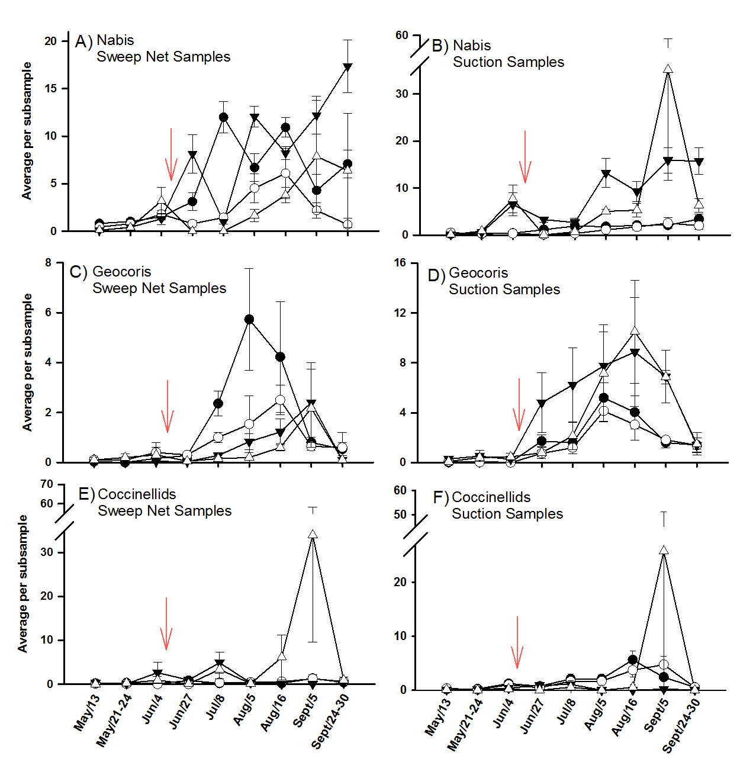
2013

Figure 2. Graphs of average predator abundance of adult and immature life stages across treated and untreated fields captured in sweep net and suction samples in 2013. The red arrow indicates the time at which insecticides were applied.

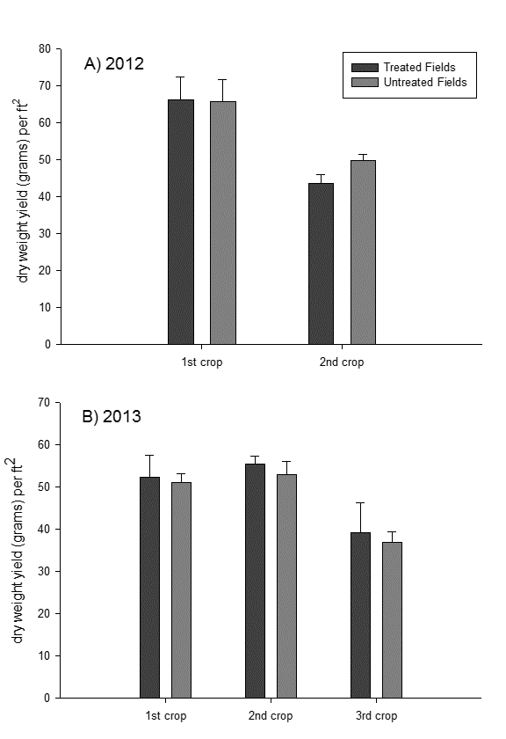
Figure 3. Yield comparison for treated and untreated fields in 2012 (A) and 2013 (B). No statistical differences (p>.05) were found in yield between treated and untreated fields for each crop in both years

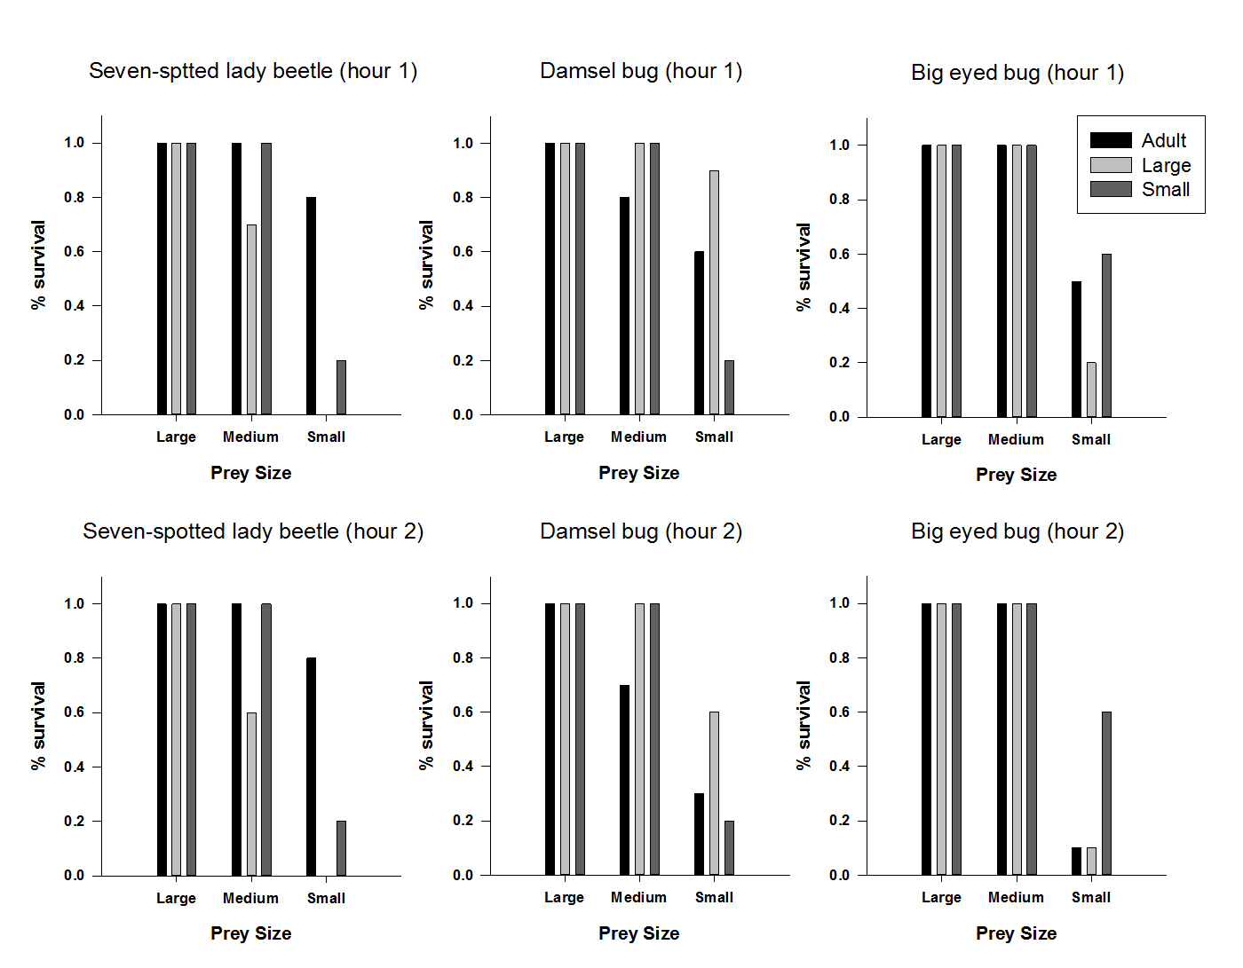
Figure 4. Proportion of beet armyworm larvae surviving at the end of the first hour (top row) and the second hour (bottom row) of predator treatments consisting of adult life stages (black), large instars (light gray), and small instars (dark gray).

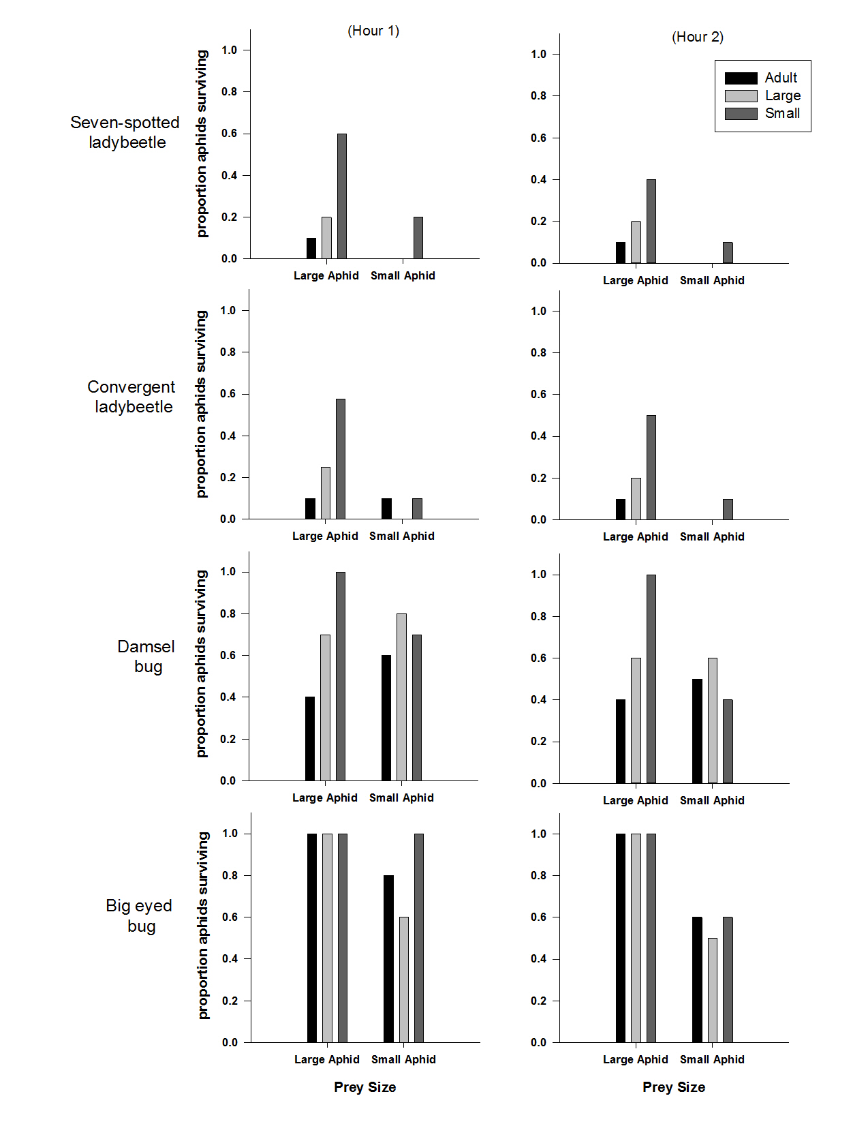Figure 5. Proportion of pea aphids surviving at the end of the first hour (left column) and the second hour (right column) of predator treatments consisting of adult life stages (black), large instars (light gray), and small instars (dark gray).
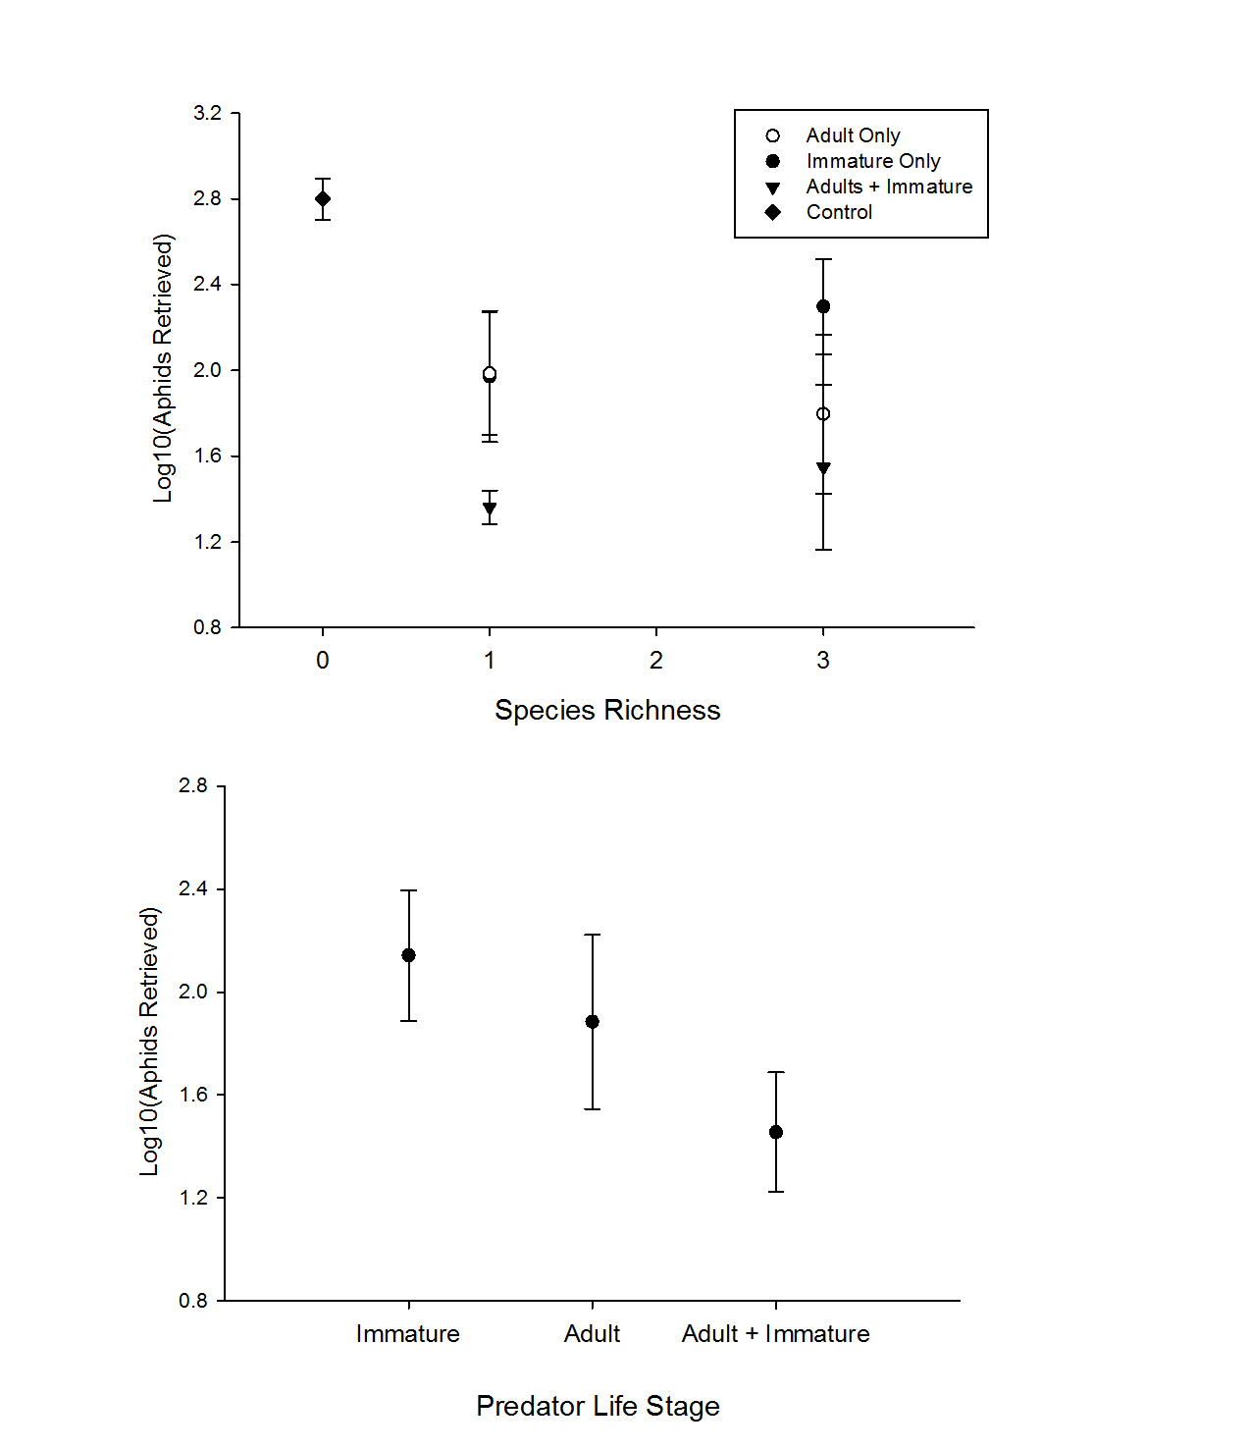

A)

B)

Figure 6. Average number of LOG₁₀ (pea aphids) remaining in cages at the end of the two week cage experiment grouped by species richness (a) and by presence of life stages (b).

