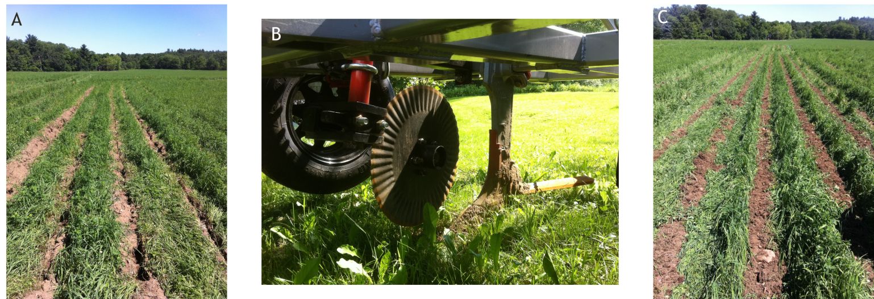
Figure 1. Several of the treatments examined in 2012 pilot study at the UNH Organic Dairy Research Farm (A) View of T2 treatment immedealty after a pass with the Yeoman’s plow; (B) Yeoman’s Plow with undercut bar used in T3 treatment; (C) strip-till (T4) treatment prior to planting corn.

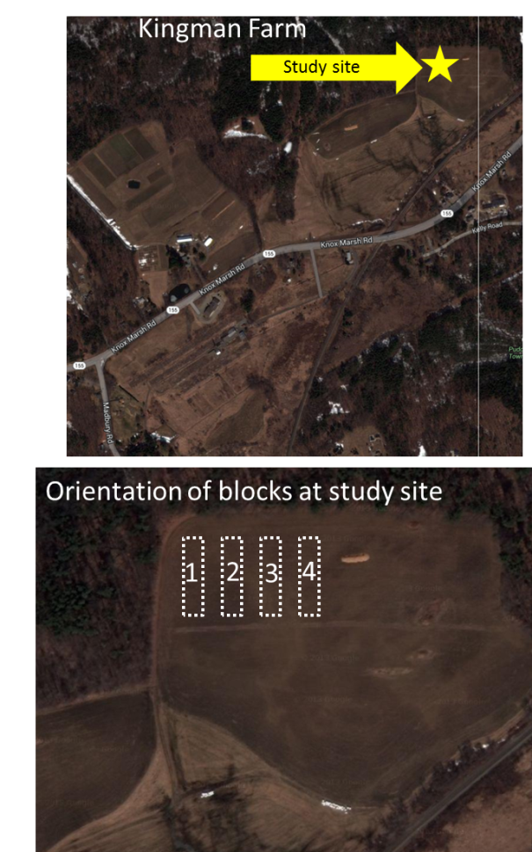
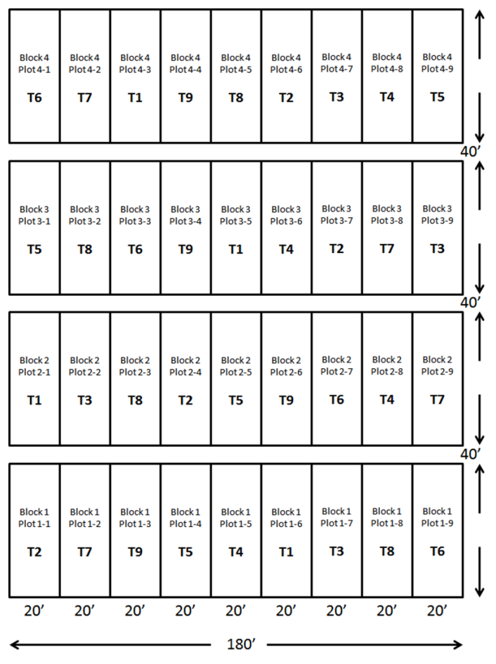
Figure 2. The experiment was expanded to nine treatments and moved to the UNH Kingman Resarch Farm in Madbury, NH in 2013. (Left) Plot lay-out of nine treatments, each replicated four times, and organized in a randomized complete block design; (Right) location of the experimental study site at the Kingman Research Farm(top right) and orientation of blocks (bottom right).

