Figure 11. A) Aerial photo taken of the corn crop (2013) at Kingman Research Farm. Lodged corn (which can be seen in the center two treatment plots) was a common feature of the treatments that relyed on mowing for alfalfa suppression prior to corn planting. B) A “stitched” aerial photo of all four replicate blocks. Both sets of imagery were taken by Dorn Cox, a local farmer and Farm Hack member who visited the farm to learn more about our experiment and capture aerial imagery with an unmanned aerial vehicle (UAV).
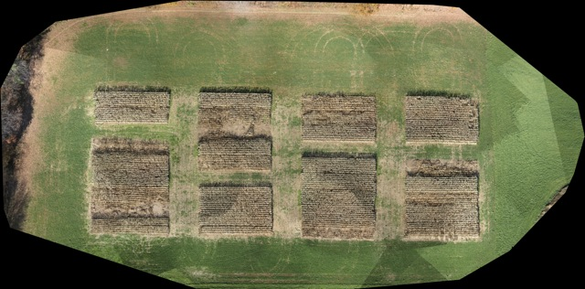
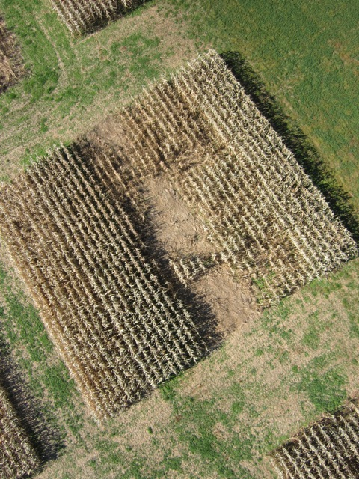
B
A

