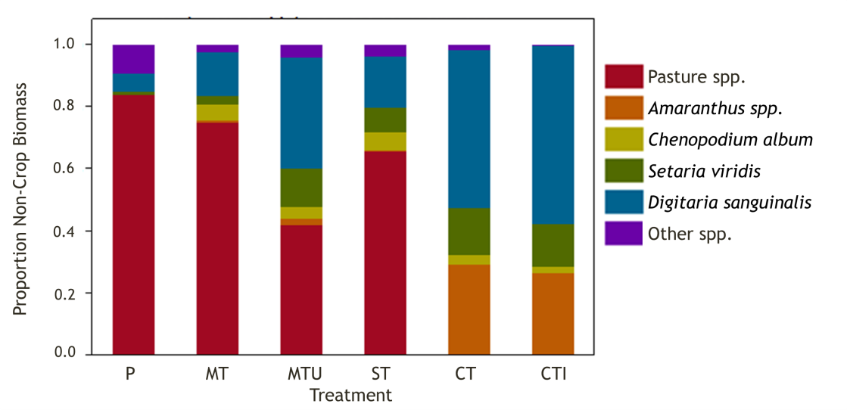

**Figure 3.** Weed and pasture biomass in August 2012 as a percent of total non-crop biomass for each treatment. Treatments are P, pasture control (T1); MT, Yeoman’s plow (T2); MTU, Yeoman’s plow with undercut knives (T3); ST, strip-till (T4); CT, conventional moldboard plow (T5); and CTI, conventional moldboard plow with interseeded crimson clover at final cultivation (T6). Y-axis is scaled from 1-0 with 1 = 100%.

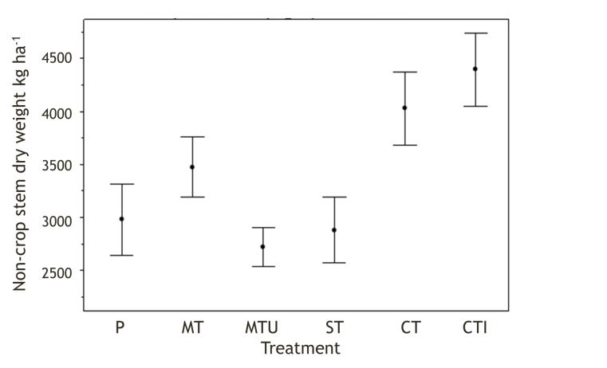

**Figure 4**. Total non-crop biomass in August 2012 in each treatment. Treatments are P, pasture control (T1); MT, Yeoman’s plow (T2); MTU, Yeoman’s plow with undercut knives (T3); ST, strip-till (T4); CT, conventional moldboard plow (T5); and CTI, conventional moldboard plow with interseeded crimson clover at final cultivation (T6). Data are means ± SE.

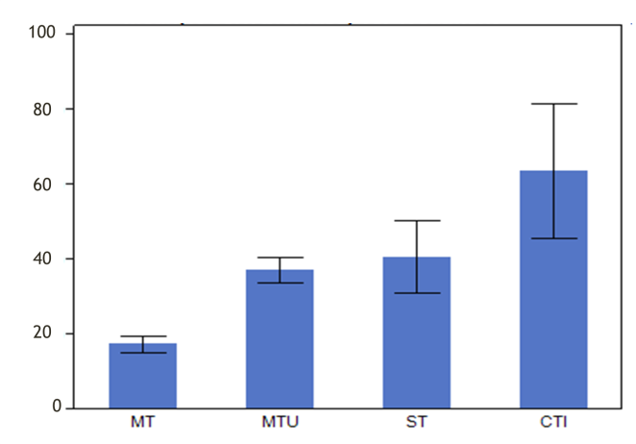

**Figure 5.** Corn biomass in each planted treatment as a percentage of the yield in the conventionally tilled treatment T5 (CT). Treatments are MT, Yeoman’s plow (T2); MTU, Yeoman’s plow with undercut knives (T3); ST, strip-till (T4); CT, conventional moldboard plow (T5); and CTI, conventional moldboard plow with interseeded crimson clover at final cultivation (T6).

**Figure 6.**

Weed and pasture biomass as a percent

of total non

-

crop biomass for each treatment

.

Measured in spring 2013.

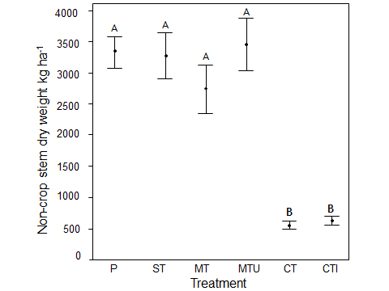

**Figure 7.**

Total non

-

crop biomass per

treatment

in spring 2013.

Data are means

±

SE. Bars

sharing the same letter are not significantly

different at P<0.05 (

Tukey’s

HSD

Test)

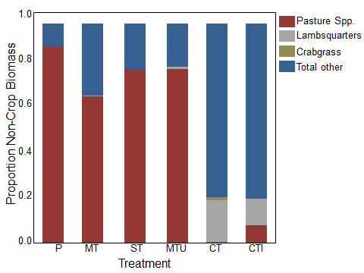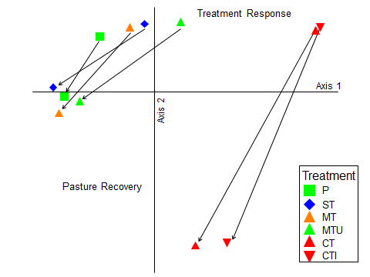

**Figure 8.** (A) NMDS ordination of plant species composition and abundance in each treatment in summer 2012 and spring 2013; symbols are plots (r2 of axis 1 and 2 = 0.96). (B) Same data; symbols are treatment centroids; arrows show change in species composition and abundance in each treatment from summer 2012 to spring 2013. Treatments are P, pasture control (T1); MT, Yeoman’s plow (T2); MTU, Yeoman’s plow with undercut knives (T3); ST, strip-till (T4); CT, conventional moldboard plow (T5); and CTI, conventional moldboard plow with interseeded crimson clover at final cultivation (T6).

A

B



**Figure 9.** Total weed biomass in corn in all treatments in late August (top panel) and in the subsequent spring prior to planting soybean (bottom panel).Treatments are arranged along the x-axis according to the method used to suppress the existing alfalfa stand prior to corn planting. Higher annual weed abundance at the time of planting (June 2014) may be a potential tradeoff associated with intense soil disturbance and complete elimination of the perennial plant community. While these practices (e.g., full tillage) resulted in high corn grain yields in 2013, they will likely necessitate additional weed management prior to planting the next crop in the rotation. Data are means ± SE, n = 4.

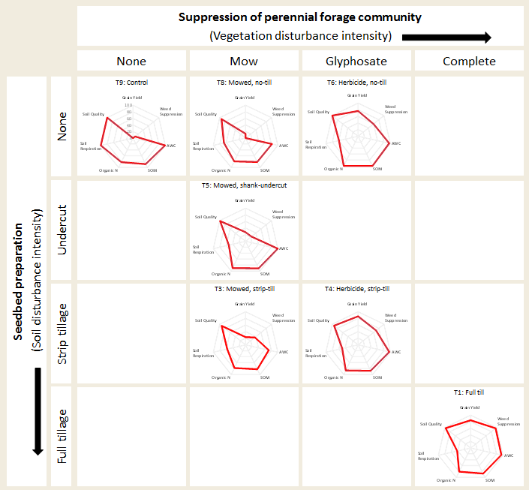**Figure 10.** Here we report on select ecosystem service indicators for seven of the nine treatments. The suite of indicators are presented as “spider plots.” Each indicator axis has been relativized based on the highest value observed for that indicator among the nine treatments. For example, the treatment with the highest grain yield is assigned a score of 100. Grain yield scores for all other treatments are then represented as a percentage of this maximum yield. Low scores for a given indicator represent low values for ecosystem service indicators relative to the higher performing treatments; thus, asymmetries in the “spider web” represent potential ecosystem service tradeoffs among system treatments. Ecosystem service and soil quality indicators are: AWC, soil available water content; SOM, soil organic matter; Organic N, fraction of SOM that is organically bound N; Soil Respiration; Soil Quality, a composite index based on the full suite of biological, chemical, and physical soil indicators measured by the CSHT. Relative to the control (T9) most treatments resulted in slightly lower scores for non-provisioning ecosystem service indicators.

T1: Full till