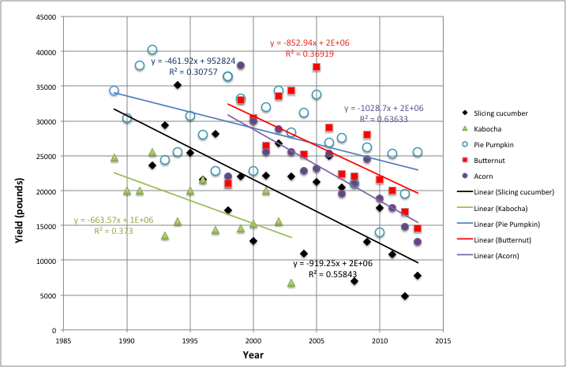

Fig. 1. Yield of cucurbit crops over 25 years of a strict 4 year cucurbit rotation.

