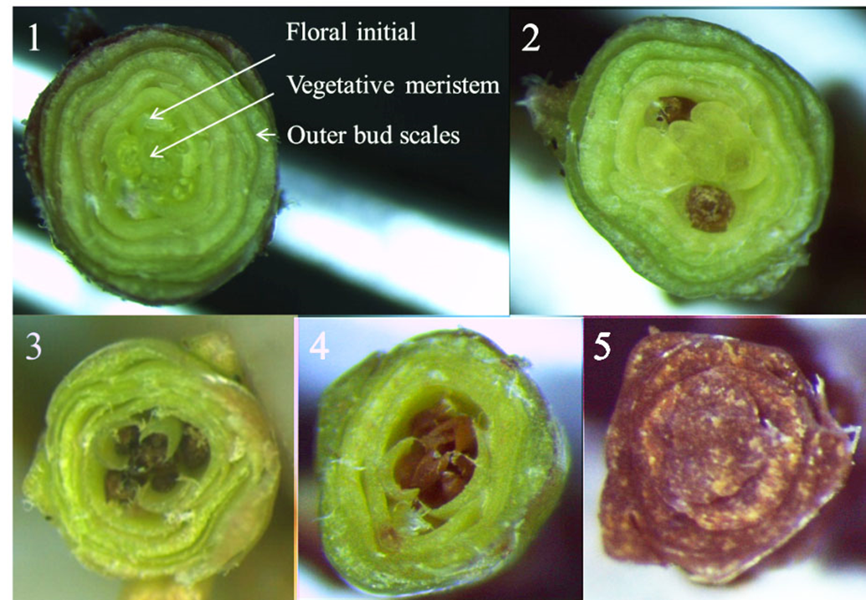

Image. 1. Images of the cross-section of cranberry buds evaluated under a microscope, illustrating different levels of frost bud damage (1) no damage in either floral or vegetative meristems (2) no damage in the vegetative meristem but some damage in one or two floral meristems (3) damage in all floral meristems (4) damage in the vegetative meristem (5) all internal tissues damaged (dead).

