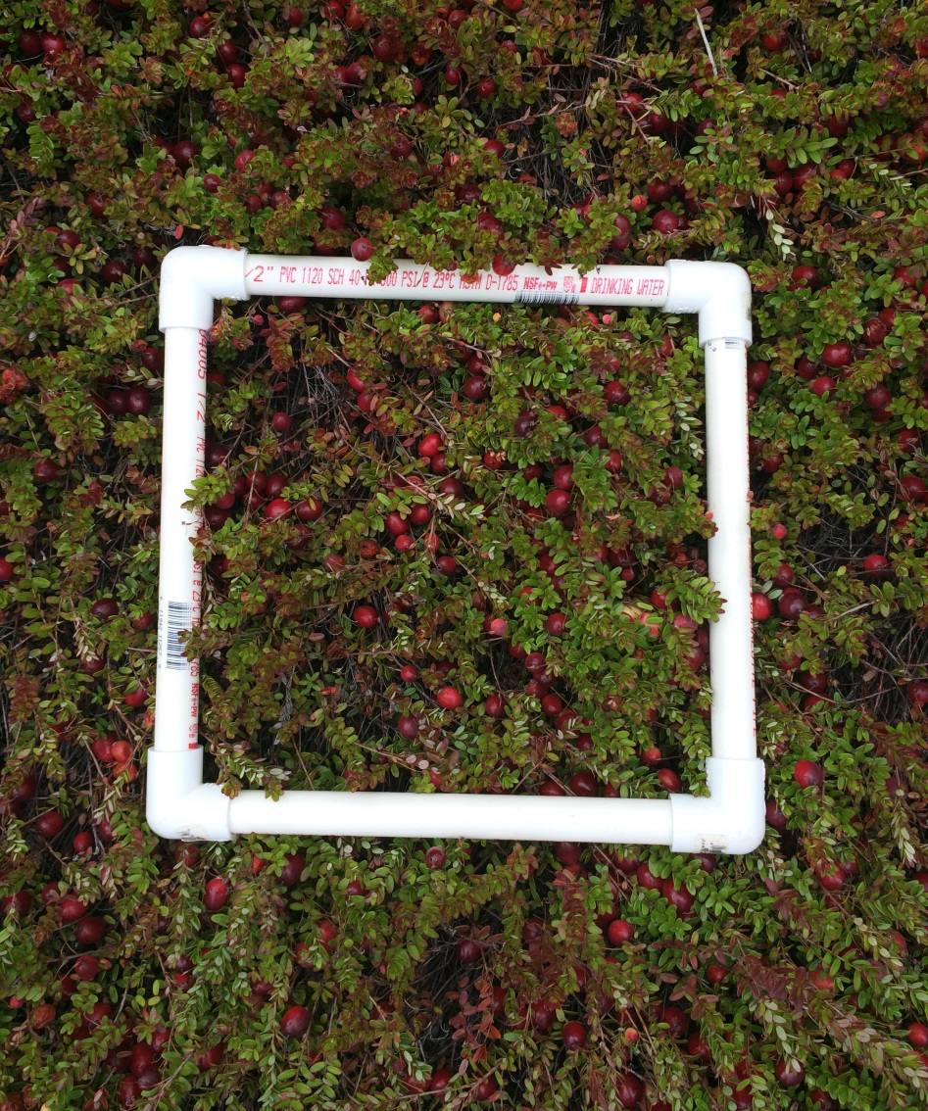
Image. 2. Quadrat (25 × 25 cm) used for sampling yield estimates on cranberry bogs in Massachusetts

