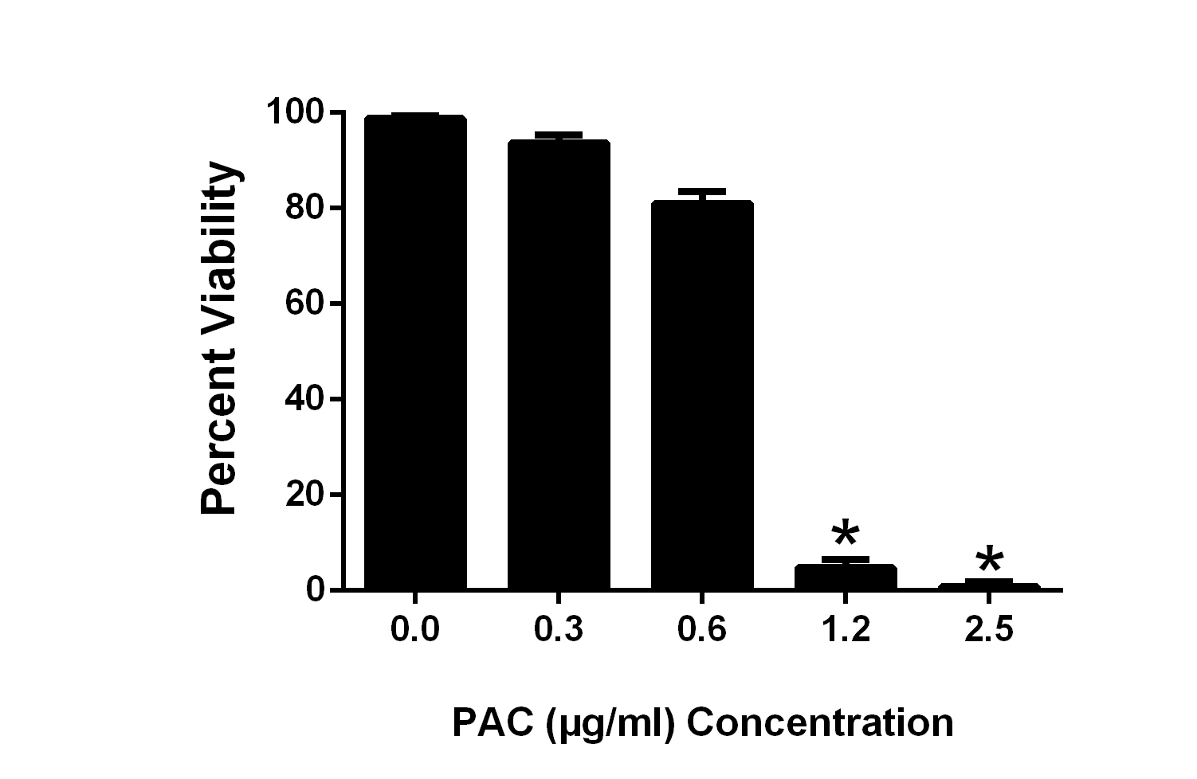

Figure 3. Effect of varying concentrations of cranberry leaf PAC extract on mortality of L1 Haemonchus contortus larvae hatched from eggs incubated for 48 hours in PAC extract.

