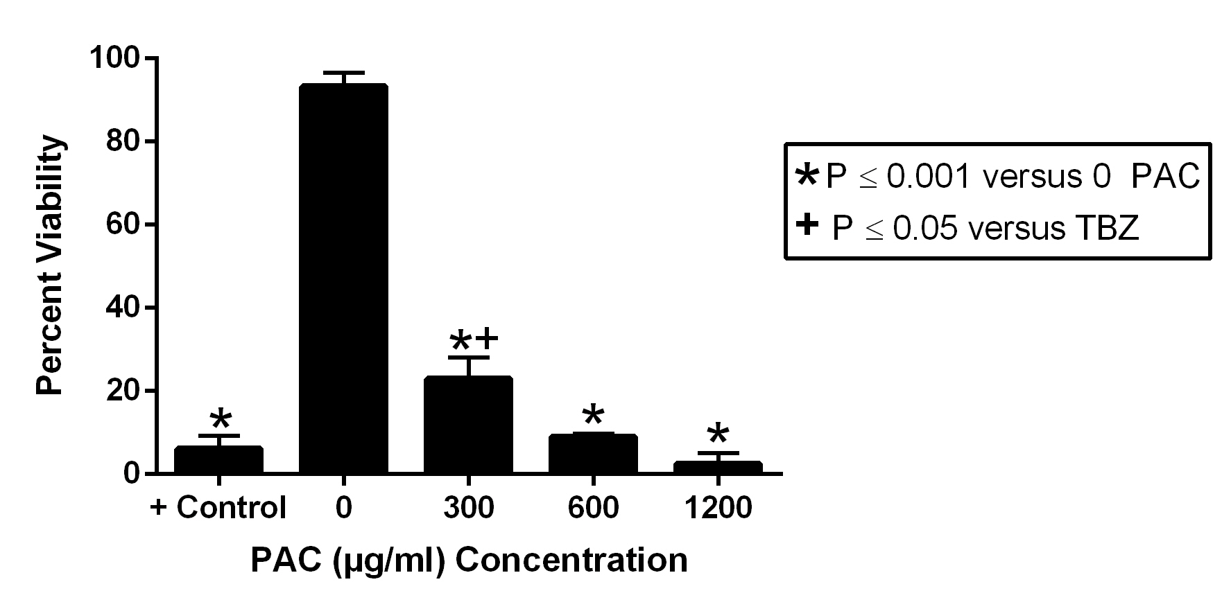

Figure 4. Effect of varying concentrations of cranberry leaf powder PAC extract on adult H. contortus wormed obtained from the abomasum of lambs experimentally infected with H. contortus. Adult worms were incubated in PAC extract or positive control (thiabendizole) for 48 hours.

