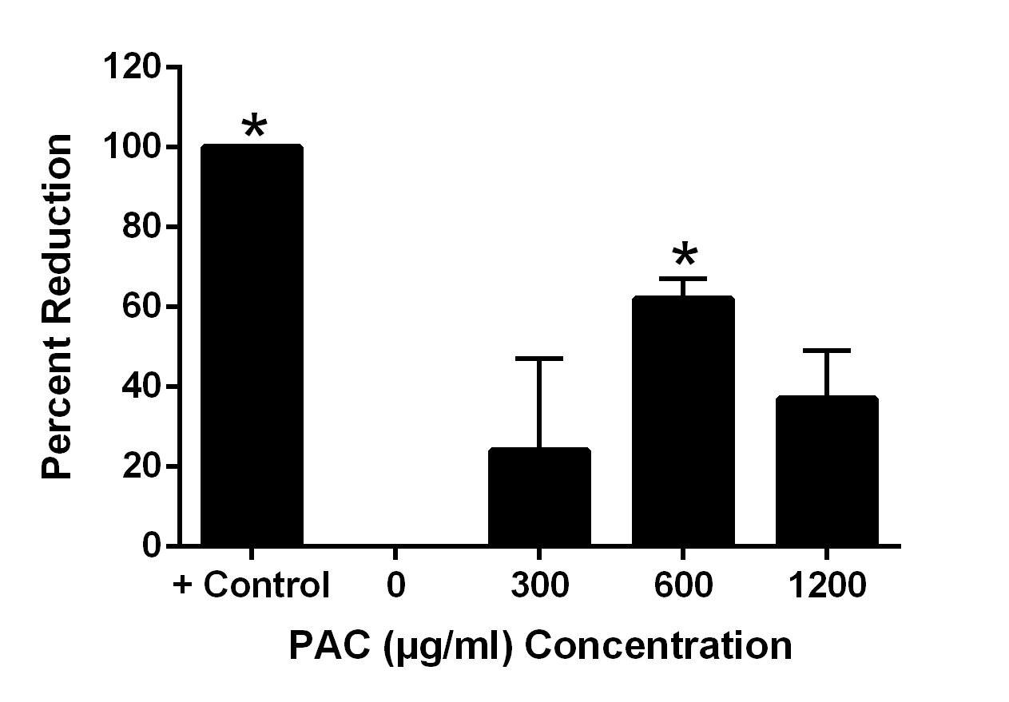

Figure 5. Effect of varying concentrations of cranberry leaf powder PAC extract on quantitative coproculture of feces from lamb experimentally infected with H. contortus. Positive control is thiabendazole, a commercially available anthelmintic.

