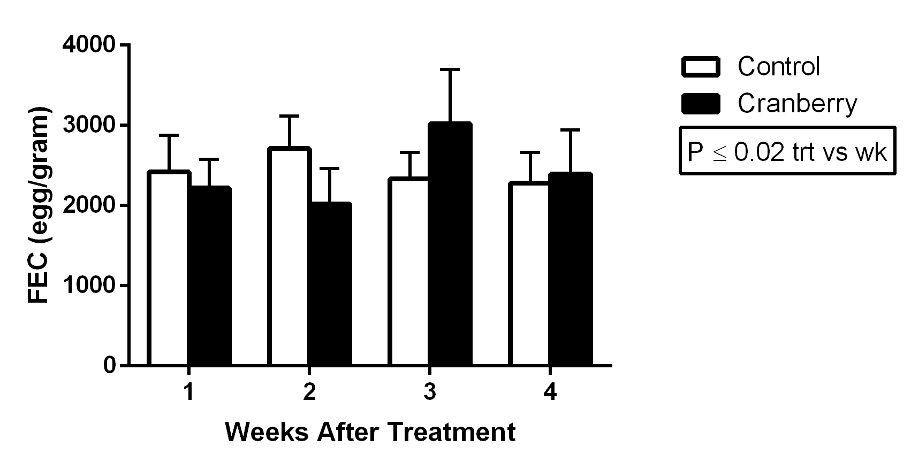

Figure 6. Effect of cranberry leaf powder (26 gm, n=9) or placebo (n=9), administered once daily for three days, on fecal egg count in lambs experimentally infected with 10,000 infective Haemonchus contortus larvae.

