**Table 1. The maize diversity panel for this project consists of both experimental inbreds and commercial hybrids.**

|  |  |  |  |  |
| --- | --- | --- | --- | --- |
| Name | Type | Source | Maturity, days | Seedling Vigor* |
| B73 | NAM founder inbreds | Maize Genetics Cooperation Stock Center |  |  |
| B97 |  |  |
| CML103 |  |  |
| CML228 |  |  |
| CML247 |  |  |
| CML277 |  |  |
| CML322 |  |  |
| CML333 |  |  |
| CML52 |  |  |
| CML69 |  |  |
| Hp301 |  |  |
| Il14H |  |  |
| KI11 | N/A | N/A |
| Ki3 |  |  |
| Ky21 |  |  |
| M162W |  |  |
| M18W |  |  |
| Mo17 |  |  |
| MS71 |  |  |
| NC350 |  |  |
| NC358 |  |  |
| Oh43 |  |  |
| Oh7b |  |  |
| P39 |  |  |
| Tx303 |  |  |
| Tzi8 |  |  |
| 71PM50 | Organic commercial hybrids | Blue River Organic Hybrids | 82 | 4 |
| 58PM36 | 96 | 4 |
| 40R73 | 105 | 4 |
| 59H44 | 108 | 4 |
| 43L96 | 113 | 4 |
| 56M30 | 94 | 3 |
| 76H50 | 99 | 3 |
| 14A91 | 102 | 3 |
| 67H19 | 114 | 3 |
| 41R00 | 116 | 3 |

**\***Seedling vigor and maturation time assessed by the Blue River Organic Hybrids.

**Table 2. The *F. graminearum* diversity panel for this project consists of isolates collected in upper New York States that have been tested for aggressiveness on maize seedlings *in vitro*.**

|  |  |  |  |  |  |  |
| --- | --- | --- | --- | --- | --- | --- |
| Isolate ID | Host of Origin | Collection Information | Year | Genotype | ca. % MSB* |  |
| Gz014NY98 | Wheat | Varna, NY (1998) | 1998 | 15-ADON | 70 |  |
| Gz835NY11 | Maize | Union Springs, NY (2011) | 2011 | 15-ADON | 22 |  |
| Gz978NY12 | Maize | bulk sample, Ag Pride, NY | 2012 | 15-ADON | 30 |  |
| Gz970NY12 | Maize | bulk sample, Ag Pride, NY | 2012 | 3-ADON | 59 |  |
| *Percent maize seedling blight incident determined from laboratory inoculation tests by Kuhnem et al., 2014 | | | | | |  |

**Figure 1. Natural variation of *F. graminearum-*induced changes in different benzoxazinoid compounds among selected maize NAM founder inbred lines is organ-specific.**

Plants grown in germination pouches inoculated with *F. graminearum* strain ZTE-2A spore suspension (1.00E6 spores/mL). Tissue harvested 3 days post inoculation; p value calculated from two-tailed Student’s t test (*p<0.05; **p<0.01; ***p<0.001; n>4); error bars represent s. d.**A.** root DIMBOA-Glc; **B.** root HDMBOA-Glc; **C.** leaf DIMBOA-Glc; **D.** leaf HDMBOA-Glc.

**Figure 2. A novel UV absorption peak representing a mixture of compound is observed and only observed in leaves of *F. graminearum* inoculated CML322 seedlings.**

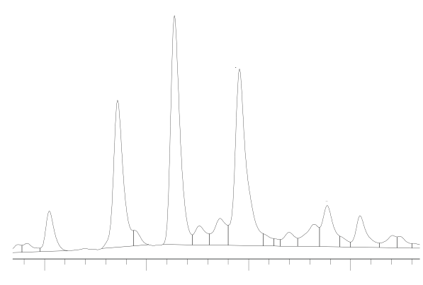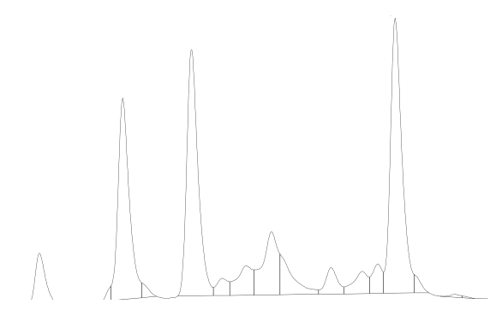

*

**A**

**B**

a

b

c

a

b

c

*



**14**

**16**

**18**

**20**

Retention Time (min)

Chromatograms obtained from ten-days old CML322 seedlings inoculated with *F. graminearum* strain ZTE-2A spore suspension (1.00E6 spores/mL; A) or 0.03% phytoagar (mock; B) 3 days post-inoculation. Retention time approximated from the original chromatogram, and benzoxazinoid peaks identified with pure standards: a, DIMBOA-Glc; b, DIMBOA; c, HDMBOA-Glc. The novel fungal induced peak is denoted with * in panel A. A peak at similar retention time in leaves of mock-inoculated CML322 seedlings (denoted by * in panel B) has a different chemical identity as suggested by their respective UV absorbance spectrum (inserts).

**Figure 3. FgTRI5 is expressed in very low level on B73 root tissues inoculated with *F. graminearum* strain ZTE-2A.**

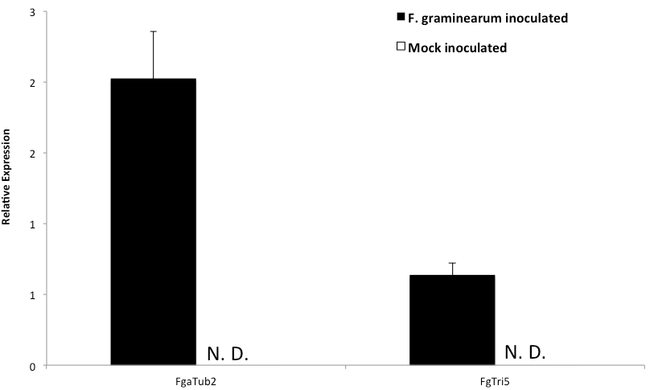

Plants grown in germination pouches inoculated with *F. graminearum* strain ZTE-2A spore suspension (1.00E6 spores/mL). Tissue harvested 3 days post inoculation; error bars represent s. d. Expressions of *F. graminearum* α-tubulin genes and TRI5 gene measured relative to maize actin genes, and are not detected (N. D.) in mock-inoculated roots.(n = 3)