Garlic Post-Harvest Trial Results
Crystal Stewart
Cornell Cooperative Extension Eastern NY Commercial Horticulture Program
PO Box 25, Johnstown, NY 12095 cls263@cornell.edu

Post-harvest handling is a yearly challenge for growers in the Northeast. Often the success of the crop continues to be dependent on the weather even after it is out of the ground, with drying going well in dry years and poorly in rainy years. We set the goal of determining the optimal handling to dry garlic through three on-farm post-harvest trials in 2012 and three more in 2013. Through these trials we were able to determine that garlic can tolerate more light, heat, and pruning during the drying process than was previously demonstrated, and that we can create a more effective drying environment regardless of the weather using high tunnels.
Choosing post-harvest treatments
Treatments were chosen based on what growers throughout New York indicated worked well for them and through the advice of the Garlic Seed Foundation. The following options were chosen: drying occurred either in a high tunnel with shade cloth or in an open air structure such as a shed or barn; Roots were either left on the bulb until drying was completed or cut off immediately (leaving the basal plate intact); tops were either left on until drying was completed or cut off at various heights during or directly after harvest, and garlic was washed immediately after harvest or was left unwashed. These treatments were combined in every possible way on each of the three farms.
Effects of treatments on bulb quality, disease incidence, drying time, and final weight
High Tunnel vs. Open Air: Across the trials garlic in high tunnels dried an average of three days faster than garlic in open air structures. Garlic dried in high tunnels had slightly better wrapper quality (tighter, less discoloration) than garlic dried in open-air structures at one site during both years. Garlic dried in tunnels also had slightly lower disease incidence (Aspergillus, Embellisia and Botrytis), though disease was not severe in any site or treatment in either year. No garlic treatments showed damage from being dried in the high tunnel.

The environment in the high tunnel needs to be carefully managed in order to be most effective. Technically temperatures can reach 121° F before waxy breakdown, the physiological disorder resulting from high temperatures, is initiated. However, to account for uneven heating in the high tunnel and possible delays in dropping temperatures through ventilation, the grower cooperators agreed that 110° F was a safer limit. Thermometers to monitor the temperature were located at the same height as the garlic.

Limiting temperature is just one aspect management. Maintaining air movement in the high tunnel through the use of internal fans helps even out the temperature and humidity, particularly if drying racks are stacked (Image 1). The grower cooperators also agreed running dehumidifiers at night and whenever the high tunnel was closed was beneficial, as it removed up to 20 gallons of water from the air during an eight-hour period and kept conditions closer to optimal. Without closing the tunnel and running dehumidifiers the humidity in the tunnel can reach up 100%, which pauses or reverses the drying process. 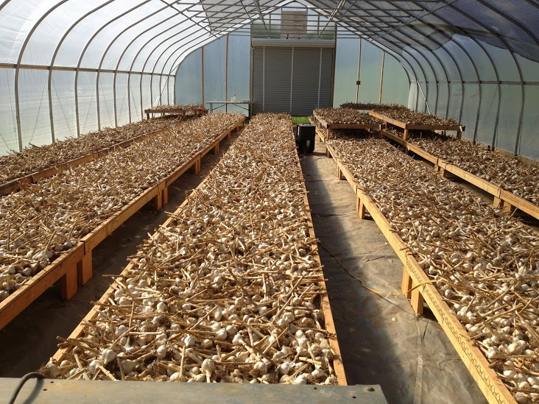
Image 1: Garlic dried in a high tunnel as part of the post-harvest trial. Fans help keep air temperature and humidity uniform in the tunnel even when it is closed. Image: Crystal Stewart

Roots trimmed vs. roots untrimmed: No statistically significant differences were observed between these treatments in regards to bulb quality, weight, or disease incidence in either year. Root pruning is considerably more difficult and time consuming on wet roots than dry roots.

Tops trimmed vs. tops untrimmed: Trimming the tops mechanically in the field using a sickle-bar mower greatly increased the speed of harvest and reduced the space needed for drying. Top trimming did not have a significant effect on disease incidence in dried bulbs, but there were differences in bulb weight at two of the farms in year one, with un-cut bulbs being slightly heavier (Table 1). It was unclear if this difference was due to weight loss or to double bulbs, since the number of bulbs is greater in the treatments with lower weights. Because of this question, relatively uniformly sized, non-doubled bulbs were chosen for the samples during year two instead of taking every bulb from a plot, including doubles, as had been done in year one. In addition to this change, additional cutting lengths were also added to determine if leaving some stem would affect weight or disease incidence. During year two, the pruning length did not affect the dried weight of bulbs significantly (Table 2). Furthermore, there were no significant differences in disease incidence across any of the trimming treatments.

Table 1: Treatments and average weights aggregated from three trial sites, each with three replications per treatment.
Treatment | Average  weight/head | Count
Cut at 6” | 0.113lbs | 1036
Uncut | 0.130lbs | 972

Table 2: Treatments, aggregated weights of treatments across replications, counts, and average weights per head from year two. Data was combined from all three sites.
Treatment | Weight/  treatment | Count | Average  weight/head
1.5 inch | 23.7lbs | 183 | 0.129lbs
6 inch | 22.7lbs | 186 | 0.122lbs
10 inch | 24.4lbs | 206 | 0.118lbs
Uncut | 39.4lbs | 302 | 0.130lbs

Washed vs. unwashed: Washed garlic initially had very clean, tight wrappers, but became more discolored than the unwashed garlic during the drying and curing process. Most discoloration could be removed by removing 1-3 wrapper leaves, but this extra step is time consuming. Disease incidence, particularly Aspergillus and Embellisia, was slightly higher in washed garlic. This treatment was discontinued after year one of the study because the returns from the process were deemed too low.
Discussion of results and next steps: These trials have demonstrated that it is possible to dry garlic quickly and effectively by creating a warm, dry environment. Garlic can be dried at 110° F without damage to the bulbs. Furthermore, one to two layers of shade cloth provides enough protection for bulbs to prevent damage from the sun.
These trials have also demonstrated that trimming the tops of the garlic while it is in the field rather than drying the whole plant intact does not increase disease issues or reduce bulb weight. This finding is particularly useful to growers who find that they have too much garlic for their drying area, as they can remove the tops without concern that the garlic will become unmarketable or lose value as a result.
Notably, all of these trials were conducted in relatively dry years. We might expect that if the season had been wetter, differences between high tunnel and open-air drying systems would have increased rather than decreased. The worse the outside conditions for drying, the more important it becomes to be able to control the environment. High tunnels offer more significant opportunities for control than most barn systems.
Not every grower will be able to use a high tunnel system to dry garlic, or will want to cut the tops. These recommendations do not need to be followed exactly for success, but if a grower is struggling with disease and post-harvest breakdown, applying the principles of limiting humidity and increasing temperature while drying should prove beneficial, whether accomplished in a high tunnel, a hay mow, etc.
To follow-up on these studies, we would like to address growers’ questions about the effects of these treatments on longer-term storage and on quality factors such as sulfur compound concentration, and would like to determine what the best environment is to store garlic for one, three, or 6 months.
If there are questions about how to apply these treatments to a specific post-harvest system, please contact Crystal. These project was made possible through the support of Northeast SARE.

