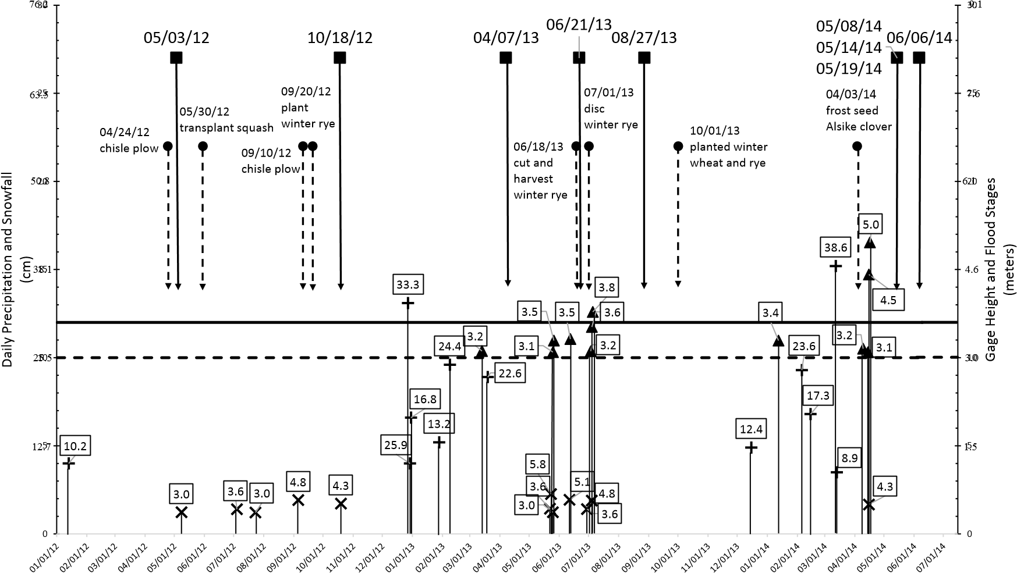
Figure 1.1: Sampling Dates, Field Management, and Peak Events. Peak events were classified by the following criteria:
Greatest Daily Rainfall Event (3.0 - 5.8 cm)
Snowfall Event (8.9 - 38.6 cm)
Greatest Gage Height Event (3.1 - 5.0 meters); solid line signifies flood stage; broken line signifies action stage for the Intervale Farming Community

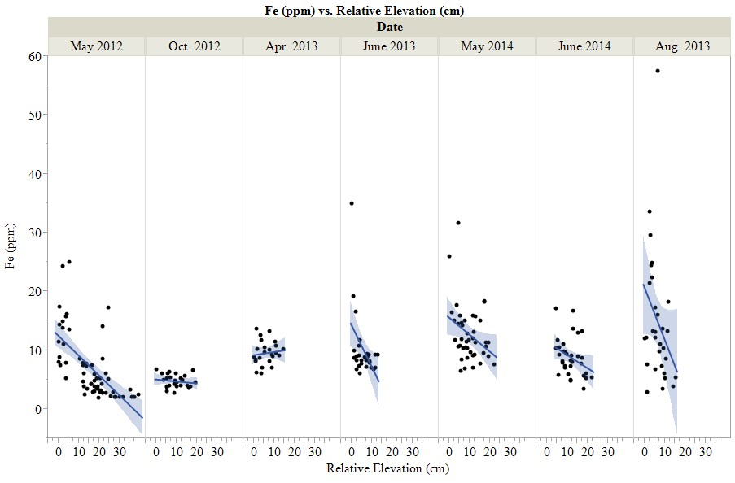
Figure 2: Regression of iron with elevation. Iron was inversely correlated with elevation on all sampling dates except for October 2012 and April 2013.
 | May | June | Elevation
Depression 1 | 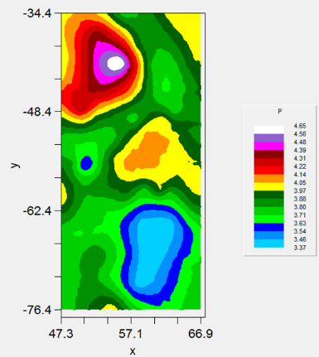 | 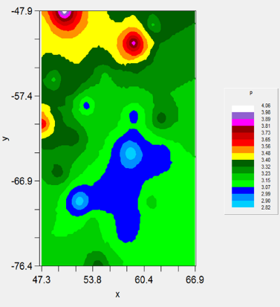 | 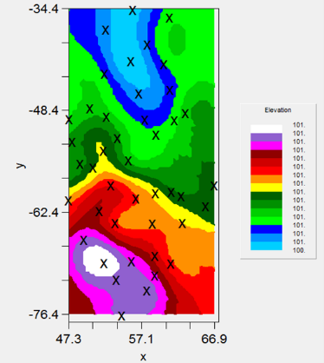
Depression 2 | 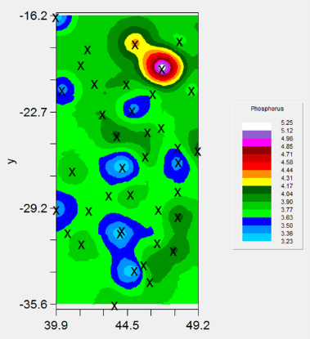 | 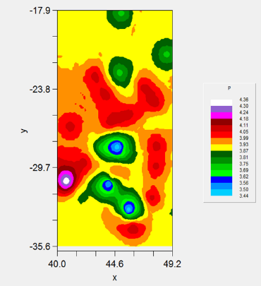 | 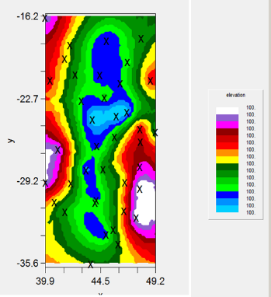
Depression 3 | 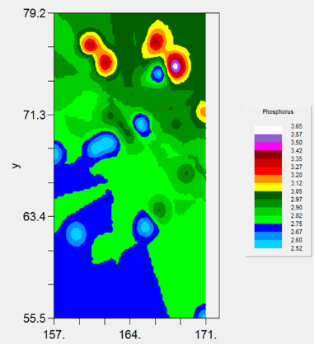 | 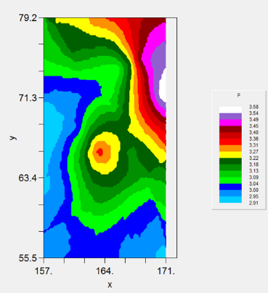 | 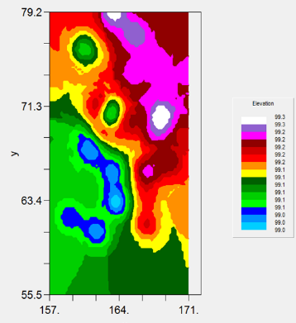
Depression 4 | 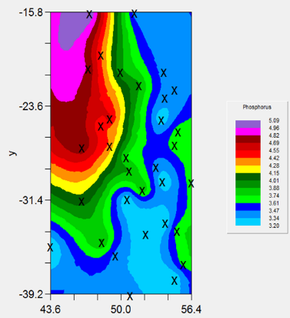 |  | 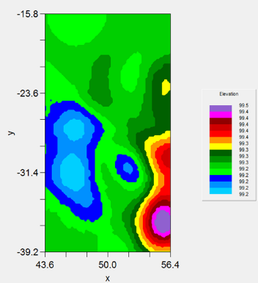
Figure 3: Phosphorus distributions across four depressions in the study field. The images show that P is almost inversely related to elevation, i.e. low elevations seem to match up with high MME-P. However, in some areas MME-P is more aligned with the slopes of the depression.

Table 1: Statistical Parameter Estimates for Moisture Distribution in Depression 1. Also listed are parameters of linear regression between moisture and elevation in Depression 1 by sampling date. Letter by mean values denote significant difference when letters are different. Significance levels of linear regressions are indicated by asterisks * <0.1, ** <0.05, ***p<0.001.
Date | n | Percent Moisture  Mean Std CV(%) |  |  | Slope | Linear Regression Parameters  Intercept SE R² P(t)
May 2012◊ | 60 | 40.28a | 4.23 | 10.51 | - 0.116 | 42.13 | 0.05 | 0.08 | 0.0278**
Oct. 2012◊ | 27 | 36.56b | 1.91 | 5.21 | - 0.172 | 38.21 | 0.07 | 0.20 | 0.0206**
Apr. 2013‡ | 24 | 38.15c | 1.31 | 3.43 | - 0.128 | 38.93 | 0.06 | 0.35 | 0.0464**
June 2013‡ | 30 | 31.75d | 1.56 | 4.91 | - 0.154 | 32.67 | 0.77 | 0.12 | 0.0562*
May 2014‡ | 43 | 35.17e | 1.80 | 5.11 | - 0.230 | 37.46 | 0.04 | 0.49 | <0.0001***
Aug. 2013† | 30 | 28.36f | 1.17 | 4.12 | - 0.114 | 29.10 | 0.05 | 0.15 | 0.0364**
June 2014† | 33 | 29.49g | 0.59 | 1.99 | - 0.008 | 29.59 | 0.02 | 0.001 | 0.7066

Table 2: Statistical Parameter Estimates for Phosphorus Distribution. Also listed are parameters of linear regression between MME-phosphorus concentrations and MME-iron concentrations in Depression 1 by sampling date. Letter by mean values denote significant difference when letters are different. . Significance levels of linear regressions are indicated by asterisks * <0.1, ** <0.05, ***p<0.001. MME-P on Post Irene and Peak Events are significantly different from non-Peak events. In most cases, the non-peak events are low except for in May 2012 when it was lower. At this point in time the soil had been flooded for a couple of months.
Date | n | Phosphorus (ppm)  Mean Std CV (%) |  |  | Slope | Linear Regression Parameters  Intercept SE R² P(t)
May 2012◊ | 60 | 2.18a | 0.82 | 37.49 | + 0.071 | 1.68 | 0.02 | 0.23 | <0.0001***
Oct. 2012◊ | 27 | 4.70bc | 2.31 | 49.27 | + 0.446 | 2.58 | 0.42 | 0.04 | 0.2993
Apr. 2013‡ | 24 | 4.56bd | 1.76 | 38.75 | + 0.319 | 1.49 | 0.17 | 0.14 | 0.0766*
June 2013‡ | 30 | 4.82cd | 1.60 | 33.21 | + 0.140 | 3.43 | 0.05 | 0.23 | 0.0080**
May 2014‡ | 43 | 3.84b | 0.31 | 8.12 | + 0.018 | 3.62 | 0.01 | 0.08 | 0.0732*
Aug. 2013† | 30 | 3.04e | 0.85 | 28.02 | + 0.011 | 2.88 | 0.01 | 0.02 | 0.4426
June 2014† | 33 | 3.26e | 0.28 | 8.48 | - 0.006 | 3.32 | 0.02 | 0.01 | 0.6894

Table 3: May 2014: Statistical Parameter Estimates for Phosphorus Distribution. Also listed are parameters of linear regression between MME-phosphorus and MME - iron in Depressions 1-4 and Scattered Set. Letter by mean values denote significant difference when letters are different. . Significance levels of linear regressions are indicated by asterisks * <0.1, ** <0.05, ***p<0.001.
Date | n | Phosp  Mean | horus (  Std | ppm)  CV (%) | Slope | Linear Regression Parameters  Intercept SE R² P(t)
Dep. 1 | 43 | 3.84a | 0.31 | 8.12 | + 0.018 | 3.62 | 0.01 | 0.08 | 0.0732*
Dep. 2 | 39 | 3.77a | 0.37 | 9.84 | + 0.010 | 3.68 | 0.03 | 0.00 | 0.6904
Dep. 3 | 33 | 2.86b | 0.30 | 10.62 | + 0.001 | 2.82 | 0.01 | 0.00 | 0.8981
Dep. 4 | 33 | 3.77a | 0.52 | 13.85 | - 0.060 | 4.22 | 0.03 | 0.10 | 0.0816*
Scattered | 19 | 2.88b | 0.39 | 13.51 | - 0.001 | 2.90 | 0.01 | 0.00 | 0.9043

Table 4: June 2014: Statistical Parameter Estimates for Phosphorus Distribution. Also listed are parameters of linear regression between MME-phosphorus and MME-iron in Depressions 1-4 and Scattered Set. Letter by mean values denote significant difference among means are denoted by different letters. There were no significant linear regressions suggesting that the inverse relationship breaks down as soils dry.
Date | n | Phosp  Mean | horus (  Std | ppm)  CV (%) | Slope | Linear Regression Parameters  Intercept SE R² P(t)
Dep. 1 | 33 | 3.26a | 0.28 | 8.48 | - 0.006 | 3.32 | 0.02 | 0.01 | 0.6894
Dep. 2 | 32 | 3.93b | 0.24 | 6.17 | + 0.013 | 3.79 | 0.01 | 0.03 | 0.3344
Dep. 3 | 33 | 3.15a | 0.31 | 9.89 | + 0.005 | 3.01 | 0.01 | 0.02 | 0.3855
Dep. 4 | 32 | 3.77b | 0.61 | 16.25 | - 0.009 | 3.85 | 0.01 | 0.01 | 0.5886
Scattered | 19 | 3.13a | 0.44 | 14.12 | + 0.009 | 3.00 | 0.01 | 0.040 | 0.4196

Table 5: Statistical Parameter Estimates for Manganese Distribution. Also listed are parameters of linear regression between MME-manganese and elevation in Depression 1 by sampling Date. Letter by mean values denote significant difference when letters are different. Significance levels of linear regressions are indicated by asterisks * <0.1, ** <0.05, ***p<0.001.
Date | n | Manganese (ppm)  Mean Std CV (%) |  |  | Slope | Linear Regression Parameters  Intercept SE R² |  |  | P(t)
May 2012◊ | 60 | 4.07a | 0.55 | 13.64 | - 0.014 | 4.29 | 0.01 | 0.07 | 0.0416**
Oct. 2012◊ | 27 | 4.85b | 0.54 | 11.08 | + 0.023 | 4.62 | 0.02 | 0.05 | 0.2845
Apr. 2013‡ | 24 | 38.14c | 6.14 | 16.24 | + 0.151 | 36.87 | 0.31 | 0.01 | 0.6302
June 2013‡ | 30 | 63.90d | 33.40 | 52.27 | - 5.650 | 97.76 | 1.41 | 0.37 | 0.0004**
May 2014‡ | 43 | 33.50e | 28.21 | 84.20 | - 2.785 | 61.23 | 0.68 | 0.29 | 0.0002**
Aug. 2013† | 30 | 27.14f | 3.07 | 11.30 | + 0.106 | 26.44 | 0.15 | 0.02 | 0.4711
June 2014† | 33 | 25.11e | 6.28 | 24.99 | - 0.301 | 28.65 | 0.23 | 0.05 | 0.1948

Table 6: May 2014: Statistical Parameter Estimates for Manganese Distribution. Also listed are parameters of linear regression between MME-manganese and elevation in Depressions 1-4 and Scattered Set. Letter by mean values denote significant difference when letters are different. Significance levels of linear regressions are indicated by asterisks * <0.1, ** <0.05, ***p<0.001.
Date | n | Mang  Mean | anese (ppm)  Std | CV(%) | Slope | Linear Regression Pa  Intercept SE | rameters  R2 | P(t)
Dep. 1 | 43 | 33.50a | 28.21 | 84.20 | - 2.785 | 61.23 0.68 | 0.29 | 0.0002**
Dep. 2 | 39 | 29.46b | 8.66 | 29.38 | - 1.831 | 35.85 0.54 | 0.24 | 0.0017**
Dep. 3 | 33 | 50.35c | 17.92 | 35.59 | - 3.250 | 66.38 0.85 | 0.32 | 0.0006**
Dep. 4 | 33 | 34.09b | 15.25 | 44.74 | - 2.636 | 44.59 1.07 | 0.16 | 0.0194**
Scattered | 19 | 41.40b | 25.66 | 61.99 | + 2.002 | 20.04 1.08 | 0.17 | 0.0819*

Table 7: June 2014: Statistical Parameter Estimates for Manganese Distribution. Also listed are parameters of linear regression between MME-manganese and elevation in Depressions 1-4 and Scattered Set. Letter by mean values denote significant dfferences when letters are di erent. Significance levels of linear regressions are indicated by asterisks * <0.1, ** <0.05, ***p<0.001.
Date | n | Manganese (ppm) |  |  |  | Linear Regression Parameters
 |  | Mean | Std | CV(%) | Slope | Intercept | SE | R2 | P(t)
Dep. 1 | 33 | 25.11a | 6.28 | 24.99 | - 0.301 | 28.65 | 0.23 | 0.05 | 0.1948
Dep. 2 | 32 | 24.26a | 4.18 | 17.23 | - 0.256 | 25.14 | 0.32 | 0.02 | 0.4259
Dep. 3 | 33 | 39.65b | 8.37 | 21.10 | - 2.158 | 50.30 | 0.29 | 0.65 | <0.0001***
Dep. 4 | 32 | 39.15c | 29.31 | 74.86 | - 4.057 | 55.46 | 2.13 | 0.11 | 0.0669*
Scattered | 19 | 28.01c | 4.70 | 16.77 | + 0.389 | 27.60 | 0.22 | 0.00 | 0.8599

