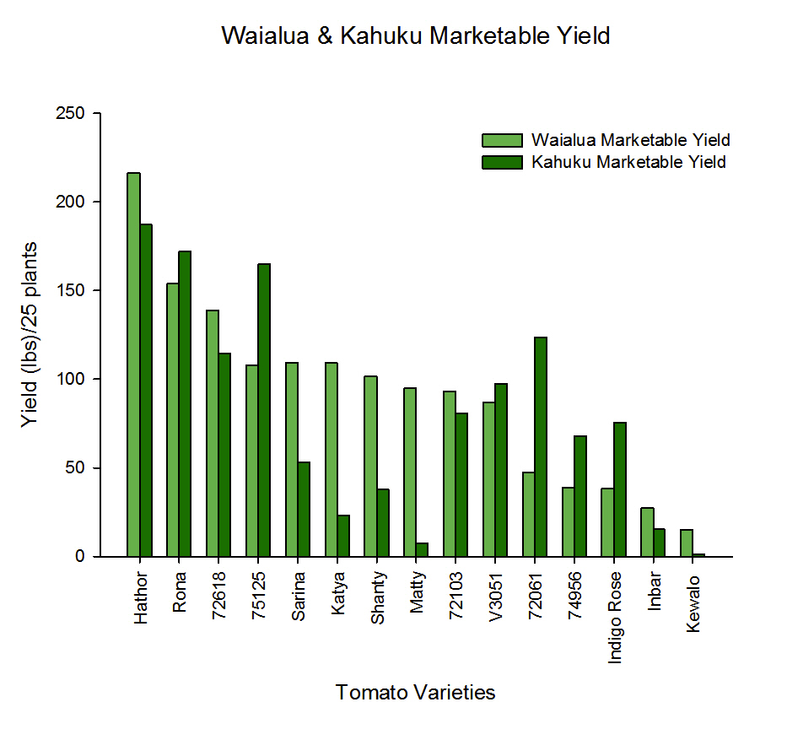
Figure1. Field trials Waialua and Kahuku Marketable Yield for all tomato varieties

