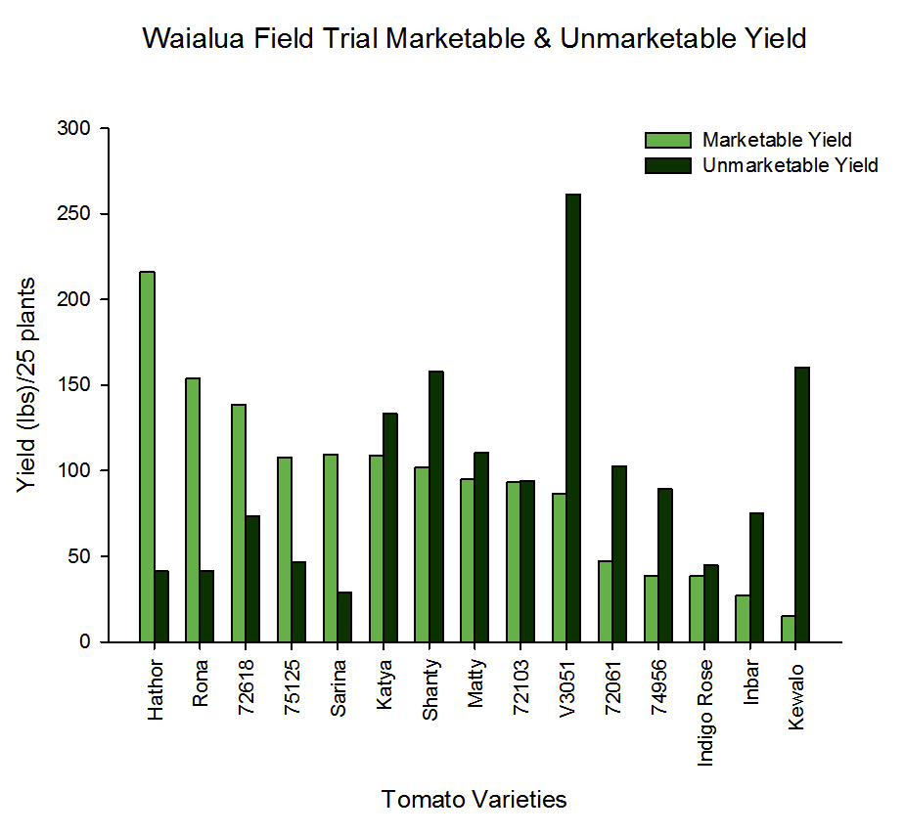
Figure 2. Waialua Unmarketable Yield comprised of five different categories; Damaged/Injured, Mite, Splotchy, Fruit Fly and Hemiptera Yield.

