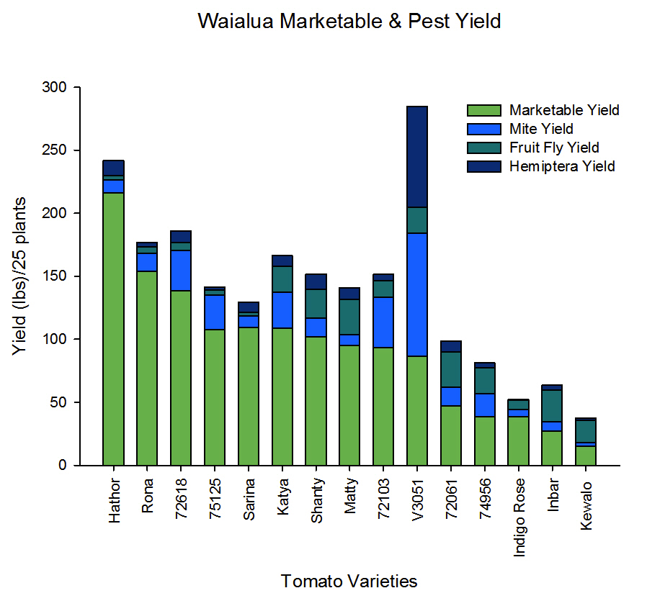
Figure 4. Waialua Marketable Yield with Pest yield comprised of Mite, Fruit Fly, and Hemiptera yield.

