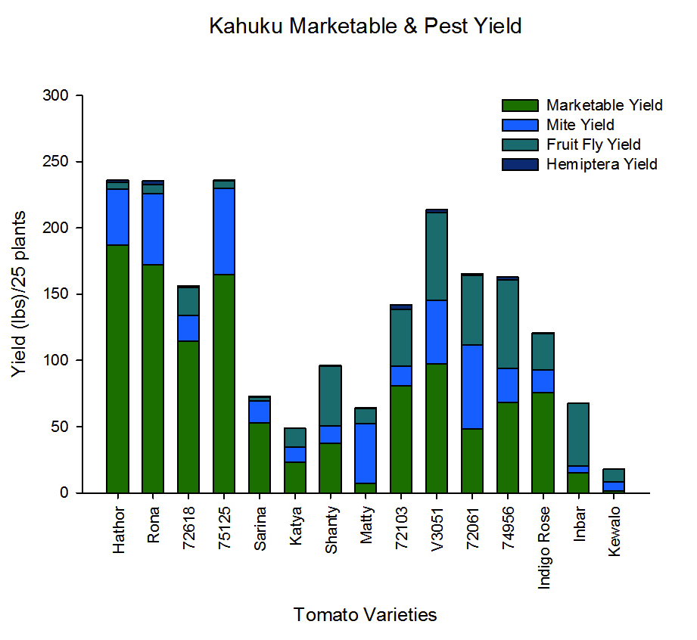
Figure 5. Kahuku Marketable Yield with Pest yield comprised of Mite, Fruit Fly, and Hemiptera yield.

