SARE PDP FINAL REPORT, FY13-FY14
Enhancing the Integrated Pest Management Academy to Provide Professional Development Opportunities for Agricultural Educators that Increase Economically and Environmentally Sustainable Agriculture in Michigan
Summary of outputs
- Bulletins published
  - Organic Raspberry Production in Three-Season High Tunnels
  - Integrated Pest Management: A guide to resources from Michigan State University
  - Disease and insect pests of asparagus
  - Cole Crops Integrated Pest Management
- 2013 and 2014 multiday IPM Academy programs
  - The target audience included crop consultants, Michigan Department of Agriculture and Rural Development personnel, Natural Resource Conservation Service employees, chemical representatives, and early-adopters from Michigan and surrounding states. The Academy was a two-day professional development program covering fundamentals of pest management and identifying resources and technology for sustainable ag practitioners. An advisory group of farmers and representatives of the target audience helped develop the Academy content to ensure a relevant curriculum and well attended program
- 2014 Michigan Agricultural Environmental Awareness Program (MAEAP) technician training
  - The MAEAP training program sought to capture the remaining MDARD technicians who had not yet received IPM training through the Academy and provided them with resources to use in improving IPM adoption through their contacts with growers.

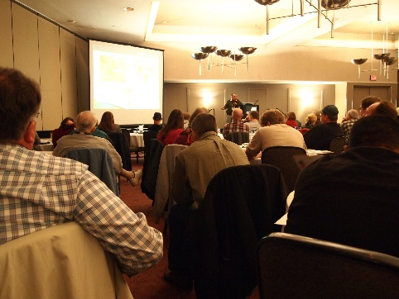
IPM Academy 2013
The 2013 Integrated Pest Management Academy was held February 18-19 in Okemos Michigan and drew 83 participants. Intended changes and knowledge gained were measured at the end of each day of programming (preseason program evaluation). In order to capture actual changes and impacts, a follow-up survey was sent to attendees via email in November 2013 (post season evaluation).

Preseason program evaluation results
Participants listen during the general session of the 2013 IPM Academy.
Day 1 evaluation was completed via a Turning Point presentation (n=56) and had a mixed audience of farmers, farm employees, university employees and industry representatives, fertilizer and pesticide retailers, crop consultants, and state and local agency employees. Day 2 evaluation was completed by the primary target audience and those that attended the breakout sessions (n=48). An additional evaluation was completed with students of the CSS 488 MSU class that partially attended Day 1 seminars (n=27).

- Outcome: Increased awareness of IPM resources available from MSU.
Result: 93% of attendees left the IPM Academy with increased awareness
- Outcome: Improved ability to identify sustainable agricultural resources of MSU resources.
Result: 86% of attendees left the IPM Academy with improved ability to identify resources.
- Outcome: Improved understanding of IPM-based sustainable agricultural practices.
Result: 92% of attendees left the IPM Academy with improved understanding of sustainable Ag practices.
- Outcome: Timing of IPM Academy contributed to motivation to implement something new for upcoming growing season.
Result: 67% Yes; 31% Maybe; 12% No.
- Outcome: Improved understanding of technology that supports sustainable agricultural practices.
Result: 93% of attendees left the IPM Academy with improved understanding of technology.

Climate Variability Attitude questions: A series of questions taken from Duke University¹ (Jan. 2013) nationally representative survey and Yale University (Sept. 2012) nationally representative survey² were asked of IPM Academy audience on Day 2.

¹ Mayer, Adair, & Pfaff (2013). Americans think climate is changing and support some action. Duke University. Nicholas Institute for Environmental Policy Solutions. Policy brief NIPB 13-10.
²Leiserowitz, A., Maibach, E., Roser-Renouf, C., Feinberg, G., & Howe, P. (2012) Climate
change in the American mind: Americans’ global warming beliefs and attitudes in September, 2012. Yale University and George Mason University. New Haven, CT: Yale Project on Climate Change Communication. http://environment.yale.edu/climate/files/Climate-Beliefs-September-2012.pdf
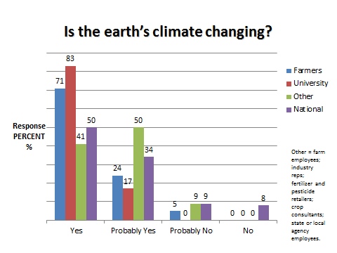
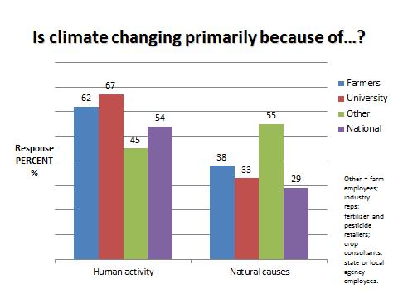
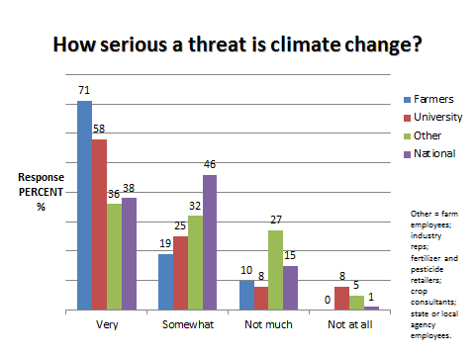
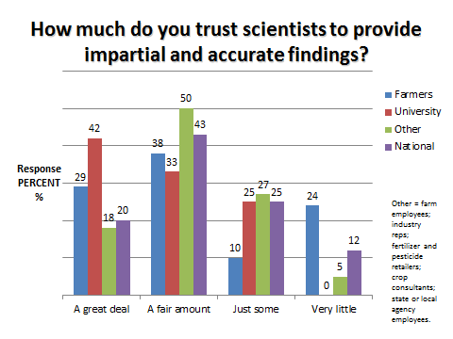
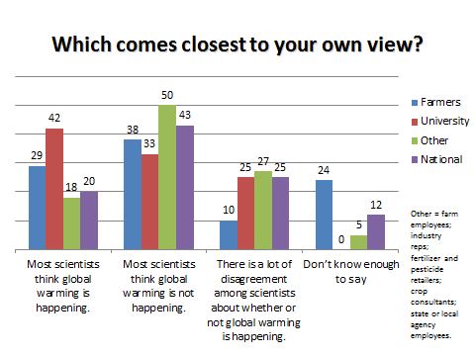
Agricultural land managed or directly impacted: Crops under cultivation (number of participants listing crop in parenthesis):
- Apples (7)
- Corn (7)
- Conifers/ Evergreens/woodlots (6)
- Vegetables (5)
- Fruit trees (5)
- Cherries (4)
- Pumpkins (3)
- Christmas trees (3)
- Strawberries (3)
- Wheat (3)
- Hops (3)
Crops mentioned by two participants: soybeans, tomatoes, grapes, blueberries, peaches, raspberries
Crops mentioned by one participant: Asparagus, Saskatoon berries, snap peas, beans, celery, sugar beets, sugar maples, apricots, blackberries, cranberries, peppers, carrots, cucurbitacea, forage

Total number of acres represented by audience:
- Vegetables 12,951 acres in Leelanau, St Joseph, Ingham, Mason, Grand Traverse, Genesee, and Oceana Counties.
- Christmas Trees 10,601 acres in Leelanau, Missaukee, and Livingston Counties.
- Field Crops & Forage 6,652 acres in Kent, Ottawa, Manistee, Hillsdale, St Joseph, Saginaw, Clinton and Gratiot Counties.
- Fruit 5,553 acres in Leelanau, Ingham, Grand Traverse, Berrien, Kent, Ottawa, Shiawassee, Manistee, Livingston, Hillsdale, and Macomb Counties.
- Hops 171 acres in Leelanau, Missaukee, and Livingston Counties.
- Nurseries 146 acres in Genesee, Lenawee, Livingston, and Lapeer Counties.
Number of acres committed to change: Acres plan to utilize, expand or improve use of the following IPM practices based on the IPM Academy.
- 31,306 Acres Access MSU IPM resources online
- 31,247 Acres Scouting for insects and diseases
- 14,949 Acres Scouting for beneficial insects
- 25,639 Acres Referencing weather modeling to make management decisions (e.g. Enviroweather)
- 8,279 Acres Only treating for pests when the economic threshold is reached, as applicable
- 5,858 Acres Supporting beneficial insect habitat to promote pest control via natural enemies
- 10,537 Acres Selection of pest resistant varieties or cultivars
- 9,858 Acres Sanitation practices (removal of inoculum, sterilizing implements etc.)
- 12,911 Acres Utilize the least biologically impactful pesticide when management is needed
- 8,438 Acres Protecting native pollinators (mowing before spraying, spraying at night, etc.)

Skills and Farm Business Outcomes
- 52% (n=25) 20,500 acres Improve the financial viability of an existing business (reducing management costs, better detecting risks, increasing personal skill, etc.)
- 44% (n=21) 2,765 acres Improve position at an existing job
- 8% (n=4) 214 acres Start a business (consulting, farming, etc.)
- 2% (n=1) 52 acres Apply for a new job

Attendance session summary
Morning Concurrent Crop Specific Sessions
- 29% (n=14) Apple and Cherry IPM
- 2% (n=1) Communicating Climate Change
- 23% (n=11) Conifer IPM
- 27% (n=13) Scouting Techniques for Field Crops and Forages
- 19% (n=9) Vegetable IPM

Afternoon Concurrent Crop Specific Sessions
- 23% (n=11) Deciduous Tree IPM
- 17% (n=8) Emerging Issues in Field Crop Pesticide Resistance
- 19% (n=9) IPM in Small Fruit Crops
- 13% (n=6) MSU Resources for Hops, Saskatoons and Chestnuts
- 28% (n=13) Vegetable IPM

Plan to utilize, expand or improve use of the following IPM practices based on the IPM Academy:
- 92% (n=44) Access MSU IPM resources online
- 81% (n=39) Scouting for insects and diseases
- 63% (n=30) Scouting for beneficial insects
- 75% (n=36) Referencing weather modeling to make management decisions (e.g. Enviroweather)
- 44% (n=21) Only treating for pests when the economic threshold is reached, as applicable
- 46% (n=22) Supporting beneficial insect habitat to promote pest control via natural enemies
- 44% (n=21) Selection of pest resistant varieties or cultivars
- 38% (n=18) Sanitation practices (removal of inoculum, sterilizing implements etc.)
- 48% (n=23) Utilize the least biologically impactful pesticide when management is needed
- 44% (n=21) Protecting native pollinators (mowing before spraying, spraying at night, etc.)

Intend to use skills gained at the IPM Academy to do the following:
- 52% (n=25) Improve the financial viability of an existing business (reducing management costs, better detecting risks, increasing personal skill, etc.)
- 44% (n=21) Improve your position at an existing job
- 8% (n=4) Start a business (consulting, farming, etc.)
- 2% (n=1) Apply for a new job

CSS 488 MSU class that partially attended Day 1 seminars (n=27)
100% were obviously university students, but they also served in other roles: 30% of the students were farmers or farm employees and 16% were industry representatives or worked for local/state agencies in addition to being MSU students. 67% of students were raised on a farm, 74% indicated that they intend to own, rent, or lease farmland someday.

- 96% agreed they will be going into a career that involves farming or agricultural production.
- 89% said they will have a future career that involves consulting on agriculture.
- 61% plan to start my own business or professional service related to agriculture in the future.
- 85% consider agricultural careers 'green industry' careers.

Post season evaluation results
There were 20 respondents to the follow-up survey. Forty-two percent identified as growers, 11% scout/consultants, 11% farmhands/techs, 26% agricultural educators, 5% government employees, 5% recreational gardeners. Three participants identified themselves as a utility arborist, public gardener and apple cider stand operator, respectively. Respondents reported the following as their home counties: Eaton (1), Genesee (2), Grand Traverse (1), Gratiot (1), Ingham (3), Ionia (1), Isabella (1), Kalamazoo (1), Lenawee (1), Livingston (1), Monroe (2), Presque Isle (1), Saginaw (1) and St. Joseph (1). Three out of state respondents reported Gibson County, IN, Morgan County, MO and Cole County, MO as their home counties.
Respondents reported actively farming, managing or directly impacting 171,227 acres of agricultural land and 15,344 square feet of greenhouse production during the 2013 season including:
- Vegetable acreage (n=9) 2,387 acres
- Tree fruit acreage (n=8) 90 acres
- Small fruit acreage (n=7) 25 acres
- Field crop acreage (n=7) 168,710 acres
- Christmas tree acreage (n=2) 1 acre
- Nursery acreage (n=2) 4 acres
- Hops acreage (n=2) 10 acres
- Greenhouse (n=6) 15,344 square feet

Over the last 6 months, the following percentages of participants indicated that had adopted or expanded their use of the following IPM strategies or resources based on their experiences at the IPM Academy:
- Scouted for insects and/or diseases (n=14) 74%
- Scouted for beneficial insects (n=10) 53%
- Increased their ability to identify pests, disease and/or beneficial insects (n=15) 79%
- Referenced weather modeling to make management decisions (n=4) 21%
- Only treated for pests when the economic threshold was reached (n=8) 42%
- Supported beneficial insect habitat to promote pest control via natural enemies (n=6) 32%
- Selected pest resistant plant varieties or cultivars (n=2) 11%
- Eliminated or reduced pesticide applications (n=10) 53%
- Improved sanitation practices (n=8) 42%
- Utilized of the least biologically disruptive pesticides when treatment was needed (n=4) 21%
- Actively protected native pollinators (n=9) 47%
- Subscribed to an MSUE News Digest or visited the MSUE webpage (n=12) 63%
- Purchased or reference MSUE publications (n=11) 58%
- One respondent also reported that they increased the number if insect traps deployed and decreased their pesticide applications. 4 Acres

The previous percentages represent the adoption of new tools or practices on 171,227 acres of agricultural land and 15,344 SQFT of greenhouse production and 4 new Enviro-weather users.
Additionally, 15% applied for a new job (n=2), 46% improved their position at an existing job (n=6), 15% started a business (n=2), and 46% improved the financial viability of an existing business (n=6) based on the resources presented at the IPMA13.
One respondent indicated that information regarding tank mixing, order guidelines nozzle selection, performance analysis (crop and product specific, wind conditions, deposition aids, size, spacing, pressures) example weed management programs, number and timing would be helpful.

IPM Academy 2014
Preseason evaluation results
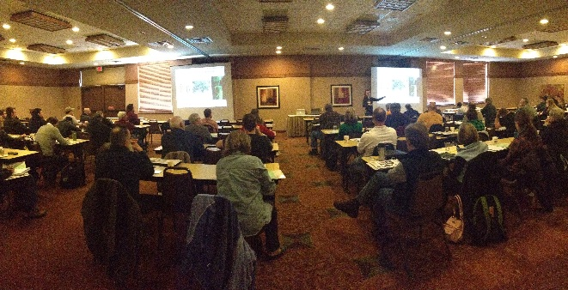
The 2014 Integrated Pest Management Academy was held February 18-19 in Okemos Michigan and drew 109 participants. Intended changes and knowledge gained were measured at the end of each day of programming (preseason program evaluation). In order to capture actual changes and impacts, a follow-up survey was sent to attendees via email in November 2014 (post season evaluation).
Participants listen during the general session at the 2014 IPM Academy.

Relationship to agriculture:
- 67% (n=37) Grower/producer
- 7% (n=4) Consultant/scout
- 7% (n=4) Landscaper
- 6% (n=3) Agricultural educator
- 2% (n=1) Student in agricultural sciences
- 2% (n=1) recreational gardener
- 9% (n=5) Other: technicians, arborist, researcher

Total number of acres represented by audience (total 23,854.5 acres):
- Vegetables 642 acres in Livingston, Clinton, Allegan, and Oceana Counties.
- Christmas Trees 1,300 acres in Kalkaska and Montcalm Counties.
- Field Crops & Forage 21,322 acres in Kent, Oceana, Allegan, Livingston, Montcalm, Muskegon, Ionia, Clinton Counties and Canada.
- Fruit 491 acres in Leelanau, Grand Traverse, Oceana, Tuscola, Mason, Ottawa, Saginaw, Antrim, and Washtenaw Counties.
- Hops 99.5 acres in Leelanau, Missaukee, Livingston, Kent, Ottawa, Calhoun, Ionia, Grand Traverse, Berrien, and Monroe Counties.

Number of acres committed to change: Acres plan to utilize, expand or improve use of the following IPM practices based on the IPM Academy:
- 24,292 Acres Access MSU IPM resources online
- 7,905 Acres Scouting for insects and diseases
- 6,077 Acres Scouting for beneficial insects
- 4,112 Acres Referencing weather modeling to make management decisions (e.g. Enviroweather)
- 7,654 Acres Only treating for pests when the economic threshold is reached, as applicable
- 1,777 Acres Supporting beneficial insect habitat to promote pest control via natural enemies
- 5,668 Acres Selection of pest resistant varieties or cultivars
- 18,367 Acres Alternative weed control strategies (e.g., cultivation)
- 4,209 Acres Alternative ground cover management (e.g., cover cropping)
- 313 Acres Sanitation practices (removal of inoculum, sterilizing implements etc.)
- 1,934 Acres Protecting native pollinators (mowing before spraying, spraying at night, etc.)
- 5,060 Acres Soil or tissue to make nutrient management decisions
- 6,437 Acres MSU information and management practices related to invasive pest management

Percentage of participants planning to utilize, expand or improve your use of any of the following IPM practices based on the IPM Academy:
- 77% (n=43) Access MSU IPM resources online
- 79% (n=44) Scouting for insects and diseases
- 71% (n=40) Scouting for beneficial insects
- 50% (n=28) Referencing weather modeling to make management decisions (e.g. Enviroweather)
- 54% (n=30) Only treating for pests when the economic threshold is reached, as applicable
- 54% (n=30) Supporting beneficial insect habitat to promote pest control via natural enemies
- 55% (n=31) Selection of pest resistant varieties or cultivars
- 45% (n=25) Alternative weed control strategies (e.g., cultivation)
- 52% (n=29) Alternative ground cover management (e.g., cover cropping)
- 34% (n=19) Sanitation practices (removal of inoculum, sterilizing implements etc.)
- 50% (n=28) Protecting native pollinators (mowing before spraying, spraying at night, etc.)
- 61% (n=34) Soil or tissue to make nutrient management decisions
- 68% (n=38) MSU information and management practices related to invasive pest management

Postseason evaluation results
The 2014 Integrated Pest Management Academy was held February 19-20 in Okemos Michigan and drew 109 participants. Intended changes and knowledge gained were measured at the end of each day of programming. In order to capture actual changes and impacts, a follow-up survey was sent to attendees via email in November 2013, the following are the results of this postseason survey.
There were 14 respondents to the follow-up survey. Fifty percent identified as growers, 8.3% as consultants/scouts, farmhand/technician and landscaper respectively. Seventeen percent of attendees were agricultural educators and 8% were ag students. Respondents reported the following as their home counties: Montcalm (1), Livingston (1), Macomb (1), Oakland (1), Allegan (1), Grand Traverse (1), and Clinton (1).

Respondents reported actively farming, managing or directly impacting 18,707 acres of agricultural land and 4,500 square feet of greenhouse production during the 2014 season including:
- Vegetable acreage (n=5) 1,314 acres
- Tree fruit acreage (n=2) 2,801 acres
- Small fruit acreage (n=3) 12,003 acres
- Field crop acreage (n=2) 2,560 acres
- Nursery acreage (n=1) 20 acres
- Hops acreage (n=1) 5 acres
- Greenhouse (n=6) 4500 square feet

Over the last 6 months, the following percentages of participants indicated that had adopted or expanded their use of the following IPM strategies or resources based on their experiences at the IPM Academy:
- Scouted for insects and/or diseases (n=9) 82%
- Scouted for beneficial insects (n=4) 36%
- Increased their ability to identify pests, disease and/or beneficial insects (n=7) 64%
- Referenced weather modeling to make management decisions (n=5) 46%
- Only treated for pests when the economic threshold was reached (n=3) 27%
- Supported beneficial insect habitat to promote pest control via natural enemies (n=5) 46%
- Selected pest resistant plant varieties or cultivars (n=2) 18%
- Eliminated or reduced pesticide applications (n=3) 27%
- Improved sanitation practices (n=2) 18%
- Utilized of the least biologically disruptive pesticides when treatment was needed (n=5) 45%
- Actively protected native pollinators (n=7) 64%
- Subscribed to an MSUE News Digest or visited the MSUE webpage (n=4) 36%
- Purchased or reference MSUE publications (n=4) 36%

Additionally, 12.5% applied for a new job (n=1), 38% improved their position at an existing job (n=3), and 75% improved the financial viability of an existing business (n=6) based on the resources presented at the IPMA13.

One respondent commented that collaborating with other growers gave them some ideas on how to improve or change some IPM practices on their farm. Another responded that having an open discussion about adapting current practices was valuable to changing their practices.

MAEAP Program
The MAEAP program was held on October 29, 2014. The session provided technicians with resources to assist growers with implementing IPM on farm and also educated technicians about all of the IPM resources available to them through MSU and MSUE. Thirty-six conservation district technicians participated in the session, the feedback was positive and technicians were pleased to learn about and obtain the Extension materials available to them to help them better serve farmers. MAEAP is estimated to access 2,300 farms across the state on Michigan and includes a large group of technicians that help to maximize the reach of IPM resources in the state.

Bulletins generated
See attached documents.

