Table 1. Percent natural gas savings and with associated cost savings for the soap bubble system and thermal energy curtain compared to the control greenhouse.

    - Soap bubble system compared to control

Time period | % Less gas used | Dollar savings
2012 Winter | 43 | $764
2013 Winter | 33 | $408
2013 Fall | 27 | $131
2014 Winter | 42 | $734

    - Thermal energy curtain compared to control

Time period | % Less gas used | Dollar savings
2012 Winter | 31 | $554
2013 Winter | 23 | $287
2013 Fall | 26 | $127
2014 Winter | 25 | $437

Table 2. Gas usage in cubic feet x 100 for all three research greenhouses, and percent energy savings seen by the energy/thermal curtain and bubble insulation equipped greenhouses compared to the control greenhouse.
 | Time period | Total natural gas usage for the period (cubic ft x 100)
 |  | Control house | Curtain house | Bubble house
2014 season | Oct. – Dec. 2013 | 381 | 283 | 280
 | % Savings over control | N/A | 26% | 27%
 | Jan. – April 2014 | 1347 | 1011 | 782.5
 | % Savings over control | N/A | 25% | 42%
2013 season | Feb – March 2013 | 952 | 731 | 638
 | % Savings over control | N/A | 23% | 33%
2012 season | Jan – April 2012 | 1381 | 955 | 793
 | % Savings over control | N/A | 31% | 43%

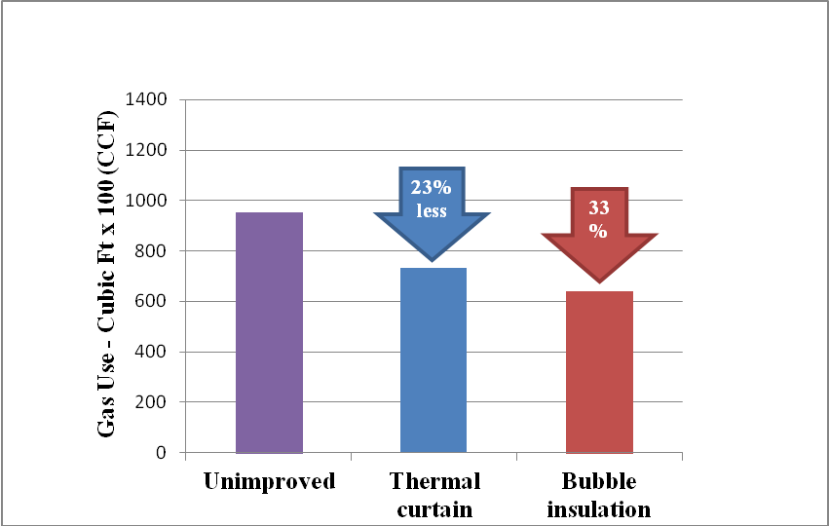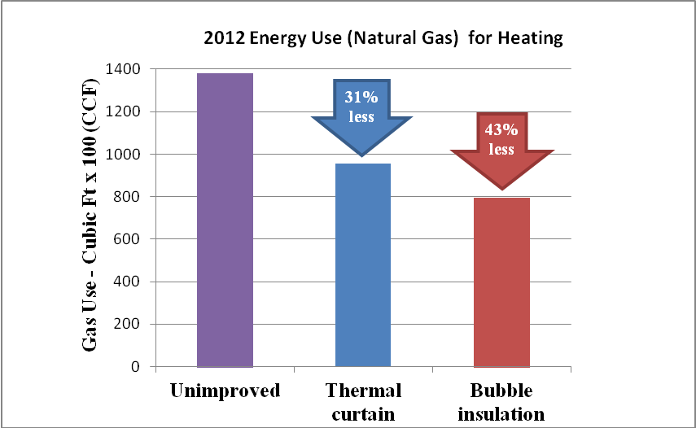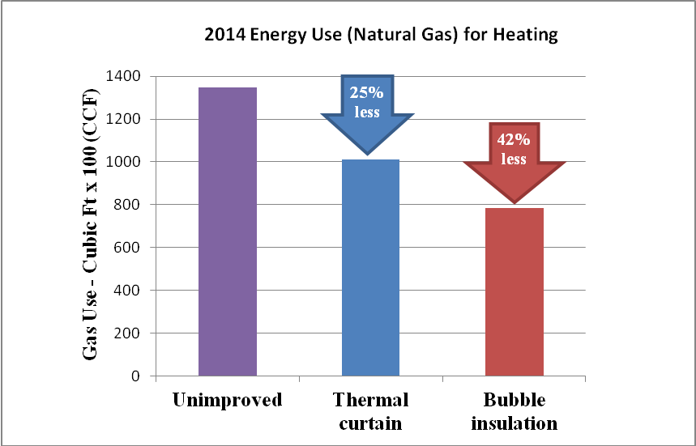
2013 Energy Use (Natural Gas) for Heating
Figure 1. Percent natural gas savings of the energy/thermal curtain and bubble insulation equipped greenhouses compared to the control greenhouse for the 2012 – 2014 winter heating seasons.

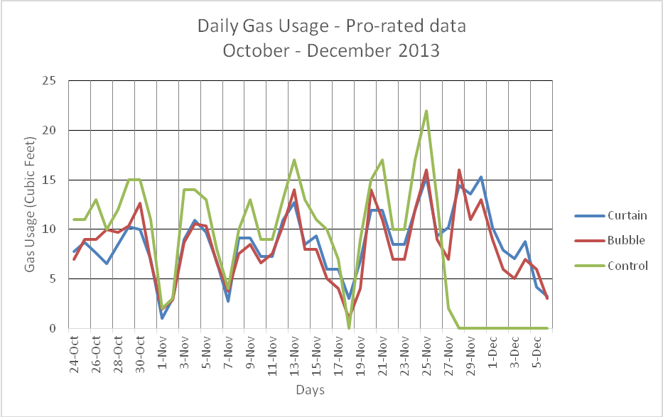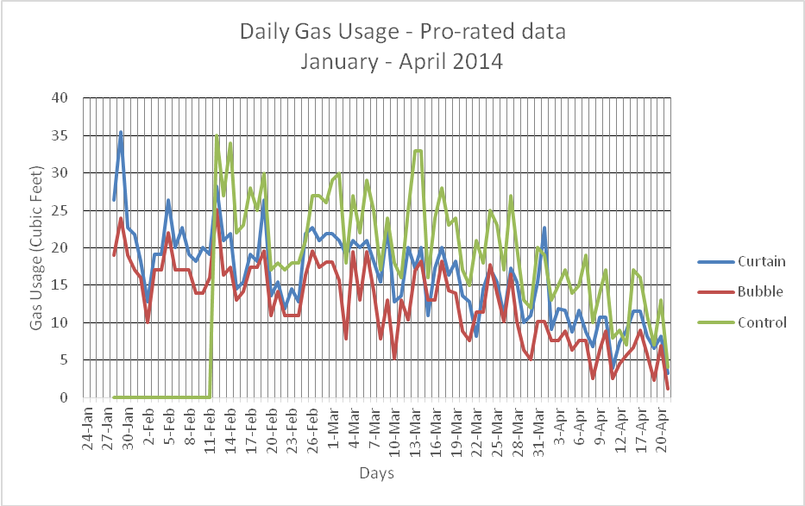
Figure 2. Gas usage October through December 2013 in the three test greenhouses at Claussens Greenhouses and Florist, Colchester, Vermont.
Figure 3. Gas usage January through April 2014 in the three test greenhouses at Claussens Greenhouses and Florist, Colchester, Vermont.

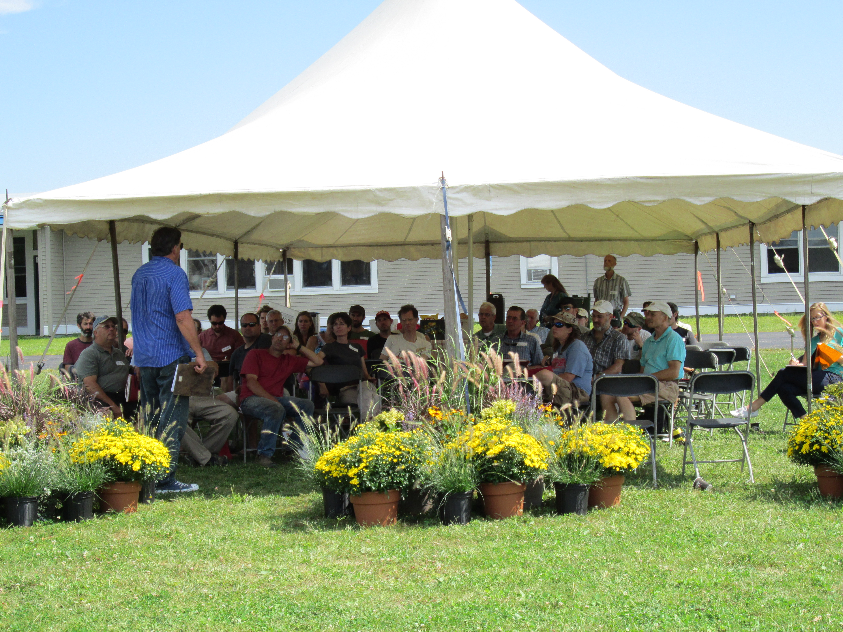
Figure 4. A grower addresses attendees at the “Energy Extravaganza” held on September 4, 2014.

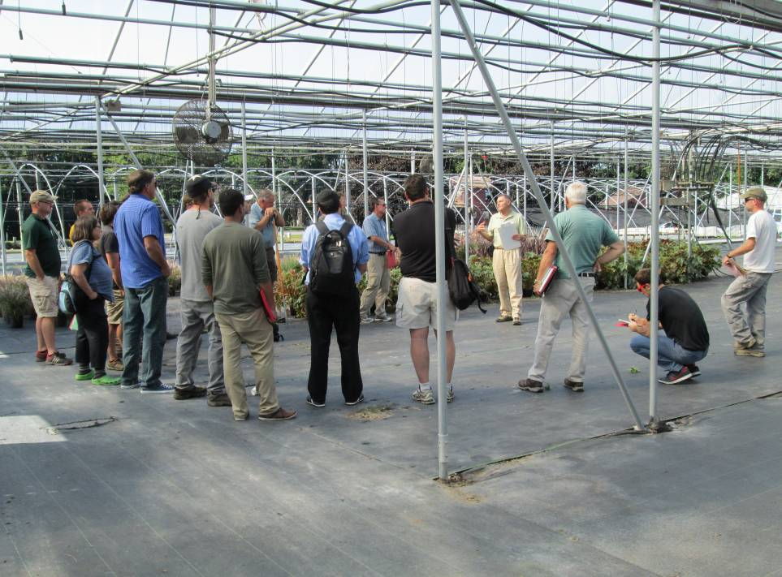
Figure 5. Conference attendees hear from John Bartok about retrofitting existing greenhouses for increased energy efficiency.

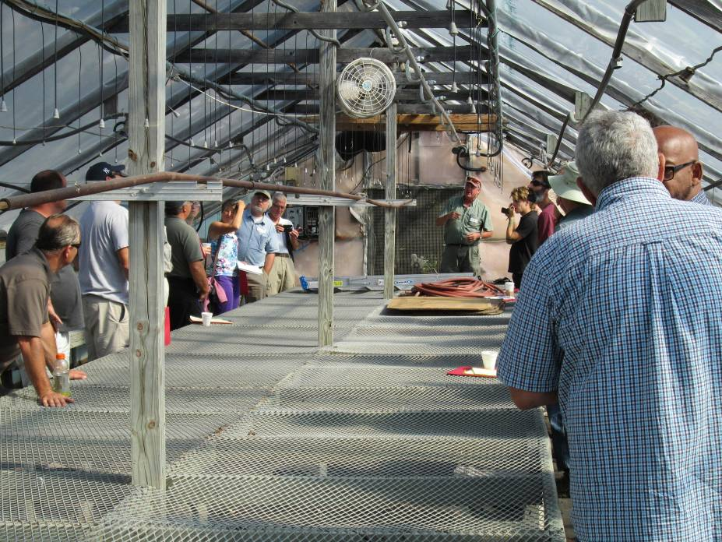
Figure 6. Participants get an introduction to and demonstration of the bubble insulation technology.

