Floppy Ear Farm * Reedsville WI * Hedge Project Update

All trees have been planted. The fence has been moved to protect it from the livestock as it grows. Trees have been mulched to keep back the weeds. Since there is only a couple inches between each plant, we did not mulch between the plants and are periodically hand-pulling weeds.
Initially we were going to just plant a straight 80 foot line, but then decided instead to plant 60 feet straight and introduce a corner into it. This will allow us to test corners as well. This 80 feet is located in the back of one of our small paddocks. We didn’t want to test too much hedge in case the project wasn’t successful.
Why a hedge?
- Provides a wind break.
- Provides a physical barrier between organic and non-organic / conventional raised fields.
- Serves as a wildlife corridor and feed for birds and small mammals.
- Serves as feed in times of drought. Goats are browsers and should help keep the hedge in check.
- Electric fencing requires electricity. Mesh fencing eventually breaks and needs patching. A natural regenerating hedge is more cost-effective in the long term.
What’s the hedge made of?
- 90% hawthorn, a relative of the apple tree
  - Hawthorn berries have a lot of uses, from jams and jellies to medicinal claims to lower blood pressure.
  - Hawthorns have thorns. Lots of thorns. Hopefully this keeps goats in and other predators like neighbor dogs, coyotes, and wolves out.
  - Hawthorns have really deep roots. Hopefully this will keep them healthy in times of drought.
- 10% American Plum and Crabapple
How’s the hedge built?
- All plants are planted 8″ apart in freshly worked and composted soil.
- Apples and plums are planted intermittently throughout the hedge.
- The hedge will initially be protected by a fence until it is big enough to test the animals on.
- We will be laying down mulch so the plants do not have to compete with the weeds. This won’t be completed until the apple and plum arrive and are planted.
What have we learned so far?
- Hawthorns have a lot of thorns. You have to plant them wearing leather gloves and safety glasses.
- A tree planter is really the most efficient way to plant. We planted by hand, measuring exactly 8″ for each one. EEK. That’s time-consuming and required way more time than budgeted.
- Mice absolutely love hawthorn. The plants were doing great until winter and the snow hit. Now we built a very successful “mouse trap line” along the hedge. This consists of two boards screwed into a long narrow teepee shape, providing a trap-laced runway for the mice. The owls and hawks think the free dead mouse offerings are delicious.
- As the snow built up, rabbits (we’re assuming based on the tracks), decided that the plum and the crabapple are yummy. These plants are now on average, nipped to about 12″ high.
Growth – Summer/Fall/Winter 2014/2015
- Arrival: plants were to be on average 2 – 3 feet in height. Most were on average, 2 feet high.
- Tallest hawthorn as of January 2015 is 40″. Average height is 29″.

Photos of the hedge in July. We ended up mulching with a mix of gravel and recfab as the wind in this particular spot kept blowing away the straw and the cardboard/newspaper mulch. We will be peeling this back some in spring to allow the hedge to spread width-wise.
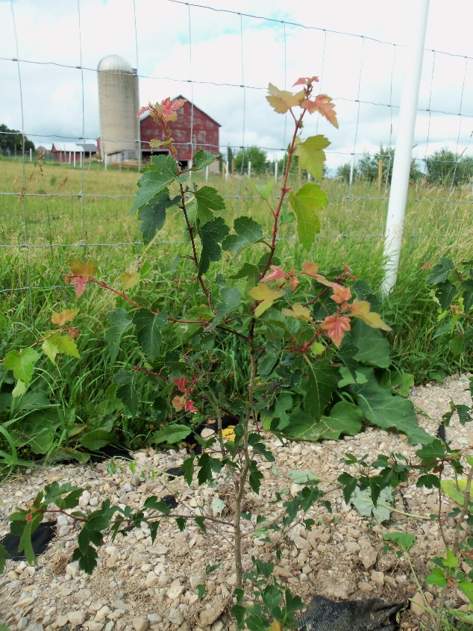
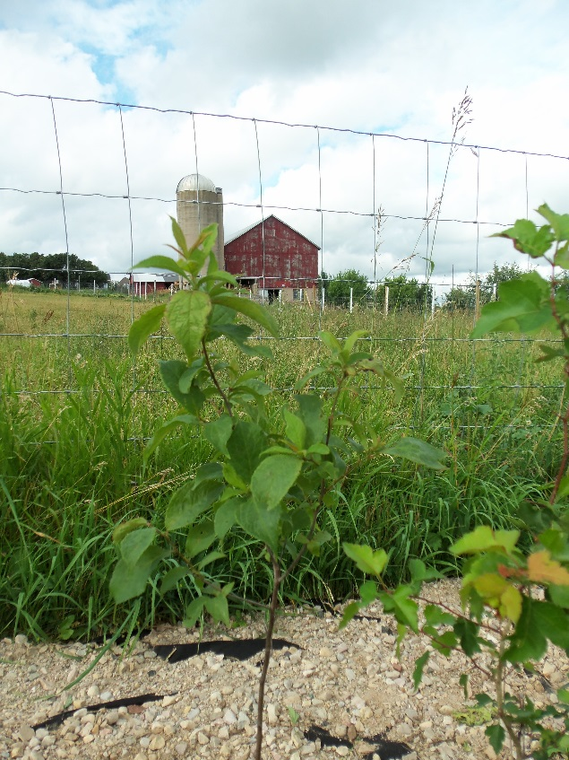

Size of thorn (July)
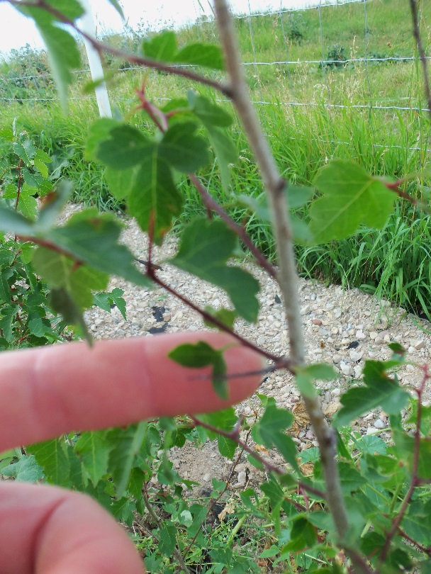

The hedge in August 2014. Far from goat proof yet. Don’t worry – the goats weren’t allowed to munch on the plants. They were there for size comparison. That’s an April baby Nubian checking out the hedge.
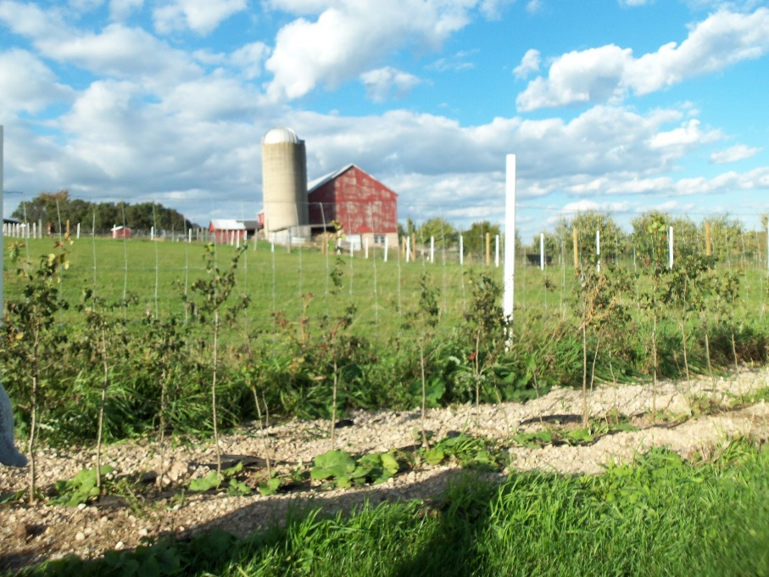
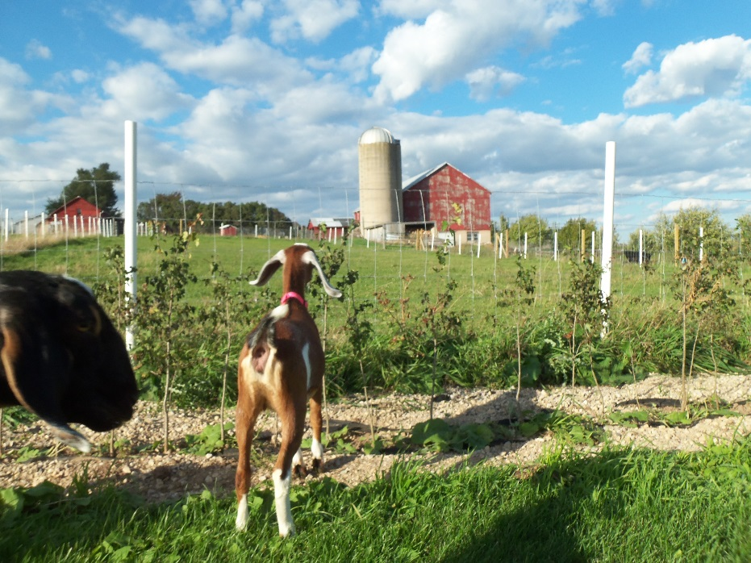

November 2014 rodent/critter damage. The wood in the background is part of our mouse trap line.

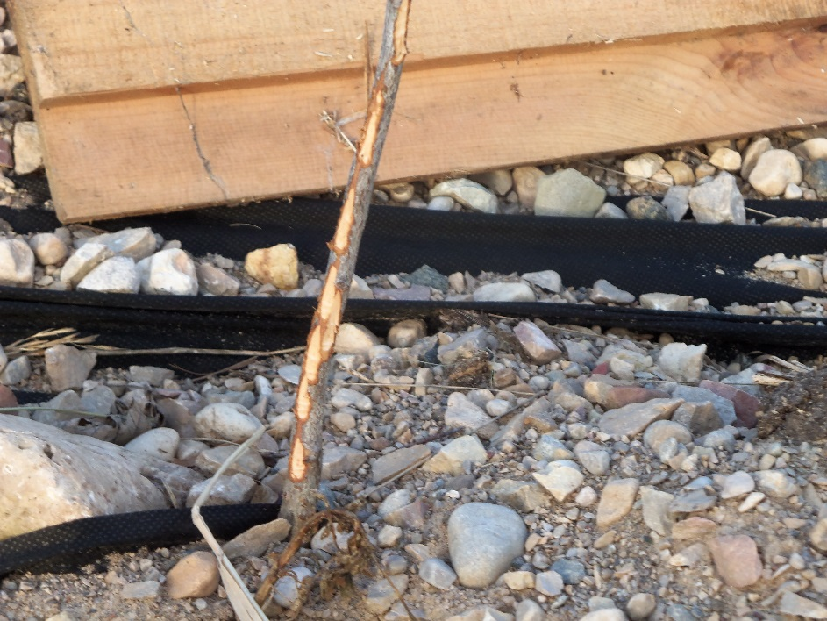

A view of the full mouse trap line.
