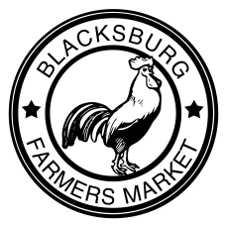
Community Forum Agenda
November 21, 2014
11am – 2pm

Objectives of the Forum

- Present results from the Montgomery County Farm to Community Planning Project
- Gather feedback from stakeholders relating to emerging issues
- Work to identify actionable items and next steps

Agenda

11:10 Welcome, Introductions, and Agenda
11:15 Background of the Montgomery County Farm to Community Planning Project
11:25 Food Venue Result and Brainstorm
11:40 Producer Results and Brainstorm
12:00 Consumer Results and Brainstorm
12:30 Lunch – The Fare Palate and Bollo's
12:50 Synthesis: Brainstorming for Action Items as Large Group
1:15 Next Steps: Small Group
1:45 Regroup, Synthesize, and Thank You!

Presenters

Jessica Schultz, Assistant Coordinator / schultz.jessica.vt@gmail.com
Ellen Stewart, Project Coordinator / bbfarmersmarket@gmail.com
Maureen McGonagle, WIC Garden Coordinator / maureen.mcgonagle@gmail.com

If you would like to continue working on these issues through the groups identified today, please write your name, contact information, and group on one of the small slips of paper and put it in one of the red cans on your way out. Thank you for all the ways you shape our food system!
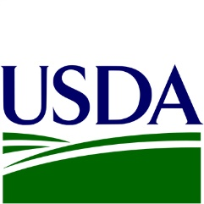
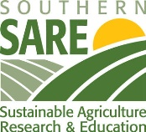

This project is made possible through grants from the USDA Community Food Projects Program and Southern SARE.

